Dreams and icons

By A Qavi Shakoor
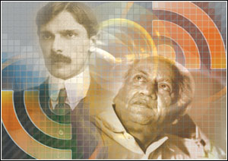
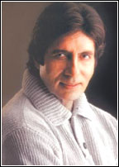
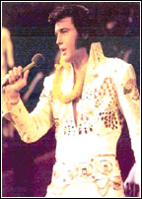
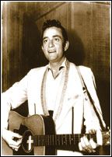
Youth is a very special period in our lives, when hard facts of life grapple with our fantasies and when heavenly dreams clash with the prosaic realities of the marketplace. We then leave the golden period of carefree boyhood or girlhood and cross the bridge into an enigmatic world of grown-ups. This is the time when the world expects us to fashion out our ideals, our role models, and our blueprints for the future. This is also the time when, caught in the whirlwind of an emotional Sturm und Drang, we discover our heart-rending crushes for irresistible older members of the opposite sex, and like Goethe’s Young Werther, are ready to lay down our lives at the altar of unrequited love.
This is also the time when the experiences of our highly impressionable childhood, our young years spent with our family and in the school, guide us to develop our own values and ideologies, our likes and dislikes, single out our heroes and select our icons. We find ourselves on the point of becoming independent individuals with a distinct mindset.
In the inner temple of our heart we have two types of images. A pantheon or a set of idols usually handed down by history or gifted to us by our culture and society. Such great names as William Shakespeare and Asadullah Ghalib belong to this category of venerable immortals. We accept them without demur, and worship them a bit perfunctorily.
But gradually we begin to introduce new images – icons – in this temple. Icons represent our own choice, and as such, are dearer to us.
As a youth I judged the world a bit severely and was dismayed by most of what I saw around me. Even so, I loved and admired a good number of personalities. Steeped in literature from my boyhood I was fond of poetry, having already started writing couplets under the penname of Tishna Brelvi, and receiving much inspiration from my aunt Bilquees Jamal, a celebrated poetess of yore. It was obvious that my inspiring icon would eventually emerge from the fragrant field of poetry.
Furthermore, I was a born liberal, and was appalled by my obscurantist environment. And to top it all, I firmly believed, even as a child, in equal rights for women. Consequently, my additional icon was destined to be an enlightened national personality, ready to fight for women’s rights.
Watching the ever-changing kaleidoscope of life as it ebbed and flowed around me, and leisurely walking through the glittering gallery of cultural and political luminaries, I was greatly impressed by Allama Iqbal, Josh Malihabadi, Akhtar Shrianee, Hasrat Mohani, Subhash Chandra Bose, Sajjad Zaheer, Churchill, Einstein, and Dilip Kumar.
Allama Iqbal, Josh Malihabadi and Akhtar Shrianee won my affection as three unforgettable Urdu poets. Maulana Hazrat Mohani (a unique poet of romance) and Subhash Chandra Bose made their mark as bold freedom fighters, rejecting the Gandhian appeasement. Sajjad Zaheer’s role as the founder of the Progressive Writers’ Association is of historical importance.
Sir Winston Churchill, historian as well as history-maker, writer and orator, has assumed legendary proportions. As a forceful and inspiring leader he extricated his nation from defeatism and blazed the trail to the Allied victory.
Who can ignore Albert Einstein? As one of the greatest physicists and mathematicians he ranks among the highest achievers of history. His Special Theory of Relativity (centred upon the famous equation, e=mc2) laid the foundation of the nuclear age, and his General Theory of Relativity, replacing Newton’s Laws of Gravitation, made a major contribution to Quantum Physics. Einstein was greatly saddened by the fact that his scientific discoveries had led to the dropping of atomic bombs on Hiroshima and Nagasaki.
Dilip Kumar is a shining star on the horizon of fame. Tinsel heroes generally remain in the limelight for a few years, but Dilip has been a super star for over 50 years. Discovered and introduced by Devika Rani in 1944, Dilip made his mark as perhaps the most popular romantic hero of the subcontinent.
But my super-icons happen to be poet Faiz Ahmed Faiz and the Quaid-i-Azam.
Selected by history as one of the greatest trailblazers and national leaders of the world, our Quaid also deserves praise in another very important field. He personified the most outstanding champion of women’s rights of his time. No leader -- Muslim or non-Muslim, and including Sir Syed, Allama Iqbal and Mahatma Gandhi -- so firmly stood for the full participation of women in the national life and unequivocally declared it to be a pre-condition for the forward march of the nation.

In the inner temple of our heart we have two types of images. A pantheon or a set of idols usually handed down by history or gifted to us by our culture and society. We accept them without demur, and worship them a bit perfunctorily. But gradually we begin to introduce new images – icons – in this temple. Icons represent our own choice, and as such, are dearer to us.

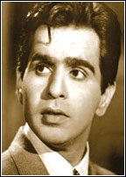
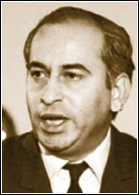
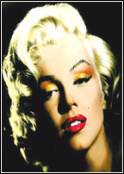
Mohammad Ali Jinnah had proved his deep commitment to women’s cause by setting a glorious example over a century ago, and that too at a time when the present-day western champions of equal opportunity were blithely treating their females as inferior beings, when in England, the protesting suffragettes -- Mrs Pankhurst, Emily Davidson and others -- were being imprisoned, beaten and even murdered by the establishment, when in the Third Republic of France, home of the revolution and cradle of liberty, the chic dames were not allowed to sign a cheque, and when in the United States, the great land of opportunity, right under the nose of the newly installed Lady of Liberty, the American ladies lacked most liberties.
Finding himself entrusted with the care of his little sister, Fatima, the young, struggling barrister gave her his love and saw to it that she received a high education and professional training as a dentist (an unbelievably practical occupation for a woman of those days), so that she could face the world on equal terms and pay her own way. This shining, yet unsung contribution of the great leader must never be forgotten by us.
Faiz Ahmed Faiz was an educationist, journalist, trade-unionist, linguist, and a political activist of international fame, known and admired all the way from Cuba to Baku, our Faiz, forming a metrical triumvirate with Pablo Neruda and Nazim Hikmat, is a many-faceted jewel, and indeed one of the most-translated versifiers.
Faiz, an exponent of revolutionary romanticism and chivalrous lyricism, is essentially a poet of love, in the amorous style of Akhtar Shiranee. Refreshingly enough, his heart-throbs — his Juliets — are modern, emancipated women. But unlike Shiranee, who could never see beyond his Salma or Rehana, Faiz is alive to the world around him and makes it his life’s mission to combat injustice, oppression and obscurantism. In his famous poem Mujh Se Pahli Si Mohabbat, so impressively vocalised by Noor Jehan, the melody queen, Faiz comes across as informing and simultaneously reassuring his inamorata in this way, ‘I’m duty-bound, my dear, to serve the suffering humanity. There are other pains and pleasures in life beside the pangs of separation and the ecstasy of lovers’ embrace; so demand no more of me the same exclusive devotion. But, withal, I love you with all my heart.’
Actually two loves co-exist in his heart – the love for beautiful woman, and the love for Les Miserables of society, and he is apologetic about neither, iss ishq na uss ishq pe nadim hai magar dil. Fervent and melodious poetry, sparkling with the sublimity of conception and artistry of words, has moulded Faiz into the most accomplished and inspiring Urdu poet since the birth of Pakistan.

