New economics of systemic risk
By Shahid Javed Burki
Monday, 02 Aug, 2010 | 12:29 AM PST |
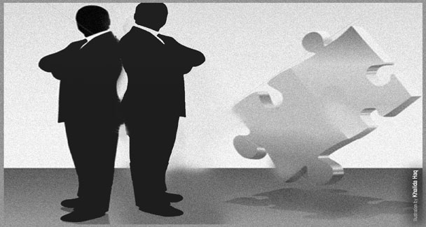
THE development of economics as a discipline has moved a long way since the time of Adam Smith, widely regarded as the founder of modern economics. Much of what the Scotsman said two centuries ago in
The Wealth of Nations, generally regarded as the bible of the discipline, was based on reflection and intuition.
Smith neither came up with mathematical equations to lend credence to his observations nor did he scientifically gather information to prove that he was on the right track. That was left to later economists such as Alfred Marshall and Paul Samuelson.
Intuition is no longer the source of many new developments. Many of the new insights in economics are based on empirical work. In development economics, most of what we have come to believe is based on the econometric analysis of the data gathered by such institutions as the World Bank, the Asian Development Bank and the International Monetary Fund.
Many of the more important advances in economics have come during and after major crises. It was after the Great Depression that John Maynard Keynes, generally considered to be the greatest twentieth century economist, came to lay the foundations of what came to be known as macroeconomics. His main contribution was to suggest that markets were not totally rational in the way they behaved. They did not automatically adjust to the changes brought about by such external events as new inventions and natural or man-made disasters.
Economies thus disturbed needed the intervention of governments, using their ability to tax and spend as well as the ability to create money. Thus was born what the Nobel Laureate Paul Krugman calls, “depression economics.”
The new crisis that produced the Great Recession of 2008-09, is also leading to new developments in the discipline of economics. In studying how to respond to the upheaval that has occurred and create a more stable system, financial officials, central bankers, international experts and academics have been focusing on a concept known as “systemic risk”.
This manifested itself in “falling domino” problem that led mortgage defaults and in the United States to lock up the global financial system because of the complex connections among banks, investment companies, insurers and other firms around the world. The phenomenon is not well understood in spite of all the work that has been done in recent months.
“We sort of know vaguely what systemic risk is and what factors might relate to it. But to argue that is a well understood science at this point is overstating the fact,” says Raghuram Rajan, former Chief Economist of the IMF and the author of a highly influential book, Fault Lines, which explored the role of the United States’ real estate and credit bubbles in the crisis that peaked in 2008-09 but is still not fully over.
It was Rajan – along with some other contrarian economists – who first suggested that the United States was heading towards an economic disaster. This was done in a paper delivered in the summer of 2005 at Jackson Hole where central bankers from around the world and economists working in the field of monetary economics gather every year to reflect on the current economic situation.
Ragan challenged the Efficient Market Hypothesis that had begun to dominate academic thinking as well as the working of the institutions such as the Federal Reserve Bank and the US central bank. Under the leadership of Alan Greenspan the Fed believed that the markets were better left to their own devices to the point of self-regulation.
Before the crisis there was a widespread belief that the prices charged by the market for various kinds of assets reflected the information available to those who buy and sell. Markets with large numbers of people with enough information and the ability to move money freely could assess the risks of different types of investments and protect themselves. That, of course, did not happen.
Watching the herd instinct that developed many economists abandoned the “rationality” principle and began to look at the way consumers and investors behave. Thus was born “behavioural economics” which has begun to invite considerable amount of attention. Its most notable practitioner is Robert Shiller, the economist from Yale University.
What is the relevance of all these on-going developments for a country such as Pakistan? The answer to this question should perhaps begin with a bit of history. In early 2006, at a seminar organised by the Washington-based Woodrow Wilson institution, I incurred the displeasure of Shaukat Aziz, the then prime minister, by suggesting that his policies had allowed Pakistan to become a “casino economics”. My observation was based on what I had observed was happening in the real estate market. There was an enormous amount of speculative behaviour in the market as investors bought and sold what were called the “files”.
These were claims to yet-to-developed plots of land in housing communities that were being built in most of the important cities around the country. Some of the files that were bought and sold did not even identify the location of the plots. The purchases of the plots created an enormous real estate bubble which, like all bubbles, was bound to burst.
Like all bubbles this one was also based on the availability of easy money. This had become available for three reasons: lowering of lending rates by the State Bank of Pakistan, tons of black money created by corruption and tax-dodging by the rich, and loads of finance that was coming in from abroad as remittances being sent by the people of Pakistani origin living and working abroad.
It was not unusual for the price paid for some of the files to double or triple in a matter of months. It was legitimate for me to call this “casino economics” since the real estate bubble began to affect all parts of the Pakistani economic system.
The returns available in this type on investment could not be replicated in other parts of the economy. Accordingly a great deal of money was sucked into the real estate sector depriving more important parts of the economy with the finance they needed. Had the administration then paid attention to the casino economy that had begun to dominate the Pakistani system, some ameliorative actions could have been taken. Tightening of money supply and heavy taxes on real estate transactions were two of the several measures that would have stopped the bubble from developing and spreading.
Taxes could have been specifically directed to curb speculative behaviour. For instance, a transaction tax could have been levied if the period between the purchase and sale of a “file” was very short, say less than a year. Transactions of files could have been discouraged by mandating that the properties they represented had to be clearly specified. None of this, of course, was done and the real estate market came crashing down. It has still to recover.
The lesson to be drawn by the policymakers from the experiences of various economies round the globe and their own experience with the collapse of the real estate market is that they should always be mindful of developments that cannot be justified on the basis of rational expectation. They must step in with appropriate policies to puncture the developing balloons.
Left to inflate they will do a lot of damage not only to the sectors that were directly involved but also to those that were somehow linked with them. Once their work is done those working on systemic risks will have a great deal to teach the policymaker including those in Pakistan.

