Controversies over water sharing
By Ahmad Fraz Khan
Monday, 14 Dec, 2009
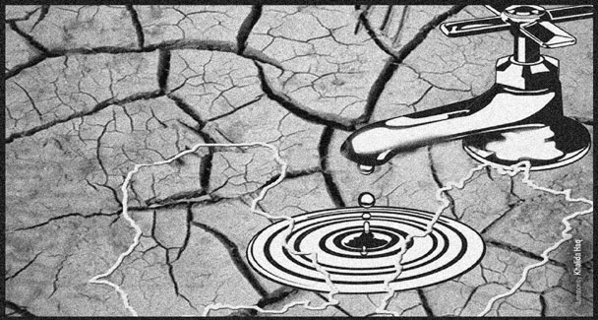
WITH the increasing water scarcity, controversies over its distribution among provinces, especially Sindh and Punjab, keep cropping up. But of late, these are becoming numerous, and many of them have political undertones.
Take the current controversy, setting Punjab against Irsa. Punjab says that it still has a share of 2.5 million acres feet (MAF) water left from the Indus arm, whereas Irsa says it does not owe anything to province from Indus. Punjab has already consumed its share from the Indus side, it is quoted in the media. Can 2.5maf water simply go missing from the system?
Irsa has delivered the said quantity and Punjab has not received it. Where has the water gone? It needs to be clarified so that such unnecessary controversies could be pre-empted in future. If Irsa has released water and Punjab has mismanaged it, the province must be taken to task. But, if the reverse is true, Irsa should be asked to behave responsibly.
The cost of such mistakes, regardless of who commits them, is simply unaffordable. Take the example of four canals – D G Khan, Thal, Muzaffargarh and CRBC – in southern Punjab, which Irsa threatened to shut down as the provincial share from Indus arm expires.
These canals, which jointly irrigate around six million acres in southern Punjab districts, cannot be fed from any other source. The DG Khan and Muzaffargarh canals supply water to around 2.5 million acres in respective districts, Chashma Right Bank Canal to around 300,000 acres and Thal canal to another 1.5 million acres.
About 70 per cent of wheat sowing has been achieved in these areas so far, and the rest is threatened by impending closure. Should the canals get closed, it would not only hit national wheat production target but also reduce he income of millions of farmers – forcing them to miss the Rabi crops. Farmers from southern Punjab cannot pump out underground water as it is a brackish belt, and subsoil water is unfit for sowing and drinking. People in the area depend on canal supplies even for drinking purposes. The closure would also threaten national wheat target. A record crop was achieved last year because southern Punjab had produced more.
Interestingly, apart from the media threats, the Indus River System Authority (Irsa) has so far neither closed canals nor formally informed the Punjab government, despite passage of almost 72 hours, of its threat of closing all four canals. Even after three days, the authority was running canals as per schedule given by Punjab for current 10-daily (this is, at least, what Irsa spokesman claimed talking to the writer). If it does not have to close canals, why did it go to the media with threat, stirring a storm in every corner of the province?
These controversies are being generated in the backdrop of around 35 per cent water shortage. The farmers’ fears that closing canals that have already been running at just more than half of their capacity, would ruin their crops and livelihood for this season.
Since the entire impact of canal closure would be concentrated in the politically sensitive southern belt – considered to be one of the most backward parts and occasionally demanding to be declared a “province” to address its problems – Punjab has no choice but to fight back. That is exactly what Punjab is currently planning, strategising its response in the media, federal government and other forums.
The entire controversy is being projected in the media alone. The canals are still running – Punjab was receiving 11 per cent water from the Taunsa Barrage even on Tuesday -- and the regulator and the “victim” have locked horns in the media.
Someone also needs to dust of 91’ Water Accord and make the Indus River System Authority read it afresh. The accord was basically a development document. Only one of its clauses spoke of shortages and mechanism to share them.
The rest 17 clauses were related to developing water resources and sharing the fruits of water richness. The authority, comprising technocrats from all provinces, was supposed to behave like a federal body – leading a national consensus on new reservoirs, selling them on the basis of their technical feasibility and educating politicians and public alike.
Over the last 18 years of its existence, one or the other province has been complaining that the political dice is loaded against it and the authority decisions have been subservient to political preferences. Currently, Punjab is reading its numerology in the same background.

