Obama in China
By Shahid Javed Burki
Tuesday, 01 Dec, 2009
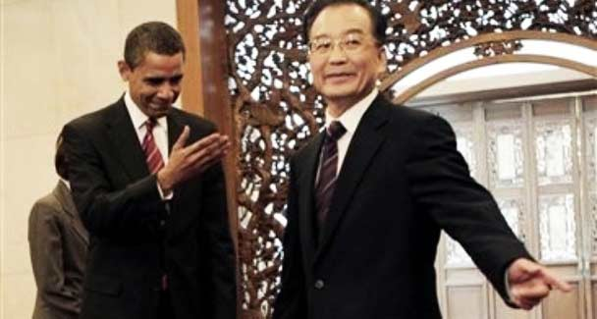
In a Nov. 18, 2009 photo President Barack Obama, left, and Chinese Premier Wen Jiabao, right, gesture to each other during the arrival at Diaoyutai State Guest House before their bilateral meeting in Beijing, China.
If there were any doubts that the global economic and political order was being reshaped they were set aside by the outcome of President Barack Obama’s recently concluded three-day visit to China.
That was the high point of the nine-day trip to Asia. It has great significance in terms of charting a new course for American diplomacy not only in Asia but in the world.
By moving to grant China an equal status, President Obama moved light years away from the approach adopted by President George W. Bush, his predecessor. Under Bush, the United States proclaimed its intention to remain the world’s sole superpower, declaring formally that it would resist any effort by any other country to claim an equal status. That course was abandoned by the new American president.
President Obama invited Beijing to join Washington within a G2 configuration — it was never called that in official or other pronouncements but the meaning was clear — that would take the world towards peace and greater prosperity. According to Geoff Dyer and Edward Luce of the Financial Times, who have watched the evolution of America-China relations for years, this signals a shift in America’s ‘specific approach to China — arguably the first time Washington has acknowledged an equal or near equal partner since the dying days of the Cold War. Perhaps counter-institutively for a candidate who inspired so much youthful idealism on the campaign trail, Mr Obama’s extended hand of friendship to China also ushers in a new era of realist diplomacy in Washington’.
What was the Chinese response to this initiative? How will it be viewed in the United States? What mechanisms will be used to move forward this relationship? How will some of the other power centres in the world react to this reconfiguration in world politics? The Chinese, ever cautious, had been preparing for the time when their arrival on the stage of international politics and economics would be taken seriously by other powerful states.
The discussion about China’s new role starts with Deng Xiaoping’s 1989 slogan ‘hide the brightness and nourish obscurity’. The highly pragmatic Deng wanted China to concentrate on developing its economy without inviting a great deal of attention from its competitors. He had given his country about 50 years to develop an economy that would begin to have a large presence in the world. This happened sooner than he had envisioned. While obscuring its intention, Deng promised that the country would ‘accomplish some things’ by adding this phrase to his edict. This year the Chinese added the word ‘actively’, to the old slogan, meaning they were prepared to actively achieve something.
A question has been asked at this point in China’s evolving relationship with the United States: whether the country is ready to partner with the Americans in the context of what is being called a G2 arrangement. This is an old relationship; it was mostly based on trade. The first merchant vessel to sail from New York to Canton in 1784 was on a tea buying voyage.
For centuries the Chinese admired America and what it had achieved in a relatively short period of time. But the American model now seems to the Chinese to have limitations. According to Simon Schama, an old China hand, ‘the secret truth is that the Chinese have not yet become accustomed to being the strong party in this relationship. The communist oligarchs who have made eyes at the American model for so long can hardly bear to see it as it is: lying in the dust, reduced to just another broken model, no more attractive than the dim and dusty memory of Karl Marx’.
While the Chinese were moving forward cautiously in establishing themselves as the joint leaders of the international community, the Americans moved in that direction briskly. Since Washington’s move meant reducing its stature in global politics and economics, it was not received with much enthusiasm by various segments of the American population. There were loud criticisms of the way President Obama handled himself in Asia, in particular in China.
‘The trip was a template for rising American anxieties about the rising Asian power,’ wrote The New York Times in an editorial assessing President Obama’s China trip. ‘President Obama went into his meetings with President Hu Jintao with a weaker hand than most recent American leaders — and it showed. He is still trying to restore the country’s moral authority and a battered economy dependent on Chinese lending. Yet the United States needs China’s cooperation in important and difficult problems, including stabilising the global financial system, curbing global warming, persuading North Korea to give up its nuclear programme and preventing Iran from building any nuclear weapons.’
How did President Obama play this difficult hand? The New York Times, reflecting the views of the liberal community in the United States, came up with a mixed review. ‘President Obama was elected in part because he promised a more cooperative and pragmatic leadership in world affairs. The measure of the success (or failure) of his approach won’t be known for months, and we hope it bears fruit. But the American president must be willing to stand up to Beijing in defence of core American interests and values.’
There were concerns in some places outside America that President Obama was perhaps moving too quickly to bring Beijing into a G2 relationship with Washington. This was especially the case with India that had begun to expect it would have a major role in the reconfigured world order.
Many influential Indians had convinced themselves that their model based on democracy was more durable than that of China directed from the top by a small coterie of unelected leaders. They saw China’s remarkable growth as a flash in the pan while there’s was sustainable. India’s hurt pride was assuaged to some extent by the warmth with which Prime Minster Manmohan Singh was received on a state visit to Washington. This was the first state visit for the Obama presidency and the president heaped a great deal of praise on the Indian leader as well as on his country.

