Rise and fall of great powers
By Tariq Fatemi
Thursday, 11 Feb, 2010
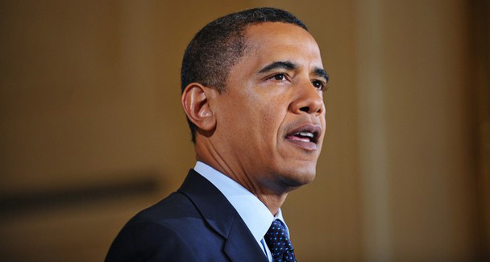
US President Barack Obama.

President Barack Obama’s first federal budget presented last week was filled with statistics that ordinary people would have found difficult to comprehend. Nevertheless, they did reveal worrying trends — a cause for general concern as America’s economic well-being has a profound impact worldwide.
The projected deficit in the coming year will amount to nearly 11 per cent of the country’s entire economic output and by Obama’s own projection, the US deficit will not return to sustainable levels in the next 10 years. In fact, in 2020, it is likely to rise again.
Part of this realisation was evident in Obama’s admission in his December strategy speech on Afghanistan, that “our prosperity provides a foundation for our power”. Obama also stated “our troop commitment in Afghanistan cannot be open-ended, because the nation that I am most interested in building is our own”.
Much of America’s predicament is, of course, the result of the ruinous policies pursued by President George Bush including his two disastrous wars in Iraq and Afghanistan.
Many also trace it to the time when a spirit of triumph swept the US in the wake of the Soviet Union’s collapse and led it to establish a ‘new world order’, with Francis Fukuyama proclaiming the ‘end of history’, seeing in this event proof of the superiority of the western political and economic philosophy. Only recently, Dr Henry Kissinger, recalled that “there was too much triumphalism on the western side. There was too much description of the Soviets as defeated in the Cold War and maybe a certain amount of arrogance”.
Others were not satisfied with merely trumpeting the West’s victory, but began to search for new dragons that needed to be slain. In such an atmosphere, Samuel Huntington had only to provide a pseudo-scholarly rationale for making out Islam as a global challenge to the West.
President Obama, more intelligent and better read than most of his predecessors, recognised early on the folly of this policy and promised to move beyond terrorism and security to address US relations with the world’s Muslims on the basis of “mutual interest”. But the opposite seems to be happening. Many are asking whether America’s powerful lobbies and its defence and intelligence agencies will permit Obama to give shape to his expressed sentiments.
The prognosis, so far, is not encouraging, with many accusing him of “not even fulfilling one of his promises to the Muslim world”. Even if exaggerated, America’s agonising economic crisis will severely restrict Washington’s ability to adopt a cooperative and conciliatory strategy towards the Muslim world, which ironically possesses those very natural resources that America desperately seeks.
It had earlier been expected that the beginning of the 21st century would confirm continued US global domination, as it “bestrode the world like a military and economic colossus”. But many credible scholars are now warning that “America’s imperial grandeur has so far masked its moral rot and economic decay”. Like imperial Rome and Britain, the US has pursued disastrous foreign adventures that have emptied its treasury and shattered its will. Worse, America’s unbridled capitalist system has weakened many of its regulatory institutions, permitting bankers and corporate barons to engage in unprecedented loot.
It was while going through Obama’s budget speech and analysing the remarkable volte-face witnessed at the London Conference on Afghanistan, that I was reminded of Paul Kennedy’s book: The Rise and Fall of the Great Powers.
He wrote: “The US now runs the risk, so familiar to historians of the rise and fall of previous great powers, of what might roughly be called ‘imperial overstretch’; that is to say, decision-makers in Washington must face the awkward and enduring fact that the sum total of the US global interests and obligations is nowadays far larger than the country’s power to defend them all simultaneously.”
His words of wisdom were discussed and then forgotten. This was not surprising, as America’s only visible rival was then stuck in the Afghan quagmire, and soon thereafter collapsed.In the meanwhile, as America’s economic crisis worsens and its moral prestige declines, China has begun to emerge as a serious challenger. Not only has it maintained a remarkable growth rate for nearly three decades, it has succeeded in ensuring stability at home.
During my visit to China last month, I was able to witness, once again, how its remarkable successes have raised its profile and made it a critical player in all global issues. It not only has over $2.4tr in foreign exchange reserves, it has lent over $1tr to the US. China has dismissed talk of the US wanting to build India as a rival to it, pointing out that it does not believe in pursuing great power politics.
Recently, however, China sent signals of a new confidence, even assertiveness. Its strong reaction to Washington’s decision to sell over $6bn worth of sophisticated arms to Taiwan, and to Obama’s willingness to meet the Dalai Lama has irked US lawmakers. But Beijing’s indignation should have been expected. It may be a one-party state, but its leaders have to be sensitive to public opinion that takes pride in its nationalist stance.
Nevertheless, China is not likely to challenge the US, for it recognises that any sign of ‘arrogance’ will only reinforce growing fears about it.
More realistically, China can be expected to pursue its traditionally cautious policy, remaining faithful to Deng Xiaoping’s counsel to “hide the brightness and nourish obscurity”. The emergence on the world stage of a new power will nevertheless change the contours of global politics, influencing political alliances and economic linkages. How Pakistan takes advantage of this historic shift will be a test of our leadership’s vision.

