Obama’s changing tone
By Shahid Javed Burki
Tuesday, 26 Jan, 2010
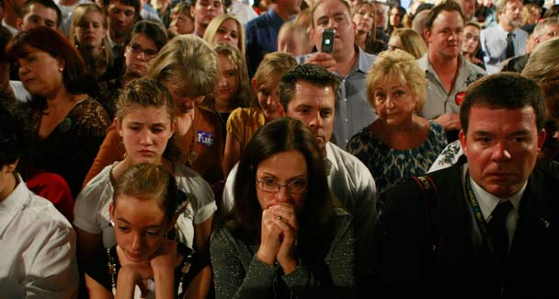
Obama’s supporters are troubled by the direction the president is taking under the pressure of events.
What has given such prominence to a string of insurgencies at this time is the fact that some non-state actors belonging to the Islamic faith have decided to challenge the West, the US in particular, by using the weapon of terrorism.
The initial response of the US to the problem was to employ force to defeat the Islamic extremists threatening its interests. This was called the ‘shock and awe’ approach that envisaged using military power against an essentially primitive enemy to obtain its submission.
This was largely the strategy followed by the administration of President George W. Bush until the final year of his tenure. Then, under the influence of Gen David Petraeus, who was responsible for developing the US counter-insurgency strategy, the Bush administration changed its course in Iraq by combining economic and political development with force to beat back the insurgents. The strategy seems to have worked. The level of violence in Iraq has subsided significantly; December 2009 was the first month since March 2003 when the US went into Iraq that the Americans did not lose a single soldier in the conflict.
Whether the same strategy should be adopted in Afghanistan, the other area of insurgent activities, is a question that was debated for four months between August and November 2009 by the senior officials of the US administration including President Barack Obama.
The latter had taken office convinced that part of the problem was a widespread impression among Muslim populations around the globe that the Americans were fighting a war against Islam. Early on in his tenure he decided to address this issue head-on. In a major address aimed at the world’s Muslims and delivered before an audience in Cairo he said: “I have come here to Cairo to seek a new beginning between the United States and Muslims around the world, one based on mutual interest and respect.”
He promised that he would build bridges between his country and the world of Islam. He wanted the Muslims to recognise that the fight against those who were committing acts of terrorism was not just America’s war or the war being waged by the West, but it was also their war. He did not wish the people in his own administration to lose sight of this fact as he prepared to define a new strategy to beat back the insurgents operating from the secured havens in the mountainous regions on the border between Afghanistan and Pakistan.
Last year, Gen Stanley McChrystal, the commander of the US forces in Afghanistan, sent in a request for 40,000 additional troops to the president. The general wanted the kind of troop surge in Afghanistan that appeared to have brought relative peace in Iraq. After an intensive discussion, led by the president, it was announced that there would be 30,000 more troops for Afghanistan. But Obama also said that he would begin the process of withdrawal of the American contingent from July 2011.
All these developments have seriously affected Pakistan which had already seen a build-up in Islamic extremism. However, just as the administration had convinced itself that it had found a way and justification for combining strong military action against the extremists with a serious development effort, the situation was complicated by a Nigerian man’s attempt to blow up an American airliner on Christmas day 2009. It was revealed that he had received training in Yemen from the Al Qaeda in the Arabian Peninsula (AQAP).
Preceding this act was the attack by a Muslim doctor, a psychiatrist, on his fellow workers at Fort Hood in Texas in which 14 people were killed. It was revealed that the doctor was also in email contact with a Yemeni imam. Under pressure from his critics who were troubled by the new president’s focus not on the use of force alone but to combine force with other types of efforts, Obama seems to be shifting his ground. He has begun to use a language resembling that of his predecessor. “We are at war against Al Qaeda and we will do whatever it takes to defeat them,” he declared, after the botched bombing attempt.
Some of those who had supported Obama in his quest for the presidency are troubled by the direction the new president is taking under the pressure of events. “Even as he fights Al Qaeda and its allies, Obama needs to be Obama. He needs to continue voicing the Cairo message of outreach to the Muslim world — not as an alternative to battling extremism but as a necessary component to that fight,” wrote syndicated columnist David Ignatius recently. “We are confronting an enemy that wants us to draw deeper into battle, so that America is more isolated and unpopular. We avoid the spider’s trap by resolving the problems that matter.”
The main hypothesis to be tested by the evolving American approach is the role of economics in producing despair among certain groups of people and to persuade them to challenge the authority of the state. If this is indeed the case it will have a profound impact on the design of public policy.
A good part of the debate in the US as President Barack Obama was deciding on a strategy to fight the Islamic militants operating in the border areas of Afghanistan and Pakistan was concerned with giving more weight to economic development in winning the war against the extremists. If economic deprivation was a powerful reason for the extremists to fight the West and simultaneously the Afghan and Pakistani states then that is where the bulk of the effort has to go.

