Dysfunctional America
By A.G. Noorani
Saturday, 06 Mar, 2010
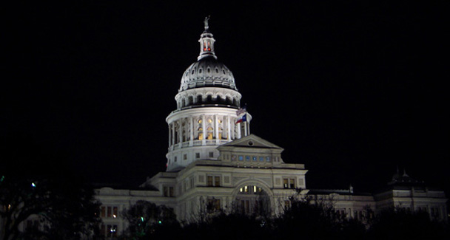
The US campaigns for the spread of democracy abroad. It would do well to fix its own dysfunctional constitutional and political system.

The United States of America campaigns for the spread of democracy abroad. It would do well to fix its own dysfunctional constitutional and political system. Its Senate is paralysed by filibuster while the house is a product of gerrymandering.
As Bob Herbert of the New York Times wrote: “We know that Al Gore got more votes than George W. Bush in the 2000 presidential election and that of the people who went to the polls in Florida, more had intended to vote for Gore than for Bush. But Bush became president.”
A divided supreme court, highly politicised particularly in recent years, upheld the result. The electoral system, the very base of democratic governance, is deeply flawed in a country which tirelessly preaches ‘free and fair elections’ to others.

“With each new election comes a new round of voter horror stories: Hanging chads. Eight and nine-hour waits in the rain. Votes lost. Votes never counted. Electronic-voting machines, vulnerable to all types of mischief, proliferating without the protective shadow of a paper trail. People in poor neighbourhoods shunning the voting booth because they’ve been led to believe they’ll be arrested for some minor violation, such as an unpaid traffic ticket, if they dare to show up at the polls.”
If the credibility of the electoral process is impaired the result can only be estrangement between the people and the men who ‘won’ the vote.

Bob Herbert put it neatly: “One of the biggest problems at the moment is the extent to which ordinary Americans feel estranged from the ruling elite, from those powerful men and women in both parties who actually influence the course of politics and government.”
The problem is two-fold, constitutional and political. The senate is stymied by filibuster sanctioned by Standing Rule XXII of the senate which is, believe it or not, an improvement on past practice.

For most of the 19th century the majority had no way to move ‘closure’ to end a filibuster and force a vote. This enabled any senator to block almost any measure just by keeping on talking.
In 1917, prompted by a filibuster against Woodrow Wilson’s wish to take America into the First World War, the Senate adopted Rule XXII, which said that it could move to closure if two-thirds of senators present voted for it, in other words 60 out of the 100.

But on Jan 19 a Republican, Scott Brown, won Ted Kennedy’s seat in Massachusetts adding a precious vote in the senate to the Republicans’ existing 40 seats. The Democrats can no longer force closure to end a filibuster.

If they all happen to come from the least populated states, these representatives of about a tenth of the population can bring Congress to a standstill.

Many a seat in the House of Representatives is filled by gerrymandering. Both Democrats and Republicans have elaborately arranged some ‘safe’ seats.
Lobbyists have a field day. Special interest groups spend vast sums of money. The Centre for Responsive Politics reported on Feb 12 that companies and other organisations spent a record $3.5bn on lobbying in 2009, much of it targeted at the administration’s health and energy bills.

And this, notes James Thurber of American University’s Centre for Congressional and Presidential Studies, includes only what is recorded by registered lobbyists, not money spent for grassroots organizing, coalition-building, and advertising. On some estimates, Thurber says, the total spent on lobbying in Washington is close to $9bn a year.
The legislative process is debased by a practice which facilitates corruption. It is pork-barrel spending, technically known as ‘earmarks’.

Pet local projects are slipped into massive government spending bills by senators and Congressman in return for their support to the bill. For the year 2008, for instance, almost 13,000 were attached to spending bills worth more than $18bn in all.

All too often they are rewards, direct or indirect, for organizations or special interests that have given money to the politicians who inserted them.
Only 10 per cent of earmarks are included in the texts of the bills. They are only listed in committee reports and have no legal force, and are a product of deals in committees. A president who ignores an earmark risks a huge outcry and defeat of his bills in Congress.
The country is badly split. Growing partisanship has aggravated the consequences of these legislature deformities. In 1995 Newt Gingrich, then speaker of the house, cut off the federal government’s funding and forced a temporary government shutdown. He wanted Bill Clinton to agree to sharp cuts in Medicare.
The Nobel laureate Paul Krugman remarked: “The truth is that given the state of American politics, the way the senate works is no longer consistent with a functioning government. Senators themselves should recognise this fact and push through changes in those rules, including eliminating or at least limiting the filibuster. This is something they could and should do, by majority vote.”
On Feb 15, Senator Evan Bayh, a 54-year-old centrist, announced that he would not seek re-election. The reasons he cited for his astounding decision should serve as a wake-up call. “Challenges of historic import threaten America’s future. Action on the deficit, economy, energy, healthcare and much more is imperative, yet our legislative institutions fail to act. Congress must be reformed.”
There are many causes for the dysfunction as he pointed out — strident partisanship, unyielding ideology, a corrosive system of campaign financing, gerrymandering of house districts, holds on executive appointees in the senate, dwindling social interaction between senators of opposing parties and a caucus system that promotes party unity at the expenses of bipartisan consensus.

