Some critical questions
By Yousuf Nazar
Wednesday, 10 Feb, 2010
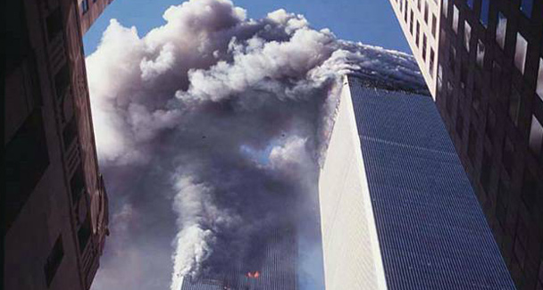
Even after seven years, the US has failed to try the alleged mastermind of 9/11, Khalid Sheikh Mohammed.

A columnist recently lamented the “emotionally charged thinking of Pakistanis” that leads them to believe conspiracy theories that present the events of Sept 11, 2001 as a plot hatched by mysterious elements in the American establishment.
There is no doubt that fundamentalism and terrorism are a serious threat to our country, but the views about 9/11 and the United States “being the only country that can help” need to be analysed with cold logic and in the context of some critical questions about 9/11 that were raised by serious Americans who did not make the movie Loose Change.
But before that, recent comments by former Malaysian premier Mahathir Mohamad; the latter told a Malaysian TV channel last month that 9/11 was an inside job. Mahathir also said some people were afraid of saying anything critical about the governments of powerful countries or accusing them of wrongdoing. But, he added, the governments of powerful countries told lies to go to war.
Mahathir is not the only senior statesman to say this. Francesco Cossiga (Italy’s president for seven years until April 1992) told Italian newspaper Corriere della Sera on Dec 3, 2007 that the attacks were run by the CIA and Mossad and that was common knowledge amongst global intelligence agencies. What about Alan Greenspan, an icon of the Wall Street Republicans?
No US official or journalist or think tank has ever raised or answered the question that Alan Greenspan posed in his book, The Age of Turbulence:
“There was no bigger question in Washington than why no second attack? If Al Qaeda’s intent was to disrupt the US economy, as Bin Laden declared, the attacks had to continue. Our society was open, our borders porous, and ability to detect weapons and bombs was weak. I asked this question of a lot of people at the highest levels of government, and no one seemed to have a convincing response.”
Mr Greenspan has known George Bush, Dick Cheney, Donald Rumsfeld and other top leaders for decades and had access to everyone who was anybody in Washington at the time. The reason he did not get a convincing response was that the people at the highest level of (US) government did not have one. Why?
On Sept 17, 2008, Time magazine published a story ‘Risking War with Pakistan’ written by an ex-CIA officer (for the Middle East) Robert Baer. He wrote:
“On Tuesday, Pakistan’s military ordered its forces along the Afghan border to repulse all future American military incursions into Pakistan. The story has been subsequently downplayed.”
Baer asked a troubling question: “Is it worth the ghost hunt we’ve been on since September 11? There has not been a credible sighting of Osama bin Laden since he escaped from Tora Bora in October 2001. As for Al Qaeda, there are few signs it’s even still alive. Al Qaeda couldn’t even manage to post a statement on the Internet marking September 11, let alone set off a bomb.”
The 9/11 commission itself charged the US government of a cover-up. On Jan 2, 2008, Thomas Kean and Lee Hamilton who served as chairman and vice chairman, respectively, of the 9/11 commission wrote an op-ed piece in The New York Times, accusing the US government of a cover-up and obstruction (of justice) as no one in the administration ever told the commission of the existence of videotapes of detainee interrogations: “…. government officials decided not to inform a lawfully constituted body, created by Congress and the president, to investigate one of the greatest tragedies to confront this country.” (Emphasis added).
John Pistole, deputy assistant director of the Federal Bureau, testified before the US Senate Committee on Governmental Affairs on July 31, 2003.
“The FBI conducted a detailed financial investigation/analysis of the 19 hijackers and their support network, [and] traced the origin of the funding of 9/11 back to financial accounts in Pakistan, where high-ranking and well-known Al Qaeda operatives played a major role in moving the money forward, eventually into the hands of the hijackers located in the US.”
There was no follow-up investigation into these grave and startling revelations. His testimony was consistent with what the Wall Street Journal had published on Oct 10, 2001. The WSJ never followed up or contradicted its story.
The fact is that even after nearly seven years of his arrest, the US government has failed to try the alleged mastermind of 9/11, Khalid Sheikh Mohammed, in a normal civil federal court. He was arrested in March 2003 and handed over to the US but never faced open trial. According to the 9/11 Commission Report he was “the principal architect of the 9/11 attacks”.
Four critical questions:
1) Why would the US government not pursue the Al Qaeda money trail leading to 9/11 attacks? 2) Why would the CIA destroy video tapes containing hundreds of hours of interrogations of Al Qaeda detainees in Guantanamo Bay? 3) Why would it obstruct independent investigation by members of the 9/11 Commission? 4) Why would the Pentagon and the CIA not try Khalid and other Al Qaeda members in a normal court under normal laws?
Unless the US government can answer these critical questions, followers of the one-sided version of history churned out by networks like Fox TV should not dismiss the sceptics as merely anti-American, emotional Muslims. The critics of the US policies include leading figures in the western world. Many enlightened, liberal, and well-informed Pakistanis have solid reasons, and are not spurred merely by emotions, to not just question but ridicule the US government theory that the Al Qaeda has safe havens in Pakistan from which it can launch terrorist attacks on America given some of the above well-documented facts.
The US government and its intelligence agencies have major credibility issues. Their record, unfortunately, includes lies, deliberate disinformation and doctored intelligence — all designed to promote and implement hidden agendas like conquest of the oil fields in Iraq behind the smokescreen of the weapons of mass destruction that never existed.

