Operation that rocked Islamabad

By Syed Irfan Raza
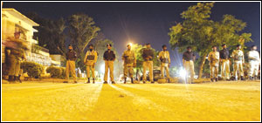
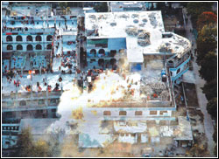
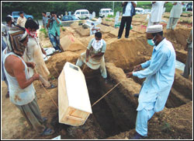
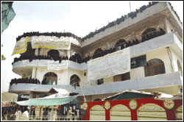
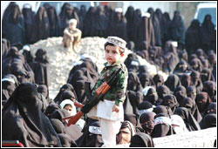
Those who call the shots in our country may have achieved their target of deploying heavy forces and fighting an eight-day fierce battle against the Lal Masjid brigade right in the centre of the federal capital, but the death of Maulana Abdul Rashid Ghazi, the public face of Lal Masjid, has totally changed public opinion in favour of the radical clerics, and those who were earlier criticising the Lal Masjid brigade for resorting to extremism and challenging the writ of the government, now feel sympathetic towards Maulana Abdul Rashid Ghazi.
A high death toll during Operation Sunrise is also a factor that has contributed to the shift in public opinion. The actual death toll is stated to be much higher than what has officially been announced. According to the official version, a total of 83 from both sides, including 10 security officials, 73 militants, lost their lives. However, according to sources, the number must be higher.
A statement given by Maulana Abdul Satar Edhi that he had been asked to provide 800 kafan substantiate the speculation that hundreds of people, including innocent women and children, died in the operation along with militants holed up in the mosque who gave a tough time to the security forces in the week-long operation.
Many people thought that the bloody battle could have been prevented if the siege of Lal Masjid by the troops had continued for a further few days, because the stocks of ration and ammunition in the mosque were about to run out, and the people in the mosque would have no option but to surrender.
Maulana Ghazi, a few hours before his death, had categorically rejected the government’s offer of ‘safe passage’ and said the government should finalise a deal with him in front of the media. He also gave massages to his supporters to take revenge for his death. It is believed that there would be a backlash of the death of Maulana Ghazi and his family members. However, no such sign has so far been noticed.
It is said that Maulana Abdul Aziz, the elder brother of Maulana Ghazi, who was arrested while escaping from the mosque in a burqa on the first day of the operation, had many followers, who, according to him, were ready to commit suicidal bombings in various parts of the country and will never forget the downfall of the Lal Masjid. They may go for possible attacks on important personalities, government buildings and installations.
Though a bloody battle between the troops and the militants has ended, many questions are still unanswered. The first one is: why did the government seek support of one of the most ‘wanted’ outfits’ leader, Maulana Khalilur Rehman, the former chief of Harkatul Ansar, during the final round of the talks between Maulana Ghazi and the Ulema delegation led by Pakistan Muslim League (PML) president Chaudhry Shujaat Husain. It was shown on some private TV channels that Maulana Khalilur Rehman was sitting alongside Chaudhry Shujaat in his car when the delegation reached close to the Lal Masjid in the midnight and offered safe passage to in-charge of the mosque. However, the dialogue remained inconclusive after which the final phase of the operation was conducted. The fighting with heavy ammunition continued for 11 hours and claimed 83 lives. Now, how can the government justify the deadly operation against the Lal Masjid administration in view of the fact that it has links with, and supported in the past, the banned jihadi outfits?
Another question that comes to mind is: why was the media deprived of its promised visit to the Lal Masjid on the next day of the end of the operation? It is believed that the authorities were trying to remove the dead bodies and other important remnants of the battle.
In a surprise move all the bodies of women, children and militants who died in the mosque were buried haphazardly in the H-11 graveyard despite the fact that a large number of parents -- who were waiting for their children harbouring the hope that their loved ones have survived in the operation or surrendered to the authorities before the battle started -- have not been informed about all the deceased. They are still hoping that their children would be among the over 1,200 people who surrendered or came out of the mosque before the final assault.
Why had the government been supporting the Lal Masjid administration for the last many years? Why did the radical actions of its students go unnoticed? Many say that the government was equally responsible for what the Lal Masjid administration had been doing.
From where a huge quantity of arms were taken and dumped in the Lal Masjid is also a pertinent question. Where were the law enforcement agencies at the time? Where were our intelligence agencies when illegal weapons were being stored in the mosque?
People want the forces behind the Lal Masjid exposed. Those who are responsible for promoting militancy, especially right under the nose of the federal government, must be taken to task.
But it is said that no such steps would be taken because not only the present government but also many officials representing previous governments ever since the Afghanistan-Russia war started, have been supporting jihadi outfits to please the United States. And now when the targets of the war have been achieved, these militants are labelled ‘terrorists’. The government is once again trying to get the favour of the US by crushing these elements at the cost of its own country's peace and progress.

