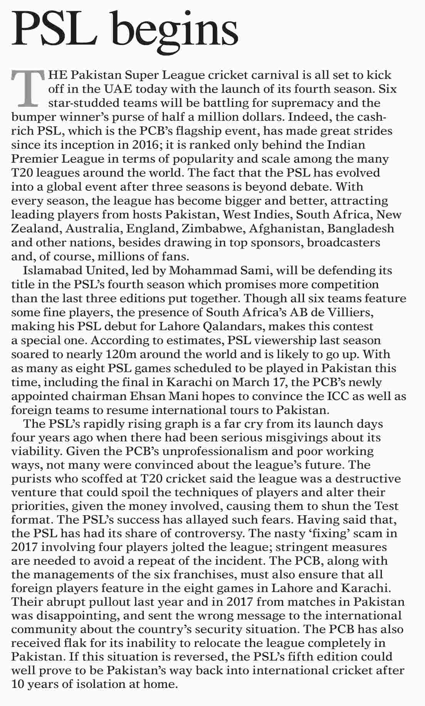

More from this page
- Organ donation
- Who controls Karachi?
- Khan`s mettle
- Security with freedoms

