Shades of intolerance
By I.A. Rehman
Thursday, 25 Feb, 2010
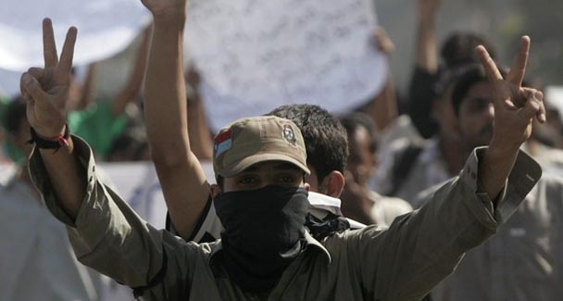
Whatever the causes of deviation from the tradition of tolerance, the process needs to be reversed: I.A. Rehman.
Public complaints received by the judiciary, government functionaries and human rights organisations reveal an alarming decline in the moral values observed by our society.

In particular we are witnessing new forms of intolerance and there is little evidence of any effort to deal with this deadly social disease.
The other day an organisation calling itself the Baloch Students Action Committee (BSAC), Punjab, set up by Baloch students studying at different institutions in the province, held a press conference at which they made extremely grave allegations against a students’ body.
According to the Baloch students’ spokesmen, five of them studying at the Government Technical College, Sahiwal, were attacked one night in January this year. All five students received serious injuries.

The matter was reported to the police but no action was taken by them. The attackers were reported to be angry at the victims’ refusal to join the organisation supported by them.
Further, the BSAC said, a series of attempts were made on the lives of Baloch students at the Multan Technical College during the current month. Pistols were used in one of the attacks and ten students are alleged to have been seriously injured as a result.

The Baloch students withdrew themselves from the institution and returned to Balochistan. They are said to have briefed the media in Quetta and met some parliamentarians but they received no satisfaction.
Baloch students at Faisalabad Technical College also were attacked and seven of them received injuries.
It is possible the facts are not exactly what the BSAC has presented but the authorities cannot possibly ignore the explosive nature of the matter. The youth in Balochistan are already in an angry mood and reports of any maltreatment of Baloch students in Punjab are bound to alienate them further.

The public in Balochistan could interpret attacks on their students in Punjab as attempts to punish the Baloch community for demanding their political and economic rights.
Unfortunately, there is another dangerous aspect of the matter. The targeted killing of non-locals in Balochistan — many of them settlers from Punjab — is no secret.

Some young persons in Balochistan have accepted responsibility for these killings and they could treat attacks on Baloch students in Punjab as acts of retaliation.
The danger that this may start a vicious cycle of violence must not be ignored. Apart from the loss of life and limb that young persons from both sides are likely to suffer, the task of persuading the people of Balochistan to end their alienation from the federation will become harder.

The presence of students from Balochistan in educational institutions in other provinces offers the host federating units a good opportunity to promote national cohesion through these young guests.

For success in this direction the authorities of the institutions concerned will be required to pay extra attention to these students’ academic and extracurricular needs. The basic issue they have to deal with is intolerance.
Some days ago a nurse found two newborn babies at a garbage dump outside a large hospital in a Punjab town. She picked up the babies and took them to a few childless couples belonging to her Christian community.

When some conservative Muslim clerics heard of this matter they promptly issued an edict that the infants were Muslim and as such they could not be offered to non-Muslims for adoption. The nurse who probably saved the luckless newborns from death found herself in conflict with the law of adoption.
What should be done to her will be decided by a court and nothing should be done that might affect the course of law. But is it impossible to take note of the conduct of the fatwa producers?

How could they determine that the babies were born to a Muslim mother? And if the religion of their parents had somehow been ascertained, what did the self-appointed custodians of the Muslim community’s interests think of the members of their flock whose cruelty to two new lives was manifest?

Was any attempt made to inquire whether the babies had been abandoned out of fear of the clerics, assuming that they had been born out of wedlock, or whether the parents were too poor to bring them up?
Every year scores of unwanted babies are left at hospitals and offices of social welfare organisations. They are discreetly given over to foster parents.

One has never heard of the mullahs’ interference in these matters on the basis of belief, except for that dreadful incident of the stoning to death of an abandoned newborn in Karachi some years ago. This incident is another example of the community’s growing intolerance of the other.
The Sindhi people are legitimately proud of their tradition of tolerance. Their capacity for observing interfaith harmony can be seen in the ordinary villagers’ deference to one another’s beliefs.

Even today, after all the havoc caused by communalised politics over almost a century, one can find shrines where people belonging to different religious groups come in search of peace and deliverance.

But one cannot say how long this tradition will survive for the conservative preachers of hate and conflict seem to be enlarging their operations.
One of their latest campaigns is the demand that the remains of a non-Muslim girl, reportedly belonging to a gypsy tribe, be exhumed and thrown away because they cannot be allowed to pollute the sacred soil of the graveyard.

It is said that the non-Muslim girl had been buried in the Muslim graveyard in accordance with a centuries-old practice.

However, the standard-bearers of the new brand of militant Islam cannot be expected to respect what they denounce as heathen. This matter too is reported to be in court and no comment can be made on the merits of the case.
One should like to ask the Sindh government and also the federal government whether they will wait for matters to be decided in courts — if they can ever be decided in this manner. Do they realise their duty to take stock of the various manifestations of intolerance?

Do they have any plans to curb the monster of intolerance by promoting an adequately strong social force capable of building a tolerant society?
To say that the rise of militant groups who slaughter innocent people has had an adverse effect on the clerics is merely stating the obvious.

Whatever the causes of deviation from the tradition of tolerance, the process needs to be checked and reversed. Otherwise our society will not be able to survive the heavy dose of intolerance it is receiving.

