An intolerant society
By Huma Yusuf
Sunday, 07 Feb, 2010
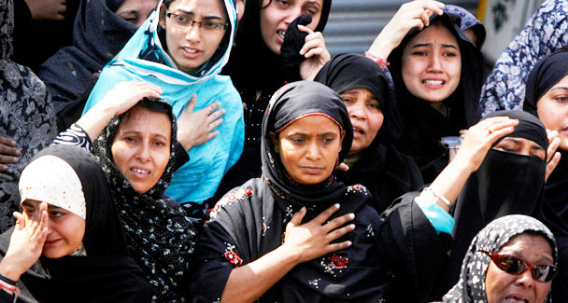
Women weep for relatives, who were killed in the attack on a bus travelling to a religious procession, during their funeral in Karachi February 6, 2010. – Photo by Reuters.

World
Talks with the Taliban

Talks with the Taliban

Coming on the heels of the Ashura tragedy, the two blasts in Karachi on Friday are a reminder that sectarian violence poses one of the greatest threats to Pakistani society. Well over 4,000 people have been killed in the past two decades in sectarian — involving primarily Shias and Sunnis — violence.
Although no group has claimed responsibility for Friday’s attacks, fingers are pointing at banned sectarian outfits such as Jundullah and Lashkar-i-Jhangvi. No doubt, radicalised militants are behind the kinds of anti-Shia attacks we saw on Dec 28, and again on Friday. But the time has come to put sectarian violence in a broader perspective.
Such violence can no longer be denounced as the work of fringe elements, an accident of history or politics. Instead, it must be recognised as a symptom of an increasingly intolerant and divisive society.
Indeed, intolerance is very much a characteristic of Pakistani society, a fact obvious to anyone who follows the media. Take, for instance, the highly sensationalised, racist jibe at Senator Babar Ghauri by Pakistan Tehrik-i-Insaf chief Imran Khan. Khan resorted to racism as a response to Ghauri’s accusation that he had an illegitimate child. But the ease with which he opted for the race card — and the resounding applause that met his comment — indicates that intolerance is thriving here.
Khan’s one-off insult cannot, however, compare with the consistent intolerance preached by other prominent personalities. Pakistani bloggers have made much of self-proclaimed strategic analyst Zaid Hamid’s Wake Up Pakistan campaign, which is explicitly anti-India. Although the campaign calls for an “ideological revolution” that restores the Muslim identity of the Pakistani state, Hamid’s dream of Radio Pakistan broadcasting from New Delhi has come to symbolise the no-compromises attitude of this particular movement.
Meanwhile, Pakistani grievances against US government policies such as escalating drone attacks and the use of private security firms may be justified. But anti-Americanism is slowly becoming conflated with anti-white sentiments: local websites, for example, publish photographs of any white person spotted here, identifying them as Blackwater or CIA agents.
Similarly, in the last year or so, public disdain for the Taliban has been expressed through discriminatory attitudes towards all Pushto-speaking people, who are being pushed out of jobs and increasingly find themselves the victims of arbitrary arrests and harassment.
Returning to a religious context, there is no shortage of examples of intolerance. Sunni-Shia sectarian violence seems to be on the rise in Karachi. Religious parties and the opposition PML-N hushed up calls for the repeal of the controversial blasphemy laws — long identified as anti-minority — after eight Christians were killed in Gojra last year. In September 2008, popular televangelist Aamir Liaquat declared that Islam sanctioned the murder of Ahmadis. Subsequently, at least two Ahmadis were murdered in cold blood. Need one go on?
The government has fuelled this widespread intolerance by employing vague terminology and heaping all the country’s problems on ‘non-state actors’ and ‘foreign elements’. This language has perpetuated a belief in an amorphous, elusive enemy that is defined by one characteristic alone: not being Pakistani. This allows anyone who believes they can define the traits of a Pakistani (increasingly synonymous with Sunni Muslim) to fill in the vague outline of the enemy with that which is considered the ‘other’: Hindu, American, Israeli, Shia, Ahmadi, Christian, Sikh.
And this practice is no longer confined to political, extremist or media circles: the trend is proliferating among Pakistan’s urban, educated middle classes. Just this week, I heard of two incidents that betray the extent of xenophobia and religious intolerance in our society. After an intense medical examination, a friend was using yogic breathing to compose herself when another patient in the waiting room asked her contemptuously if she were Hindu.
Across town, incidentally in another hospital waiting room, an aunt decided to say her prayers. When she was done, a woman spitefully asked her if she belonged to the Ahmadi community. When she responded that she was not, the woman asked, “how can you not be, if you pray with nail polish on?”
In other words, we now live in a society in which any evidence of divergent beliefs or differing practices invites judgment. Rather than embrace diversity and pluralism, or respect people’s personal choices, we are becoming a people who label, despise and even attack that which is deemed to be variant.
A 2005 International Crisis Group report concluded “sectarian conflict in Pakistan is the direct consequence of state policies of Islamisation and marginalisation of secular democratic forces”. But, as the above examples suggest, sectarianism and other forms of intolerance have gone well beyond the political realm, and are now in danger of becoming social norms.
Indeed, a January 2010 report by the Legatum Institute, a London-based think tank, argues that Pakistani society will become more Islamist in the coming years. The report says that religious parties will not win more votes, but will exercise more ‘soft power’ through participation in political coalitions. This power will manifest itself in a move towards ‘Islamic values’, which will be articulated in increasingly conservative and intolerant legislatures; for example, Sharia-compliant laws to govern the banking system, limited women’s participation in the public sphere, public displays of piety, and the further marginalisation of minorities.
This means that the horrors Karachi saw on Friday, and that the country has grappled with for decades, will no longer be the extreme activities of militant groups — they will be an expression of public sentiment. We can already see how incitement to hatred is a prerequisite for representing Pakistanis, while religiously, racially and ethnically motivated violence is becoming intertwined with nationalism.
If our politicians, public figures and media personalities do not make a concerted effort to preach and practise tolerance, Pakistan will continue to head down an explosive path.
huma.yusuf@gmail.com

