Secularism vs Islamism
By Iqbal Akhund
Monday, 22 Feb, 2010
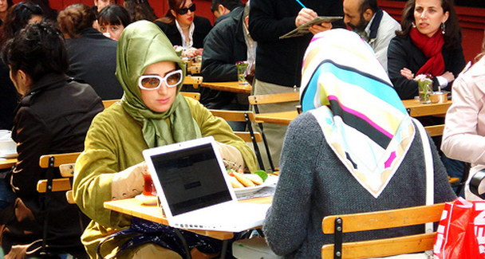
The average Pakistani is devout and religious but is not willing to be ruled by clerics.

In a recent TV debate on this subject, the applause meter would have given the win to Islamism. The debaters, three on each side, faced a small mixed audience — quite a few girls, many wearing hijabs, also young men in jeans and a handful of beards.
The ‘secularists’ appealed, in measured tones, to the intellect, made references to European history, called for tolerance, pluralism and progress. The ‘Islamists’ were assertive, emotional and received applause when they spoke of the ‘moral decadence’ of the West and condemned, to louder applause, the West’s aggression against Muslims in Palestine, Chechnya and Iraq.
So do the people of Pakistan want an Islamist state? Well, yes and no.
A poll of young persons in a recent issue of the Karachi monthly Herald shows the complexity of the Pakistani mindset. A substantial majority (64 per cent) wanted an Islamic state but the religious parties that espouse this cause received only three per cent of the vote. By an emphatic majority they preferred democracy to military rule. Most were optimistic about the future, but even so 53 per cent would leave the country if given the chance. There were other questions that touched on lifestyles, friendship, marriage, etc, the answers to which showed a predictably conservative bent of mind.
During the TV debate’s question time, one young girl in the audience said: “Show me one verse of the Quran that is against tolerance, human rights and democracy. Then I too shall be for secularism.” She was saying in effect that western secularism does not offer anything that Islam as such does not provide, refuting both Samuel Huntington and Maulana Maududi.
It brought to my mind what a French thinker had written at the time of Iran’s Islamic revolution: nothing worthwhile can be done in Muslim countries except in the name of Islam.
However, when someone in the audience recalled the tolerance and progressiveness of Moorish Spain, one debater on the ‘liberal’ side responded: let us not always be talking about past glories. The dismal present of the Islamic world, she said, is what we must face up to — poverty, ignorance, intolerance, and corrupt and autocratic governments. “In the entire Muslim world there isn’t one world-class university.”
What one may make of this, if one takes the Herald poll as representative, is that the Pakistani youth has faith in the Islamic system but does not go along with what is proposed by the religious parties; thinks democracy is compatible with Islam; is patriotic but also pragmatic; and is conservative in the matter of social mores. He/she feels strongly about the West’s policies towards Muslims and is repelled by its sexual permissiveness.
Could one say then that the gulf between Islamists and secularists is not as wide as the 60-year contention on the subject would indicate? The dispute arises from confusion over the terms of the debate. Secularism in its European meaning of separation of church and state does not apply to Islam which has no church, no priesthood. What our Islamist parties want would indeed amount to creating a sort of institutionalised priesthood.
In their view democracy, in which decisions are taken by majority vote and not according to the will of God, is not Islamic. In the first Constituent Assembly they proposed that a council of ulema, which can interpret His word, be established to vet all legislation. They did not get this but the assembly instead adopted an Islamic ‘Objectives Resolution’.
This somewhat ambiguous document, when all is said and done, says no more than that Muslims should be ‘enabled’ (not obliged) to order their lives in accordance with Islam. Otherwise it calls only for all accepted democratic values — equality of status, and freedom of thought, expression, belief, faith, worship and association.
But in due course more substantive measures followed. Only a Muslim could be president or prime minister (what then of equality of status?). Ahmadis were declared non-Muslims. A more draconian blasphemy law was introduced, along with the Hudood Ordinance, the Qisasand Diyat(an eye for an eye) law, and the Qanun-i-Shahadatregulations under which a woman’s word is worth half that of a man. And the list doesn’t end there.Few, if any, of these provisions were introduced as a result of public demand or debate. Most of them, such as the ban on interest, have remained a dead letter, no one has had his hands cut off, no adulterers have been stoned. When the Hudood Ordinance was amended some time ago there was no public outcry. I daresay there wouldn’t be too much if it was done away with altogether.
The real debate is not between Islam and secularism but between democracy and theocracy, and in that context the entire history of our constitution-making shows on which side the people stand.
The situation is paradoxical. The average Pakistani is devout and religion is an important part of his being. Islamic signs and symbols are everywhere but Pakistanis are not willing to be ruled by clerics and do not vote for the religious parties. Yet a rightwing Islamism (the Shariat Court calling land reform un-Islamic, for instance) coupled with an exhibitionist religiosity has been making headway in the country’s politics and hearts and minds.
The Islamists care little for votes and elections but rely on sympathisers in the administration, the education system and the military to promote an agenda concerned with ritual and revival rather than welfare and progress. Obscurantist teachings in madressahs, Friday sermons spewing sectarian bias and, more recently, some religious TV channels have cast a medieval pall over Pakistani society and created an atmosphere of bigotry and intolerance.
It will not be an easy task to bring about a more open-minded, tolerant attitude. Musharraf’s ‘enlightened moderation’ did not go anywhere because it did not have the support of his power base in the army and he did not have the courage of his convictions. For the moment nobody else is even trying. I don’t at all see the Taliban in our future but don’t rule out Taliban-lite, some of which is here already.

