OMCs warned against fuel crisis
By A Reporter
Tuesday, 28 Sep, 2010
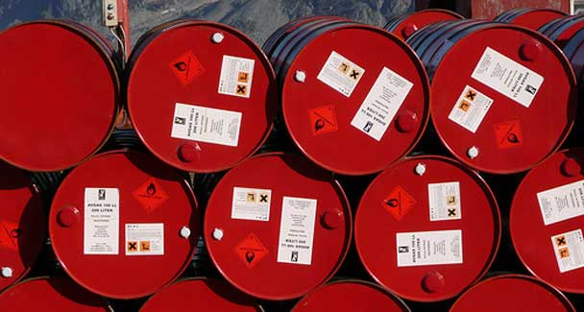
The OMCs explained that recent shortages occurred due to damage to approach roads and bridges leading to the country’s largest Parco refinery because of floods. - File Photo.

Business
The regulator under clouds

ISLAMABAD: Federal Minister of Petroleum and Natural Resources Syed Naveed Qamar on Monday advised the oil-marketing companies to take necessary measures to avert recurrence of petrol shortage in future and to examine the causes that led to fuel crisis in some parts of the country.
Presiding over a meeting with OMCs, the minister conveyed government’s serious concern over petroleum shortage and difficulties faced by the general public.
The meeting was attended by senior officials of Oil and Gas Regulatory Authority (Ogra). In a statement issued by the ministry, Naveed Qamar asked the OMCs to maintain substantial storage stocks of 20 days which is also a mandatory part of the licensing regime in the country.
As operational matters of OMCs are being regulated by the Ogra, the minister advised Ogra to take action against those OMCs which were not fulfilling conditions in the licensing agreement.
The OMCs explained that recent shortages occurred due to damage to approach roads and bridges leading to the country’s largest Parco refinery because of floods.
Further Indus and National Highways were also blocked at some places by flood water which restricted oil supplies from Karachi to upcountry, especially Parco-fed areas of Punjab.
The minister directed the OMCs to build up stocks of all products prior to the winter season (October 31), as CNG availability would possibly be less during winter.
Ogra chairman Tauqir Sadiq, petroleum secretary Imtiaz Kazi and Director-General Oil Sabar Hussain were also present in the meeting.

