Venturing into community power generation
By Shahid Khakan Abbasi
Monday, 26 Apr, 2010
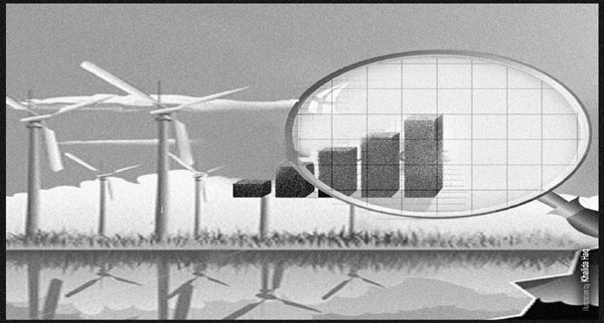
The shortage of electricity is inhibiting economic growth and contributing to business failures and unemployment. And no solution seems to be in sight to resolve the worsening crisis.
The reason for such a serious and growing power crisis remains clouded in ambiguity. An objective analysis will reveal that the problem has more to do with scarce financial resources rather than installed capacity, with management issues rather than physical infrastructure, and with political will rather than technical competence.
The problem appears to be rooted in the high-cost Independent Power Plants (IPPs) negotiated in the 1990s whose tariff structure peaked in the last five years. The problem was further compounded by the high fuel prices and the depreciating exchange rate of the rupee, both of which are pass-through costs under the IPP agreements.
Several Wapda and independent studies of that era clearly pointed out that the IPP policy was not sustainable. However, the counter-argument then advanced was that there was no choice either. “Whatever the truth be, Pakistan was led into a trap of high-cost power generation with a clear inability on the part of the government to sustain the subsidies required to keep the tariff affordable for the consumers, especially in a high demand-growth scenario.
Now, perhaps because of the perceived lack of an alternative, the government seems to have placed its bets on the Rental Power Plants (RPPs), which are at best a poor and expensive interim solution. A question with no credible answer is: how will the payments under the arbitrary power purchase agreements be made to the RPPs when there are not enough revenues to pay the IPPs?
The consumer who already bears the burden for one of the world’s highest electricity rates, and has suffered tariff hikes of over 50 per cent in the last 18 months, certainly cannot be asked to pay more; and we fall further behind the supply-demand curve, continue to inhibit our GDP growth, and create dangerous social volatility.
Is there a way out? The current investment climate and the economic issues do not support traditional large-scale power generation models. One has to look for an innovative solution that addresses our unique set of problems.
A credible immediate solution to our electric power problems exists and it will ensure that Pakistan has surplus electricity within two years and power costs will go down for the consumer without reliance on foreign investors.
The idea is simple: Community Power Generation (CPG) – small, cheap power plants in the private sector, producing electricity locally, and selling it directly to local consumers over the existing secondary power distribution networks.
The CPG concept is based upon providing the consumer with reliable and cheaper electricity by taking the government out of the electricity business, unleashing the ingenuity of the national entrepreneur, providing the financial community with alternative investment potential, and creating local employment and business opportunities.
The government’s role will be limited to providing an enabling regulatory environment and provision of a franchise to sell power directly to local consumers. It will not carry any financial or technical liability, nor will it be required to be involved in any contractual matters.
The issues of investment, financing, technology, infrastructure, efficiency, management, supply-chain, billing and growth would be the business of the entrepreneur. The government would award a franchise to an entrepreneur to set up and operate a power plant, typically in the 5-20 MW range, to provide power to a specific geographical area, typically based on the constraints of the existing low-voltage distribution system.
The franchise would produce the power and distribute it to consumers, maintain the distribution network, and manage the billing process. The government would be a net beneficiary, while “privatising” the electricity generation and distribution business and gaining substantial revenues in the shape of franchise fees, distribution network usage charges, and taxes.
It is easy to envisage the setting up of 300 to 500 MV local power plants within two years, thus removing over 5,000 MW of demand from the national grid and making the country surplus in electrical energy.
The CPG concept enjoys three major advantages over the traditional electricity generation solutions. First, low-technology second-hand power plants will drive capital investment down by over 60 per cent. Second, the local use of waste-heat to provide consumers with steam, hot water, and space heating provisions will add additional revenue potential. And third, reduction in transmission losses and theft will provide higher operating margins.
The capital savings provided by used power plants are substantial. It is relatively simple to install used low-technology power plants for $300/kW as compared to the over $1,000/kW cost of sophisticated brand-new plants. Power plants do not enjoy great economies of scale as their size increases; for example, a small 5MW engine based local power plant with a crude heat recovery system has almost the same efficiency level as a large 200MW gas turbine power plant with a sophisticated heat recovery system.
The age of the power plant is also not a major differentiating factor, the per-unit capital cost difference between a small 10-year old power plant and a large brand-new power plant will more than offset the operating efficiency gains of the new power plant.
Over 55 per cent of the fuel energy required to generate electric power is lost as waste heat. A local power plant can recover a significant portion of this waste heat by providing the homes and industry in its franchise, especially in urban areas, with steam for industrial uses, space heating or cooling, domestic hot water, and even cooking. Such heat-exchange technology employment can substantially reduce the usage of natural gas or electric power that is currently employed for these purposes.
Estimates of the losses in the national grid system due to technical losses during transmission and distribution, and power theft range from 25 per cent to 35 per cent. A local power plant should be able to reduce these losses by 50 per cent as it does not have to carry electricity over great distances and can manage its distribution network more efficiently, thus giving it an additional 10 to 15 per cent operating margin, resulting in lower power costs for the consumer.
In addition, the technical and growth flexibility available to local power plants coupled with the rupee denominated financing from local banks will insulate them from major price escalation factors and provide opportunities for additional business by driving demand. Secondary business opportunities and employment will be created in fuel storage, fuel transport, plant maintenance, and the like.
With surplus power becoming available for industrial use, a major constraint on GDP growth will be removed and result in reduced outflow of foreign exchange.
But to implement the Community Power Generation concept, the government would need to address potential infrastructural, regulatory and environmental issues

