Renewable energy options
By Humair Ishtiaq
Monday, 18 Jan, 2010
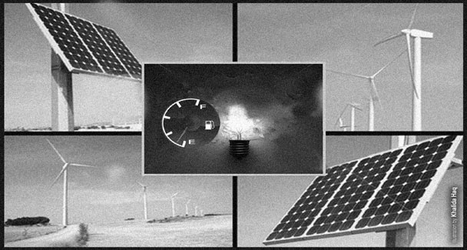
THE energy crisis – both in terms of electricity and gas supplies – continues to cause huge losses to the industry, especially in Punjab. Despite all the promises made by successive governments, the crisis has only worsened with the passage of time and there are no signs yet of anything changing for the better in the near future.
Experts in the energy sector insist that while doing what it can in the short-term, the government has no option but to take a long-term view of the scenario. Renewable energy, according to them, is the only way forward.
Citing published reports, an Islamabad-based consultant said the government is believed to have decided to constitute an energy sector high-level task force whose membership will be sold to the Friends of Democratic Pakistan (FoDP) for at least $100 million. The relevant ministry is in touch with Islamabad-based diplomats representing the countries concerned.
Hoping that the deal will come through, the consultant, who preferred anonymity, reiterated the need to invest in the renewable energy sector which, he said, would be particularly feasible for local weather and living conditions.
The FoDP Summit meeting in New York a few months ago had identified issues of persistent energy shortage and its impact on the economy. The meeting had agreed to support Pakistan in preparing a sustainable and integrated energy plan.
In this regard, the summit had mandated the Asian Development Bank (ADB) to take the lead in mobilising international assistance to Pakistan for its energy-specific needs. Leaders had also requested a report on the energy sector so that an action plan could be prepared at the earliest.
The draft also proposes the setting up of a secretariat and a steering committee to provide oversight and direction to the task force. The way forward will be finalised in consultation with the government and FoDP members. The task force would create a forum for international partners and the government to work together on an integrated action plan and a report on the energy sector which would help the members to prioritise areas for supporting the energy sector.
Irfan Afzal Mirza, another consultant who has formerly been with the Alternative Energy Development Board (AEDB), said the recent agreement signed by the Dutch government to provide Rs356 million for the Pakistan Domestic Biogas Programme that is being implemented under the Rural Support Programme Network (RSPN) is an indication that the world is interested in nudging Islamabad to move further on the road to renewable energy.
The current reliance on oil-based power generation, according to a spokesman for the ministry of water and power, has reached “the alarming level of 46 per cent compared to 5.6 per cent internationally.” This is so basically because of the shortage of gas which generally accounts for around half of the country’s needs for the purpose. Domestic and imported oil produces another 28 per cent.
Mirza said the agreement signed recently by the visiting Dutch minister for development cooperation was a good step forward. A public-private partnership, it has been designed to lay the foundation for a commercially viable biogas sector which can relieve 30 to 40 million people in the rural zones from the energy shortfall.
Initially, the funds will be used to construct 14,000 biogas plants in Punjab which has the largest potential for biogas and that will lay the institutional foundation for the sector whose overall unused potential has been assessed at five million such installations.
The large agricultural and livestock sector produces large amounts of biomass in the form of crop residues and animal waste, such as bagasse, rice husk, cotton stalks, jute waste, straw and dung in rural settlements. Much of it is currently collected and used outside the commercial economy as unprocessed fuel for cooking and household heating. Besides, municipal solid waste (MSW) produced by a large urban population is openly dumped, which could instead be disposed of in proper landfills or incinerated to produce useable methane gas or electricity.
As things stand today, sugar mills use bagasse for co-generation purposes and have been allowed to sell surplus power to the power grid. The potential can be seen from the fact that last year Faisalabad Electric Supply Corporation signed a power purchase agreement with a private sugar mill under which it was to receive over 2500MW of bagasse-based electricity per year. This, naturally, is surplus power for the mill concerned which first meets its own energy needs. If this is what one private initiative can do, things can radically change if it is promoted on a national scale, said Mirza.
One ton of municipal solid waste when combusted reduces oil use by about 45 gallons and coal use by about 0.28 tons. Every city across the country produces thousands of tons of MSW and its combustion using modern waste-to-energy technologies that have inbuilt pollution control equipment can produce clean energy. This will diversify the energy mix and reduce its dependence on fossil fuels.
Other than Punjab, Sindh is also getting active on the biogas front. The provincial chief secretary recently directed all the departments and stakeholders concerned to expedite efforts for alternative energy production using the Cattle Colony in Landhi as a significant source for the purpose.
Such colonies that are spread across Karachi house millions of buffalos and cows, which, according to an official estimate, produce 9.5 million kilogrammes of fresh dung, which can be used in the alternate energy project for getting power and gas. Such initiatives, Mirza said, was in line with the global trend favouring alternative energy. According to the US Energy Information Administration, 18 per cent of the global consumption comes through renewable sources. Of the remaining, three per cent is nuclear energy and 79 per cent comes from fossil fuels. Sweden leads the way with 40 per cent dependence on renewables, while China heads the list of major producers with more than 50 gigawatts of alternative energy per year.
The State Bank of Pakistan’s decision late last year to introduce financing facility for the establishment of new power projects using renewable energy, Mirza said, was also an indication that the country is getting serious on the issue. “Better late than never,” he concluded.

