Public awareness & power crisis
By Dr M. Asif
Monday, 22 Feb, 2010
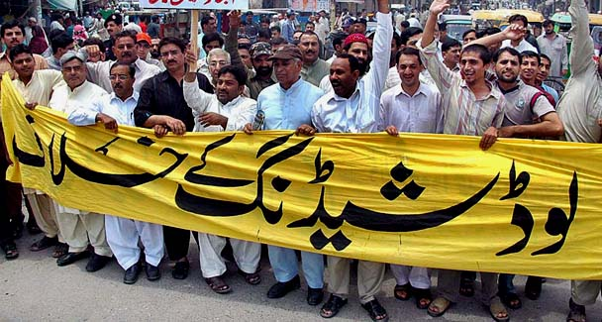
The key is to educate the masses about the energy crisis to prevent violent protests.
Since 2006, Pakistan has been facing violent protests and demonstrations triggered by rampant loadshedding. The intensity of violence in these protests is on the rise.
For example, last year we saw ugly scenes like the blockade of roads, the destruction of Wapda (Water and Power Development Authority) infrastructure, the burning of trains, the looting of banks and other public offices, clashes between police and demonstrators and general destruction, resulting in some deaths.

The year 2010 has started with similar scenes. Since there is not going to be any relief in terms of loadshedding in summer (in fact matters may worsen), the situation with regard to protests is also likely to exacerbate. These are alarming signs for the political system in the country.

There are valid fears that if the trajectory of violent protests continues, things may get out of control for the law-enforcement agencies, thus leading to extremely unpleasant circumstances.
It is therefore of utmost importance that the authorities pay meaningful attention to tackling the issue of demonstrations in a pragmatic fashion by making quick and effective arrangements to lessen the gravity of loadshedding.
The key here is to educate the masses about the energy crisis. In Pakistan, the common man’s understanding of energy is very weak. As an important stakeholder the consumer has a vital role to play in the success of national policies concerning energy.

The major contributing factors towards the citizens’ below-par understanding of crucial energy issues are: a poor literacy rate, lack of energy-related courses at universities and colleges, and the virtual absence of government/departmental initiatives for increasing public awareness.
Energy consumption patterns in Pakistan are very inefficient. There is simply not enough attention offered to this vital and precious commodity. Energy-saving through improving methods and habits of consumption is the need of the hour. It would benefit not only the nation but also individuals.
As far as poor literacy is concerned, there is hardly anything that can be done in the short to medium term. Still, considerable change can be brought about with the help of the educated segments of society.

Students with a better understanding of energy issues can contribute significantly in bringing a positive change to our energy consumption culture. Children can also play a very important role in improving energy consumption attitudes at home.
In energy-conscious countries, methods to save energy are taught in a very easy and friendly manner as part of the school curriculum. Government/departmental initiatives in the form of public awareness campaigns and incentives can also be very helpful.

Over the last few years, there have been examples of energy-saving campaigns in the national print and electronic media, which is a commendable effort on the part of the relevant departments. These campaigns need to be made more appealing and to be launched on a frequent basis.
Public education is of utmost importance to tackle the issue of growing, violent demonstrations. The frustration of the common man — who pays his taxes yet has to face 18 hours of loadshedding — is understandable, especially when the situation is leading to the loss of thousands of jobs and disrupted daily routines.
The demonstrations clearly indicate the widening communication gap between the policymakers and the common man. It is crucial to win the confidence of all stakeholders in society in order to overcome the energy crisis.

The relevant authorities need to come out of their lavish offices to have a constructive dialogue with various segments of society. In the wake of the endless torture he is experiencing because of the energy crisis, the common man is in dire need of comfort and counselling.
He needs to be assured that the authorities are doing their best to lessen his sufferings. These assurances must be translated into action. Unless such initiatives are taken, citizens will continue to express their frustration in the way that they have been doing in recent years, i.e. violently.
Citizens need to be educated that activities like violence and attacks on energy infrastructure and national assets are not going to help things get any better. Activities like damaging Wapda infrastructure, beating its staff and destroying other national assets will not bring any relief to the public.

Citizens must be made to realise that there are other, more peaceful and effective methods of recording their protest. The authorities can at least guide people in the right direction to express their frustrations.
As for the current chaos, despite all its weaknesses it is not Wapda that is to be held accountable but the previous regime. Since the early 1990s, Wapda has been barred from installing thermal power plants, a decision that has only added to the woes of the power sector.
Despite its repeated pleas and warnings between 2002 and 2006, Wapda was not allowed to set up new projects nor were alternative arrangements made. It must therefore be the real perpetrators — key political and bureaucratic figures — who should face the music rather than the Wapda staff.
Nevertheless, the current government must also realise that it cannot pass the blame for loadshedding to the previous government forever. It has been running the show for two years now, yet there are no meaningful efforts in place to tackle the issue. The needless rental power programme has also badly dented its credibility.

The prerequisites for any efforts to solve the problem are clear intent, right strategy and due commitment, which have not been reflected in the government’s actions thus far.

