Reducing poverty
By Reema Murad
Monday, 21 Sep, 2009 | 01:04 AM PST |
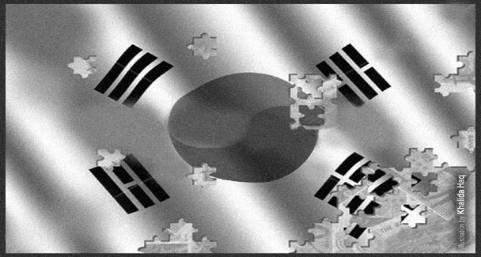
POVERTY is defined by the United Nations as “a human condition characterised by sustained or chronic deprivation of resources, capabilities, choices, security and power necessary for the enjoyment of an adequate standard of living and other civil, cultural, economic, political and social rights.”
The World Bank defines poverty as, “The most commonly used way to measure poverty is based on incomes. A person is considered poor if his or her income level falls below some minimum level necessary to meet basic needs. This minimum level is usually called the “poverty line”. What is necessary to satisfy basic needs varies across time and societies.
Therefore, “poverty lines vary in time and place, and each country uses lines which are appropriate to its level of development, societal norms and values.” There are four ways of defining poverty: absolute poverty, relative poverty, budget standards and income proxy all with their benefits and disadvantages.
The absolute poverty concept is the concept of ‘minimum subsistence’ in order to survive. This is more in relation to developing countries where the incidence of abject poverty is highest meaning minimum caloric intake for survival and some form of shelter. The relativist approach in contrast uses the average national income as a benchmark-household earnings below that average are said to be below the poverty line. This approach to defining poverty is used in the more developed countries such as the UK. The third way of defining poverty is that of budget standards —this is similar to the absolutist approach but there is concept of a basket of goods and services, having the elements of “subsistence” and “basic minimums for social lives.”
The final and fourth approach depends on family consumption patterns - that is the choice between what is necessary and what is a luxury depends on the income of the household with the result that low income households spend more money on basic necessities and high income spend more on luxury goods and services but with the perception that these items are necessary for survival.
The World Bank has estimated crude poverty lines ranging from $1-$14 a day depending on the state of the country. $1 a day poverty line is applied to countries in which there is incidence of abject poverty while $ 14 a day is used for high income economies under which South Korea falls.
South Korea is termed as the, ‘Miracle of the Han River’ due to its developing from one of the poorest nations of the world after the Inter-Korean War of 1950- 53 to the 13th largest economy in the world. Korea also enjoys the smallest gap between rich and poor in high income Asian economies and it is the fourth largest Asian economy.
From 1962, the situation in South Korea started to slowly improve because of the two programmes: the Five-Year Economic Development Plan and the export-led industrialisation as well as focusing on heavy industries. The GNP jumped from $85 in the 1960s to $257 by 1970s.
But this prosperity increased the disparity between rural and urban inhabitants. There was a mass migration from the rural to urban areas exerting pressures on the infrastructure of fragile city systems. Until the 1970s, 80 per cent of rural communities lived under thatched cottages and were using lanterns because of lack of electricity.
To combat these problems, South Korea launched the Saemaul Ondong--the Rural Reconstruction Programmes to improve the lives of inhabitants. It consists of three main elements: diligence, self-help and co-operation. ‘Sae’ means new and ‘maul’ means village so literally translated it means ‘new village’ and that is the philosophy of the Sameul Ondong movement. This transformed rural areas in the 1970s through local participation and encouraging community empowerment. Its success in rural development and increased agricultural productivity was replicated in other countries including the Philippines.
Saemaul Ondong promotes a holistic approach. While promoting development of physical and social infrastructure such as roads and education, it incorporates traditional customs and stresses conserving and sustaining natural environment. Saemaul Ondong movement believes that progress can only be made when basic human needs are met. It puts the improvement of living conditions on the top of its objectives list.
The basic goals of the Saemaul Ondong movement are: develop a modern, comfortable and convenient social community; establish companies that workers can be proud of and where sustained growth is achieved in a cooperative and trusting working environment; develop and maintain a sound and healthy society and build a continuously improving nation.
First introduced in rural areas to create self-help communities, the movement has been reproduced in workplaces and schools. This movement helped raise the GNP per capita from $257 in 1970 to $10,548 in 1996.
Korea has achieved economic development owing to its specific nature of industrialisation as well as citizen-orientated policies. The percentage of population living below poverty line in South Korea is 15 per cent. The elderly make up a large portion of this percentage. This figure is attributed to rapid transformation of family structure and because the elderly are not included in South Korea’s welfare system. In contrast to this, the family structure was different in the 1970s with grandparents living with their children and grandchildren. Now many couples prefer nuclear family system.
To conclude, South Korea has come a long way since the 1950s. With this, there also needs to be a constant evaluation of the progress being made so as not to infringe on the traditional customs of Korea while promoting economic development- the elderly being an example. There is a need to include the rapidly aging population of Korea in the welfare system.
Pakistan may look at South Korea’s Reconstruction Programme and see whether it can benefit from it in its efforts to reduce poverty.

