Poverty: data and reality
By Akram Khatoon
Monday, 01 Feb, 2010
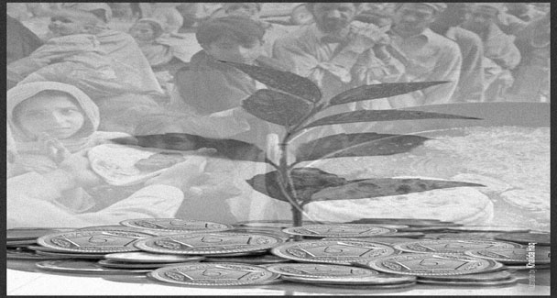
RAPID and sustainable GDP growth rate is seen as the most effective measure to reduce poverty. In recent years, the developing countries speeded up their efforts to achieve a high economic growth rate surpassing eight per cent per annum in countries like China, India, Ghana and Pakistan (from 2003 to 2005).
But at the end of the day, it was revealed that despite increase in per capita income, the plight of majority of the down trodden did not improve in these countries.
No doubt, poverty was reduced in some of the urban pockets of these countries, but according to a report by France’s Commission on Measurement of Economic Performance and Social Progress, poverty statistics based on household income and expenditure surveys in a number of developing countries, showed unchanged status of poverty among major sections of the poor.
Positive quantitative change in per capita income has not brought qualitative change in the social well- being of a major chunk of the population living below poverty line. With the exception of industrial and business hubs in these countries, poor living in less developed or rural areas are not better off, economically as well as socially.
As one can recall that during mid-decade of 2000 when Pakistan had recorded economic growth rate of eight per cent and statistics revealed almost 10 per cent reduction in poverty, quite a large number of people from low and middle income brackets were pushed below poverty line due to lack of employment opportunities, pay cuts or loss of jobs due to restructuring process in a number of public sector organisations and the rising food inflation which resulted in depletion of their incomes.
These are distributional issues relating to resources and services, which falsify a positive official data on poverty released by relevant governments. Thus the French Commission views poverty reduction through increase in per capita income and economic growth rate in conjunction with non-income dimensions of poor people’s well-being.
It is common with low income developing countries that they, while recording declining poverty data based on economic growth rate and increasing per capita income continue to have more poor people due to higher population growth rate than percentage with which poverty is declining in these countries.
Secondly, increasing share of private sector in economy, both in respect of social services and process of production is a favourable indicator of fast and sustainable growth of economy, which is essential for alleviating poverty. But cutting down or altogether eliminating of public sector services adversely affects major section of poor. Reduction in provision for subsidised or cost-free services like education, health care and transportation aggravate the poverty status.
The official poverty statistics, not based on standard household survey measures of well-being in fact, overstate the improvement in the well-being of impoverished population due to increasing role of private sector in providing essential and social services. As is evident in case of Pakistan, initiative of private sector to promote quality education at all levels have in reality resulted in increasing financial burden on poor families.
In quest of quality education, even the poor want to send their children to private schools which are running on profit with exorbitant tuition fee. According to official statistics available in this respect, almost 25 per cent of children from low and middle income families are enrolled in private schools for primary education.
Household income and expenditure survey results forming criteria for determining level of poverty are also misleading and not based on facts. For example, inequalities within household need to be taken into account as women and children in family are given lesser weightage. Measures taken for well-being of families are to be divided by household size, and per capita income and consumption at family level, which, in turn, need to be based on realistic figure pertaining to each member of the family with emphasis on gender and age group.
Women, particularly in rural areas are ignored in census surveys and one cannot rely on information relating to wellbeing of impoverished families just on the basis of economic growth rate, resulting in improved per capita income. Due to women’s inaccessibility to social services like education health care and the lack of physical assets ownership, the percentage in economically disadvantaged population exceeds 70 per cent. Thus poverty rate reflected in official statistics is always lower than what realistic income distribution in a country would show.
Poverty continues to be much higher in rural and less developed urban pockets.About 35 million out of total of 47 million impoverished poor were found living in rural areas in 1990s and difference in incidence of poverty among rural and urban, which was five per cent in 1991 increased to 14 per cent by the year 2000 due to disproportionate impact of overall economic growth rate.
Similarly, developing countries, which have been subjected to structural changes in all sectors of their economies, are faced with a situation of diverse impact on various tiers of poor based on their geographical location as well as their access to economic opportunities. It is because these structural changes resulted in providing better employment and work opportunities to some poor people, whereas a large number of poor were laid off from their jobs. Thus increasing working efficiency of restructured units instead of bringing economic well-being for all, enhance incidence of poverty.
During the late nineties and early decade of 2000, financial sector and various state owned organisations gained significant growth momentum in their profitability, business expansion and overall operational efficiency, thus providing benefit to some skilled labour. But consolidation and restructuring approach laid off a sizable number of semi-skilled and unskilled workforce thus mitigating the expected well-being of working class.
The growth rate of agriculture sector either remained stagnant or slowed down resulting in the current plight of poor farmers. Thus high economic growth rate and improved per capita income could not reduce incidence of poverty despite official figure depicting 10 per cent reduction in the number of poor during the decade.
Statistical measurement of poverty gives unrealistic figure in case of high death rate among poor. Death of poor both in case of natural disaster or man-caused disaster have brought misery and sufferings, thus aggravating poverty situation, but statistics show the region’s overall improvement and a number of people coming out of poverty net..
As such emphasis of the Commission on the Measurement of Economic Performance and Social Progress on use of household survey-- covering a set of data based on gender inequalities within household, environmental, rural and urban disparities and birth and death rates-- is the realistic approach to determine level of poverty. It is expected to give true picture enabling governments to formulate economic policies leading to sustainable well- being than a short-lived relief for the poor.

