- DAWN.COM
- DAWN URDU
- TODAY'S PAPER
- DAWNNEWS TV
- CITYFM89
- HERALD
- AURORA
- EVENTS
- DAWN RELIEF
- Saturday 15th December 2018 6:48 am
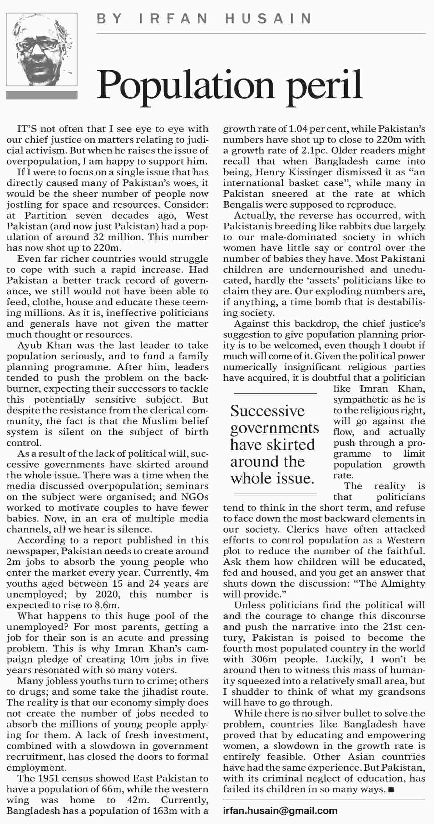
[TOP]

More from this page
- Kashmir`s fate
- Past chaos
- War aims
- Thar: plea to CJ

