The ever-growing population
By Ahmad Hayat
Monday, 08 Feb, 2010
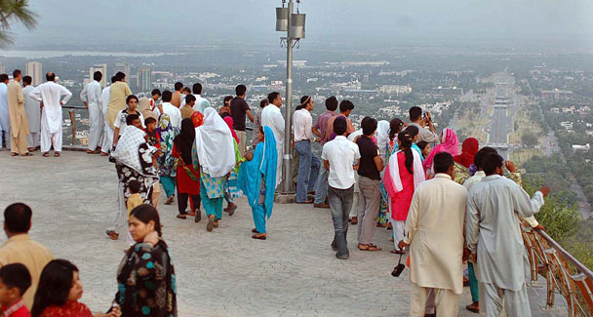
Our population is projected to rise to 335 million by 2050. We must change our ways before it is too late.

In July 2012 the world’s population will reach the seven billion mark, which means a jump of one billion since 1999. In stark contrast, it took 123 years for the global population to rise from one to two billion between 1804 and 1927.
The three billion figure was touched only 33 years later, by 1960. Since then growth has picked up more pace with a billion being added to the population every 12 to 14 years. Most of this escalation can be attributed to underdeveloped countries where as much as 60 per cent of the people subsist on two dollars a day.
Prominent amongst these countries are those blighted by high inflation and poor governance. Conversely, Europe and Japan with per capita incomes of roughly $30,000 show static or declining populations.
In 2009, which happened to be its platinum anniversary, the British Council launched a study to capture the attitudes and needs of Pakistan’s youth in the 21st century. Titled Pakistan: The Next Generation, the study was based on a survey of 1,500 young people between the ages of 18 and 30. It was said at the study’s presentation that “It is the next generation [which wants] to help a nation … tired of poverty and hunger, of disappointment and hardship”.
Theoretically, Pakistan enjoys the demographic dividend (DD) to do exactly that. Nearly 67 per cent of its inhabitants are less than 30 years old and only four per cent are over 65. In the world of economics, demographics is an important determinant of growth. Its impact can be measured by the number of economically active people relative to those who are inactive.
For instance, if 75 per cent of people work while others are studying or unemployed, the economy will fare better than in a situation where only 50 per cent produce while the remainder are inactive.
When this ratio rises, the economy grows and people enjoy greater discretionary income. Having a young population like ours is a great boon in this equation. But the decisive element here is productivity.
Two things are fundamental to the dividend: ample employment opportunities and a commensurately trained or educated workforce. The challenges we face in both areas are daunting. Pakistan’s workforce of 51 million suffers from an unemployment rate of 15 per cent. At the same time, 70 per cent of children do not reach secondary school and only five per cent enter universities.
It is not reasonable to expect the government to provide job openings. The overriding need is of less government and more private-sector entrepreneurial involvement. For its part, what the government needs to provide is an enabling environment and a level playing field.
A segment of our society feels that switching all schooling to English will immediately uplift our education system. English in itself does not further education; it is only a mode of communication. Our vernaculars are better suited to facilitate learning, especially for a wider cross-section of targeted trainees.
The call is not to equip every student to be a bureaucrat, engineer or doctor, for the hierarchical constitution of societies requires a wide base of appropriately trained youths. This warrants focused and mass vocational training. In egalitarian societies a carpenter or plumber is as content and productive as his more privileged compatriots. Consequently, it is important to take a fresh look at how we educate our youth. Compulsory universal education is essential if we are to progress but commitments made in this regard have never been implemented.
Madressahs are often quoted as examples of mass education. Despite its popular association with militancy and terrorism, this is still a workable model. Without debating our madressahs’ real or perceived linkages with extremism, let’s analyse what they can provide.
These institutions offer free boarding, lodging and education. This frees underprivileged parents from the burden of school costs and concerns about rearing their children. If the government was to facilitate such parallel institutions in the private sector or through NGOs, parents who deposit their children in madressahs would readily agree to the alternative.
All governments of consequence provide free high school education and this arrangement will be in keeping with that objective. That said, the government should not take on this responsibility all by itself — the umpteen ghost schools ‘running’ on taxpayer money are proof enough of officialdom’s failings. All it needs to do is regulate, strictly monitor and partially finance these institutions.
White-collar job requirements are more or less met by our existing education facilities. The primary emphasis should be on making our children civic-minded citizens with a sense of discipline and equipped with sound occupational training. In an agrarian country like ours it is unfortunate that we continue to import essential food items. Little wonder then that many are moving to urban centres in the hope of finding livelihoods.
If Pakistan is to become its own granary then we need farmers, cattle breeders, dairy producers and others to be formally educated in contemporary techniques. It is not healthy that ancestral abodes are being abandoned in the ongoing mass migration to the cities. Rural life provides a special communal support system that should be replicated rather than squandered.
The education and health sectors are abysmally manned. We have some good doctors but few and below-par health technicians and nurses. We have PhD professors but inadequately trained primary and middle school teachers. Investment is required here in the form of training the trainers.
Growing demands are being made that developed nations should come to our rescue and help optimise the DD effect. The world owes us nothing and may not come to our aid in any substantial way. These are problems we created and we need to resolve them.The two-fold challenge is to ensure that children get a better education for a better future and the economy is stimulated to create decent jobs that keep pace with our growing numbers. If we dither, the demographic dividend may become a Malthusian millstone. It is projected that Pakistan’s population will rise to 335 million by 2050. We must change our ways before it is too late.

