Not Peshawar anymore
By Murtaza Razvi
Tuesday, 01 Sep, 2009 | 08:28 AM PST |
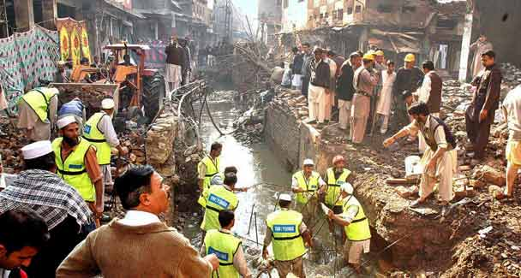
Rescue workers at the site of a blast near Qissa Khawani Bazaar in December 2006. – APP (File Photo)

WITH the closure of the city’s only cosmopolitan hotel, the Pearl Continental, Peshawar is indeed poorer.
The closure comes as a telling sign of the real impact the war against terrorism has had on the Frontier province on the whole, and its fabled, yet not too long ago modernising, capital. A majority of airlines have simply struck Peshawar off their maps.The provincial government’s demand that the war against terrorism and its impact must be counted among the factors that form the basis of an equitable distribution of the federal divisible pool among the provinces is more than legitimate.
The province stands quite high on the overall poverty index as huge swathes of its countryside comprise utterly underdeveloped towns and villages. Even a cursory look around the capital, Peshawar, reveals the extent of the damage the province has endured. The wounds inflicted by terrorism require much more than just a dressing of the emotional renaming of the Frontier as Pakhtunkhwa.
In the past year or so, many of Peshawar’s affluent businessmen have relocated to Islamabad and Lahore along with their families, taking their businesses with them, or keeping just a shadow of what these used to be in Peshawar. The Saddar area has lost its twinkle. The Saddar Bara and the adjacent high street, Arbab Road, with its department and bookstores and many rent-a-car outlets wear a deserted look. The old Dean’s Hotel, another landmark, sprawling property harking back to the pre-independence days, has long gone; in its place now stands a massive shopping mall, but where are the shoppers, you may ask.
The Mall (road) and its adjacent tree-lined boulevards are under security surveillance. Not many dare to venture out for pleasure after dark. The entire area around the chief minister and the governor house is cordoned off to the public. The Peshawar Club, another major venue for the chattering classes, and from where emerged the country’s squash legends, wears a deserted look. The sombre atmosphere at the Abaseen Art Centre and the Peshawar Museum, the repositories of popular culture and national heritage of the Gandhara civilisation, respectively, are matching. The museum houses the most spectacular of Gandhara sculptures (2nd century BC to 5th century AD).
In the city proper, the once bustling Khyber and Qissa Khwani bazaars and their many corollaries have seen a series of bombings in the past months. The Namak Mandi food street of sorts, the nearby carpet sellers’ and buyers’ mecca along Khyber Bazaar, the Afghan Metal Works, a handicraft workshop over the train tracks on Pajjagi Road, find few pilgrims. Gor Khatri, the eerie tomb of a fabled donkey, it seems, is all that remains as a sentinel of the cold winds of change that have been blowing over the vale of Peshawar.
Unfortunately, the only places bustling with human activity are the Lady Reading Hospital downtown and its somewhat distant cousins, the Khyber Teaching Hospital (of the Afghan jihad days’ fame) and Hyatabad Medical Complex. For here are brought the victims of terrorism for treatment from far and wide, and the infirm from among the displaced persons. Not too far away, coffins ready to be filled with their cargo and trucked off to distant towns and villages line the main road. They must be selling; that’s why they are there.
The Peshawar University, Engineering University and Islamia College campuses reflect the glum mood encompassing their surroundings. Not too long ago, the authorities here emphasised that men and women students and faculty should not walk on the same pavement. The girls got the pavement on the left of the road, the right-wingers obviously got the men on the right side. Some sense of priority. Nearby a number of shops showcasing Afghan wedding gowns draped over mannequins seemed so out of place.
In Hyatabad, the city’s upscale suburb, security forces’ pickets and their patrolling vehicles are permanent sights. In Hyatabad itself and further up the road in the famous Barra market near Khyber Agency, the possibility of random shootouts breaking out between security forces and suspected militants looms. Peshawar is just not Peshawar anymore.
Under the circumstances, the challenges before the ANP-led provincial government are daunting in their enormity. The province lies in a state of complete socioeconomic disarray. Peshawar as a melting pot of its original Hindko and Pushto-speaking dwellers is now home to hundreds of thousands of Afghans (and Central Asians) of different denominations and backgrounds, as well as the many internally displaced people hoping to eke out a living there. Reconstruction and rehabilitation of the multiple facets of life seems well nigh impossible given the inimical paucity of funds the Frontier faces.
The province deserves special attention in terms of its diverse, emergency needs. Keeping the peace even in the capital itself has not been an easy task. The federal government must ensure that Peshawar is given its due share in the funds Pakistan has been begging the world to provide in order for it to cope with the consequences of the war against terrorism. The least Islamabad can do is release the overdue sums in hydropower production royalty to the Frontier government.
The National Finance Commission award being considered now hopefully on the basis of multiple factors, and not just the size of a province’s population alone, should offer Peshawar an equitable share of funds in the federal divisible pool. But even that will not be enough and additional money must be made available to deal with the fallout of terrorism.
No grievances will be fully addressed unless provinces are given fiscal autonomy over their own resources. This can only be done by drastically cutting down the federal concurrent list, and restoring to the federating units what is rightfully theirs. If a representative government does not do this, no one will.

