**Golden Memories A Tribute to Shoaib Hashmi**

[Dr Sabiha Mansoor](https://dailytimes.com.pk/writer/dr-sabiha-mansoor/)

May 17, 2023

The sad news of Professor Shoaib Hashmi’s demise swept like a wave today amongst literary circles and social media. Professor Hashmi was an icon for the “generation” of the 1960s and 70s. The news stirred memories of an era gone by and nostalgia for when creative arts were flourishing in their beloved city Lahore.

Professor Hashmi married Professor Salima Hashmi, daughter of Faiz Ahmed Faiz. Their romance preceding marriage and the purple shutters of their hub post-marriage was the talk of the town and Lahoris’ passing by Mozang, would look up to catch a glimpse of the happy couple.

Professor Hashmi was a scriptwriter and authored and directed many plays.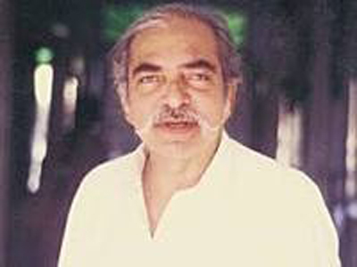

His TV play “Such Gup” was sensational. I remember vividly how families would rush to the TV room; to watch the play, not wanting to miss a single act of the hilarious and witty comedy.

Professor Hashmi was an excellent teacher as he held the key to his students’ hearts and minds. I still remember my husband Mansoor, who was a student at Government College Lahore, telling me how Professor Hashmi made learning fun by code-switching English, Urdu, and Punjabi. How he taught Economics by citing in Punjabi about farmers and buffaloes. Later, when Shoaib was teaching a course at the Lahore School of Economics a course on Language, Culture, and Society, he would take the entire class to the old city of Lahore to discover their “cultural heritage.”

As a university professor, I salute Professor Shoaib Hashmi the legend, who changed the worldview of the youth of Lahore for generations to come.

*The writer is the former vice-chancellor of LCWU and a professor (LSE)*