RESILIENT RELATIONS
February 16, 2019 the nation
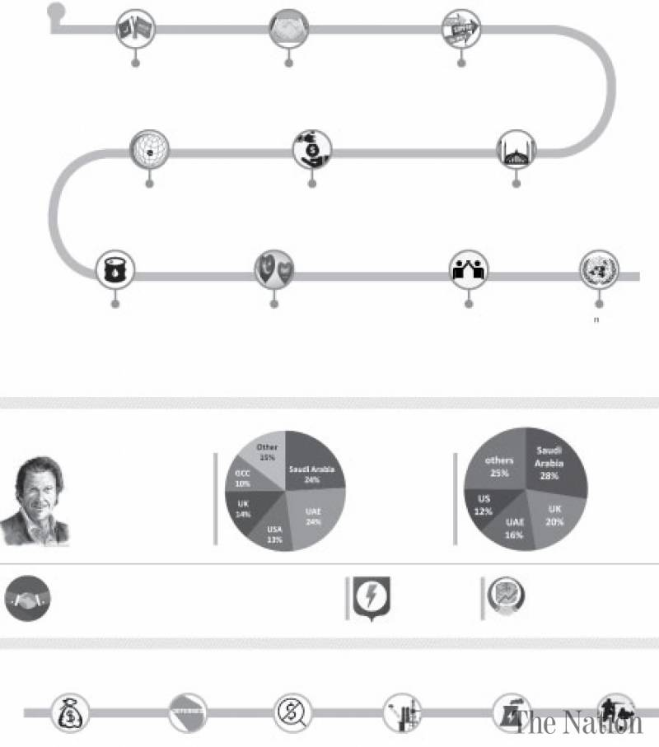
Past

Saudi Arabia was one of the first countries to accord diplomatic recognition to Pakistan.

Pakistan and Saudi Arabia concluded a Treaty of Friendship as early as 1951, laying the foundations of an enduring friendship.

Saudi Arabia came to Pakistan’s assistance during the 1965 & 1971 wars, following Soviet invasion of Afghanistan and the ensuing refugee crisis, and after imposition of sanctions by the west, post nuclear tests in 1998.

It was with full backing and support of Saudi Arabia that Pakistan hosted the Second OIC Summit in Lahore in 1974.

Besides direct financial support, Arabia has funded numerous health, education, infrastructure and welfare projects. It extended full support to Pakistan in the aftermath of the 2005 earthquake and 2010/2011 flash floods.

Saudi largesse is evidenced by the naming in Pakistan, of a large number of projects after scions of Saudi Royal family. Shahra-e-Faisal in Karachi, the Faisal Mosque in Islamabad and Faisalabad are all named after King Faisal.

Following nuclear tests, Saudi Arabia extended Pakistan the facility of oil on deferred payment. Nearly 50,000 barrels of oil were provided daily for a year.

The people of Pakistan harbor an abiding attachment with HarmainSharifain, the Saudi royal family, and the land of Saudi Arabia. The royal family of Saudi Arabia, in turn, has an immense love and affection for Pakistan and Pakistanis. It has been most benevolent and affectionate towards Pakistan.

Pakistan continues to stand unequivocally by the side of Saudi Arabia, and in case of any violation of Saudi Arabia’s territorial integrity or threat to HarmainSharifain, will stand shoulder to shoulder with Saudi Arabia and its people.

Pakistan and Saudi Arabia continue to extend each other valuable support at multilateral forums, including the UN and OIC.

PRESENT

Prime Minister Imran Khan’s first state visit to a foreign country was to Saudi Arabia, where he was accorded an unprecedented welcome. This was followed by another visit from to participate in the second Future Investment Initiative Conference.

Saudi Arabia is also the largest source of remittances to Pakistan; In 2017-18, Pakistanis based in Saudi Arabia remitted US$ 4.8 billion back home; accounting for 29% of total remittance receipts.

At 2.6 million, nearly one-third of Pakistani expatriates (28%) live in Saudi Arabia which is home to the largest Pakistani community abroad anywhere in the world.

Since inception of the new government, Pakistan and Saudi Arabia have maintained a high momentum of leadership level exchanges. The Saudi Ministers for Information and Energy have visited Pakistan; the Foreign Minister has met his Saudi counterpart on the sidelines of the UNGA Session.

Saudi Arabia remains an important source for Pakistan’s energy security.

Twenty five Saudi companies have operations in Pakistan, while 350 Pakistani investors are registered with Saudi General Investment Authority.

Future
At the request of Prime Minister Imran Khan, Saudi Arabia has deposited US$ 3 billion in the State Bank of Pakistan. This deposit is meant to extend balance of payments
support to Pakistan.
Saudi Arabia has also graciously agreed to provide one year deferred payment facility or import of oil up to US$ 3 billion. This arrangement will be in place for 3 years, and will be reviewed thereafter.
A decision has been reached in principle to reduce visa fee for Pakistani expat workers by 85 percent.
Negotiations are in the final stages on setting up by Saudi Arabia, of an oil refinery in Gwadar, entailing investment of up to $ 10 billion. An agreement in this regard is expected to be
concluded shortly.
Saudi Arabia has also evinced keen interest in investment in Pakistan’s mineral sector and acquisition of RLNG power plants.
Pakistan will provide training and defence assistance to KSA. Presently 1680 Pakistan troops are in KSA providing training while 77 KSA military cadets are being trained at Kakul.

