Trade & peace: are they linked?
By S. Akbar Zaidi
Monday, 15 Feb, 2010
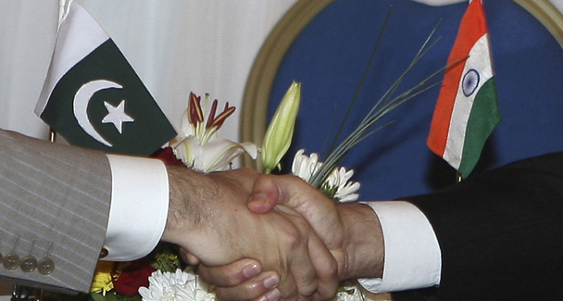
Trade between India and Pakistan was at its peak in the year following Kargil.

Few people know that from amongst the more than 100 countries with which Pakistan trades, India is Pakistan’s ninth largest trading partner.
This means that Pakistan traded far more with India than it did with France, Italy, Thailand, Iran, Canada, Malaysia and, surprisingly, even Japan in 2007-08, the latest year for which we have complete data.
Moreover, if we exclude Saudi Arabia and Kuwait from this list, as we import primarily oil from them, then India jumps to the seventh position. In economic terms, India’s important position as Pakistan’s trading partner makes complete sense.
For numerous reasons one trades most with one’s neighbours, as the global pattern of trade affirms. However, given the fact that India is seen by many as Pakistan’s ‘greatest enemy’, this ranking is most exceptional and challenges a great deal of what is perceived to be conventional wisdom.
It is not difficult to understand the economic arguments which give trade between neighbours such importance. We know that transport costs between neighbours are bound to be much lower than when countries are further away. Tastes and lifestyles are also often not very different, and within geographical regions such cultural and social similarities are accentuated, allowing for an exchange of products to take place.
There are also the economies of scale to be considered. Often neighbours have access to much larger markets than their own, allowing for local and international firms to look at regional markets rather than national ones. Clearly, in this era of global trade and open borders, there is no economic rationale for neighbours not to trade. Politics, it is presumed, is a different issue altogether.

Countries can cease trading with one another if there are disputes, disagreements or hostilities. Yet, despite such political issues, countries which are adversaries or have tense ties often conduct a great deal of trade with each other.
Taiwan and China have a huge and growing trade relationship, as do Japan and China. India and China still have unresolved border issues, but today China is India’s largest trading partner. And Pakistan and India have traded for all but nine of their 62 years, albeit at levels which have always been below potential.
More importantly, trade between Pakistan and India has increased whenever there has been a general in power in Pakistan, which has been the case far too frequently. Trade received a big boost when Gen Ziaul Haq ruled Pakistan, and then it was Gen Musharraf who actively opened up trade and other relations with India.
Most civilian governments, which have followed the ubiquitous military regimes, have continued with the opening up started by the military as the incumbent PPP government has done. What is surprising, however, is that trade between India and Pakistan was at its highest ever in the year following Kargil.
Even the Mumbai attacks have not significantly dented India-Pakistan trade relations. If anything, Pakistan’s exports to India grew by 20 per cent in the financial year 2008-09, which ended many months after the Mumbai attacks. If trade and hostilities (or peace) were linked, this pattern may have been very different.
Those who argue that ‘peace is good for trade’ or vice versa, that ‘trade leads to peace’, have failed to factor in the rather strange India-Pakistan relationship. While there has never been complete peace between India and Pakistan, and it has been more of a relationship of ‘not-war’, trade has not taken off for numerous reasons and not just those related to diplomacy.
More importantly, we have seen that even when trade between Pakistan and India has picked up, peace has not prevailed as exemplified by the case of Kargil and Mumbai. What is important to emphasise, hence, is that both trade and peace are important in their own right, and any cliché of linking one with the other, does not give a factual picture and serves the purpose of neither.
It is difficult to argue for a position other than that Pakistan (or any other country) must have peace, not just for economic progress, but for itself as well. Citizens require conditions of safety and peace in order to live and to pursue their interests, in fact to exist as human beings. In conditions of war or hostility, the quality of life, material and non-material is heavily compromised and suffers. Even if countries do not trade with certain others, peace is the basic right of all citizens.
Trade, on the other hand, is a purely economic activity which may have social and political consequences, but this need not always be the case. Trade is opportunistic, for given equal conditions, firms and countries will conduct business with whoever appears to have the better product, price or terms.
Ethical reasons, while they do increasingly play a role, are less important than the profit motive or economic considerations whenever business is undertaken. Trade would not take place unless it was profitable or essential. And trade, as numerous examples prove, can be profitable even if one trades with one’s adversary.
In linking trade with peace, those who want peace between India and Pakistan misunderstand the nature and essence of both. Peace should be the unconditional goal of both countries and their citizens, while trade will follow largely economic logic and arguments. If both complement each other, well and good; but it is a mistake to make either binding or conditional on the other.

