Tough on the peace lobby
By Kuldip Nayar
Friday, 29 Jan, 2010
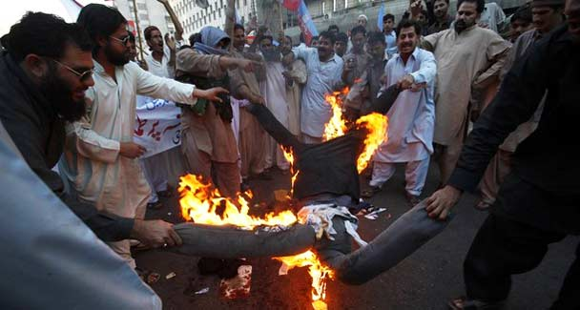
Interior Minister Rehman Malik has hinted that Indians would be discriminated against. He does not know how strongly the public has reacted against the trade-bound IPL.
From President Barack Obama to US Defence Secretary Robert Gates, the one message that is being drilled is that terrorism can destabilise the countries in South Asia.
People and governments in the region do not have to be warned against the obvious. America has seldom admitted its own nefarious role. Washington decided several years ago to train and arm militants to bleed the Soviet Union during the Cold War, creating a bulwark of fundamentalism to defeat communism. The result is that the fire of bigotry which the US ignited is consuming stable and democratic forces.
The visit of Gates to the region was significant. For the first time the US used Indian soil to send a warning to Pakistan about the terrorists. He indicated that an attack like the one in November 2008 on Mumbai could result in war. It was a provocative statement. What New Delhi does or does not do will depend on the circumstances at that time. War is not an option when both countries are nuclear powers. America is unnecessarily clouding relations between India and Pakistan in the name of helping them sort out their differences.
Gates reportedly conveyed the same warning to Prime Minister Yousuf Raza Gilani in Islamabad. Gilani is said to have posed the question to Gates that when Pakistan had not been able to protect its own nationals against terrorists, how could he guarantee that another 26/11 would not take place.
The reply of Indian Foreign Minister S.M. Krishna was unfriendly. He said that India would react if there was another 26/11. Doesn’t it amount to a threat? Soft-spoken Defence Minister A.K. Antony has also warned his countrymen that there might be a terrorist attack and has drawn attention to the LoC “violations”.
With incidents escalating over Kashmir, Islamabad would have ‘reason’ to reject the Gates proposal that it faces an existential threat on the western rather than the eastern frontier. No amount of convincing can change Pakistan’s stance because it considers India an enemy. This is a tragedy.
The language used by Gilani, Krishna and Antony is couched in words reflecting mistrust and bias. Such expressions are lessening the space for conciliation between the two countries. True, they cannot cooperate. But they do not have to be jingoistic in their observations. They can at least be civil.
Since New Delhi is almost convinced about an impending attack on India, it might help the situation if Islamabad is given the information we have. Whatever the status of its relationship with another, no government can ignore reports of groups planning an attack at a certain place.
Gates was correct in assessing that Al Qaeda has adopted different nomenclatures for operations in Afghanistan, Pakistan and India. And all the terrorists are together while planning and executing the attacks. It goes without saying that there has to be a regional approach to fight them. But the glue for cooperation is an equation between Islamabad and New Delhi. And that possibility is receding day by day.
The manner in which the Pakistani cricketers were rubbed the wrong way during the Indian Premier League (IPL) auction shows that India is still not alive to Pakistan’s sensitivities. After the players fulfilled all the requirements, they were nowhere in the reckoning, not because they lacked merit but because the elitist IPL had reportedly sent word to the franchisees that nobody should bid for the Pakistani players.
The government should have intervened to see that the bias against the Pakistan players was rectified. Home Minister P. Chidambaram’s late reaction seems to have had its effect as IPL commissioner Lalit Modi has thrown hints at the inclusion of Pakistan players. My point is that if any annoyance was to be shown, it should have been against Australia where 1,500 attacks have been made on Indians in one year.
When the IPL took matches to South Africa last year, one felt bad because our security system was not considered good enough to protect the players. This time the IPL is said to have bought peace. It has placated the Shiv Sena which had reportedly threatened to disturb the matches if the Pakistani players were allowed to participate. Who is running the Indian government, the Shiv Sena or the Congress?
Governance means law and order and security for all. Already the Congress government in Maharashtra has vitiated the atmosphere, first by insisting that taxi drivers must learn Marathi, meant to feed Maratha chauvinism, and then taking a U-turn, saying that knowledge of Hindi or Gujarati would do. Still the requirement that a taxi driver would have to be domiciled in Maharashtra for 15 years is a serious attack on India’s federal structure.
Whatever the mess the Maharashtra government might have created, the remark by Pakistani Interior Minister Rehman Malik was no less messy. He has hinted that Indians would be discriminated against. He does not know how strongly the public has reacted against the trade-bound IPL.
In the process, an important clue to unravel the 26/11 imbroglio has been lost. In the conversation intercepted between the assailants on Mumbai and their instructors in Pakistan, some Hindi words were used. Obviously, the speakers included Indians. This only strengthens the general belief that there were ‘sleepers’ in the country when Mumbai was attacked.
New Delhi has said everything about the attack but not a word about the persons who helped the terrorists. At a recent Indo-Pakistan meet in Delhi, the eminent Pakistani lawyer, Aitzaz Ahsan, raised this point again and again but there was no answer forthcoming.
However, the entire scenario between India and Pakistan is tough on those who are trying to build bridges between the two countries. Whatever structure of goodwill is raised it comes tumbling down because of indiscretions and provocative statements.
Peace-seekers should not feel discouraged because theirs is a commitment to friendly relations between India and Pakistan.

