The boundaries within
By Asha’ar Rehman
Saturday, 23 Jan, 2010
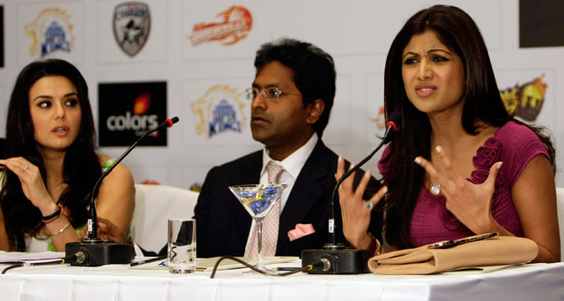
Rajasthan Royals' co-owner and Bollywood actress Shilpa Shetty, right, addresses a press conference as Indian Premier League (IPL) Commissioner Lalit Modi, center, and Kings XI Punjab team co-owner and Bollywood actress Preity Zinta look on in Mumbai. -Photo by AP

THE Shabab-i-Milli crowd is out in force in Lahore. They can hardly be expected to demonstrate for peace and are certainly not protesting the recent show of belligerence on the borders for which the Indian forces have been held responsible.

They are not angry at having to receive the bodies of Pakistanis who have died in Indian jails or at the frequent arrests of Pakistani fishermen. What they are pressing for is the Pakistani cricketers’ right to make fast bucks in the Indian Premier League.
This is a reminder of how grave the paradox is, one which extends beyond India-Pakistan ties.
The so-called IPL snub to Pakistani cricketers can certainly be viewed as a setback to the system. The protagonists of the system have been relying too heavily on things to sort themselves out. The mantra says that all you need to do is to introduce capital-intensive activity in a sector and rest assured that this means will in time become an end in itself.
In this case, it is merely about the cricket circus, with the global chief manager of the game expressing how eager he is for Pakistan and India to resume cricketing ties. He is justified in seeing capital-expansion potential in the Ashes-like rivalry between the two South Asian neighbours. But can the formula, be applied to all situations indiscriminately?
The standard diagnosis and prescription procedure is somewhat reminiscent of a theme in a Manto story whose main character believed he had a cure for constipation and wanted to convince people that they all suffered from it.
Take something as complicated as Kashmir. Trade alone, it is sometimes argued, can make the Kashmiris overcome their accumulated problems. Trade does take us forward. It creates a constituency for peace. But having said that, the Kashmiris have every right to be wary of an illusion machine that has a knack for coming up with selective images to prove the success — or failure — of an initiative.
While economic, and more precisely financial exchange and mutual monetary benefits, are handy and a boon for a peace process, what we are essentially looking for is peace and reconciliation of the political type. We are looking to create a situation which can guarantee smooth selling and buying. Seriously, buying and selling have to be couched in positive political realities, even if words such as ‘plebiscite’ and ‘referendum’ are out of fashion.
The latest wave of ghairat sweeping Pakistan is illustrative of the complex that we have built over time. For the first year or so in power, the Gilani-Zardari combine appeared to be going out of their way to extend an olive branch to India. Whereas the thinking at the top and subsequent policies of the state may still be the same, certain Zardari loyalists have been constrained by political realities to raise the Indian bogey once again.
Not to speak of PPP lawmaker Jamshed Dasti whose desperate search for a popular issue, other than the embargoed push for a Seraiki province, has led to many comic situations; even Interior Minister Rehman Malik has been quite vociferous in his condemnation of Indian designs. (Need we be told, Mr Malik, that the game is far from over? National interests remain and if anything they have become international interests.)
Latest is that Sports Minister Aijaz Jakhrani has asked for a ban on Indians playing in Pakistan as also on the telecast of future IPL games in the country. It can be, looking at it from one angle, predicted that the process is set to continue. Mr Jakhrani’s words are not likely to prevent interested Pakistanis from following the next IPL season on television.
From another, however, it is clear that the way the Pakistani players were rushed into an IPL auction, on a popular level, has caused great harm to the ideal of good-neighbourly relations between Pakistan and India. Popular sentiments are a difficult area.
In pure market terms, it is not difficult to figure out why no club in the IPL bid for the exciting Pakistani talent on sale earlier this week. With Sohail Tanvir and to a lesser extent Kamran Akmal helping her Rajsathan Royals clinch the first IPL title a couple of seasons ago, Shilpa Shetty tried to explain that it was not a case of her not wanting to have Pakistani players in her lineup; it was a situation where she could not have them for reasons of security, etc. She and other bidders at the now infamous auction can hardly be faulted for choosing not to gamble on men they were not sure that they would be able to field.
Much media space has been given to the delight Indians must be experiencing at disgracing a set of Pakistanis; it will also be useful to have a look at the role of Pakistani authorities in the episode.
We have to remember that no Pakistani player was put on sale at an earlier auction for the coming edition of the IPL. The fact that Pakistani players were included in the second auction was due largely to the insistence of the Pakistan Cricket Board and the players themselves. A little more effort on the part of the PCB, with the cooperation of the Pakistani mission in India and our top cricket administrators would have known what was in store for the players on the day of the auction.
For those who thought of it as more than a business matter and for those whose ghairat is easily violated, an honourable way would have been for the individuals, or the PCB on their behalf, to withdraw their names from the auction. What the PCB did instead was hope that the process itself would throw up a solution, which it didn’t. Next a helpless PCB chief revealed to the world that the IPL boss, Lalit Modi, did not even bother to take his telephone call. Looking for snubs, this certainly was one.

