Talks about talks
By Tariq Fatemi
Thursday, 25 Feb, 2010
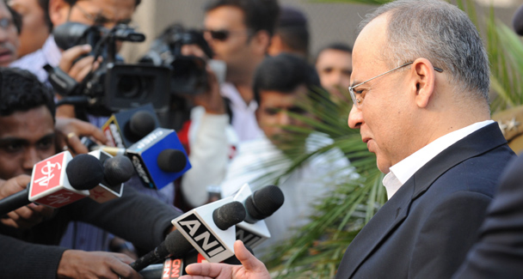
Pakistan's Foreign Secretary Salman Bashir (R) addresses the media upon arrival at Indira Gandhi International airport in New Delhi.

On the day this article is published, the Pakistani and Indian foreign secretaries will be leading their delegations to the first formal meeting between them in more than a year. Given our perilous state of relations, this should give some hope to the tormented billion-plus who live in the region.
Expectations, however, are not too high given the tortured history of earlier such encounters. Many are even questioning if it is worth the time and effort that has gone into it, particularly as the Indians remain sceptical about Pakistan’s commitment to dismantling alleged terror networks. In fact, ever since the November 2008 Mumbai attacks, India has refused to restart bilateral negotiations, known as the composite dialogue process, while mounting a diplomatic campaign in major capitals to pressure Pakistan to ‘mend its ways’.
Pakistan, on the other hand, has been calling for the resumption of the process, which is the only formal, structured format to which both countries have been wedded since June 1997. This view is reinforced by Islamabad’s fear that Delhi has been trying to wriggle out of the composite dialogue, opposed as it is to any discussion on Kashmir as an agenda item in structured negotiations.

While acknowledging India’s anger and outrage at the Mumbai attacks, Pakistan advocated continuing engagement through existing institutional arrangements. Moreover, the issue of terrorism cannot be divorced from that of Kashmir, where the 60-plus years of Indian occupation and accompanying atrocities have created conditions that foment indigenous anger and resentment, as demonstrated by the strongly burning flame of azadi.
Making the dialogue process a victim of the Mumbai incident did neither country any favours. The composite dialogue not only kept negotiations on track but also achieved considerable progress on Siachen and Sir Creek. And if former foreign minister Kasuri’s claims are to be accepted, remarkable headway was made on the issue of Kashmir as well, though in the ‘back channel’, and primarily on account of the military dictator’s willingness to abandon Pakistan’s historically established positions.
India’s foreign minister has emphasised that the Delhi meeting may be a one-off exercise, though the home minister has indicated that India may agree to discuss measures to strengthen some of the Kashmir-related confidence-building measures. There are also indications that India may be willing to listen to our allegations about its involvement in Balochistan and complaints on water. Nevertheless, there is speculation as to the reasons that led India to soften its stance on talks with Pakistan at this time.
For a start, there was a growing realisation that India had failed to galvanise the kind of international pressure it wished to exert on Pakistan, with major powers recognising the complexity of South Asian politics and opting for non-involvement apart from urging restraint on both sides. Even worse, India failed to respond to the newly elected Pakistan government’s oft-repeated desire for genuinely cordial relations, an initiative that enjoyed the support of the major political parties as well.
Sadly, the Indians appeared to be stuck in a time warp, nostalgic for an authoritarian regime’s proclivity to offer out-of-the-box proposals. Moreover, with Pakistan then in the throes of terrorism that included frequent suicide attacks all over the country, there were many who wanted Pakistan to stew in its own juice. Consequently, instead of responding to Pakistan’s urgings for cooperation on anti-terror mechanisms, India decided to pursue a rigid and unimaginative policy, which dampened Islamabad’s earlier enthusiasm for rushing into talks.
In the meanwhile, the Pakistan Army was able to score major successes, both in its military operations as well as in hunting down militant leaders, enabling it to speak with greater confidence both at home and abroad. It also reiterated a modified rationale for Pakistan seeking “a strategic depth in Afghanistan” and a demand to be viewed as “a core player in whatever the US decides to do in Afghanistan”.

The army chief also took advantage of his Indian counterpart’s provocative statements to articulate an appropriate military response to India’s Cold Start doctrine. But most likely the turning point was the London Conference, where the extent of India’s isolation on Afghanistan, notwithstanding its billion-dollar investment in that country, must have been painful to Delhi.
The Obama administration too played a helpful role in nudging India towards responding to Pakistan’s repeated pleas for resumption of official talks. Senior administration officials have confirmed that while Washington refrained from injecting itself into the India-Pakistan equation and even avoided mentioning the ‘K’ word in Delhi, it has nevertheless been supportive of a return to dialogue. US Defence under Secretary Michele Flournoy remarked during her visit to Islamabad last week that “we will do everything in our power to support successful … talks”.

But the US has to do more than merely encouraging dialogue between Delhi and Islamabad. America has to appreciate that its enormous power is meaningless unless it is channelled into positive and productive diplomatic ventures. It cannot continue to shy away from involvement in major regional disputes on the plea that it is for those involved to resolve their problems themselves. If that had been the case, Pakistan and India would have settled their differences decades ago.
In any case, whether it is realism on India’s part or disappointment at its failure to get the appreciation it wanted for its role in Afghanistan, it is now incumbent on both Delhi and Islamabad to recognise that the international community is simply tired of their constant bickering and frustrated with their inability to resolve their differences. Admittedly, both continue to be saddled by the enormous baggage of a painful history but it is in their common interest to set aside their inhibitions and to overcome their fears. India is much bigger and far stronger, and its economy too has done exceedingly well. These factors have further fuelled its ambition to play a role far beyond its borders but it cannot do so as long as it remains mired in a hostile relationship with Pakistan. The unresolved Kashmir issue hanging around its neck, albatross-like, doesn’t help either.
Pakistan too has to show greater confidence in its own abilities, especially now that we have a democratic dispensation which needs to re-orient its foreign policy to cater to the aspirations of the people. We cannot continue to pray for fortuitous developments in the region, or to count on far-off friends, while neglecting to forge cordial and cooperative ties with our immediate neighbours. Let the Delhi meeting not merely be talks about talks.

