Success of talks is the priority
By Kuldip Nayar
Friday, 12 Feb, 2010
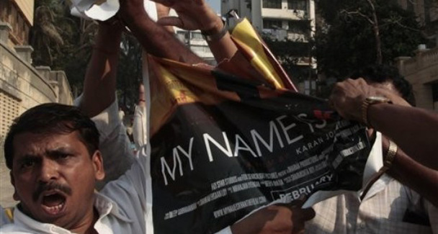
Shiv Sena activists tear a poster of Bollywood actor Shahrukh Khan's latest movie 'My Name is Khan', outside Khan's residence in Mumbai.
Developing countries have in parochialism a menace which disrupts normal life. A small number of people take the law into their hands and whip up a frenzy by playing on divisive and communal sentiments. They not only mar the rhythm of development but also weaken the nation’s cohesion.
The Shiv Sena in Mumbai is one such organisation which feels proud in sowing the seeds of separation. Its followers are like the Taliban, less violent but equally fanatical. They have adopted Marathi, one of India’s 14 main languages, to push their agenda for a distinct identity. They openly preach Hindutva.
Therefore it was not surprising when it picked on a Muslim for attacks which were until then confined to north Indians. The Shiv Sena asked Indian cinema’s leading star, Shah Rukh Khan, to apologise for supporting Pakistani cricket players. He had regretted their absence from the Indian Premier League and wished they could have participated.
Shah Rukh stood his ground and rebuffed the Shiv Sena by not showing any regret over his remarks. He had the support of the entire nation. A TV survey showed that 94 per cent of respondents backed him. Of course, the depressing part was the silence of most actors who were expected to speak out in favour of Shah Rukh. I was not surprised by the silence of Amitabh Bachchan. He travelled all the way to Ahmedabad to show his movie to Chief Minister Narendra Modi of the Gujarat carnage fame.
Why the Maharashtra and the central governments, both led by Congress, tarried in taking action against the Shiv Sena was a sad commentary on the party’s secular credentials. But electoral politics made the Congress play soft on Hindutva in Gujarat as well.

What woke up the Maharashtra administration was Rahul Gandhi’s visit to Mumbai. The country applauded his observation that every part of India belonged to every Indian. He literally bearded Shiv Sena in its den, much to the humiliation of its chief Bal Thackery. It is now taking revenge on hapless theatres and viewers wishing to screen or watch Shah Rukh Khan’s movie.
Arousing anti-Pakistan sentiment is a hobby horse of the Shiv Sena. Yet it is only the lunatic fringe which has not reconciled to Pakistan, primarily an Islamic country. That is the reason why Shah Rukh was called “a traitor” while he repeatedly said he was an Indian and stood for good relations with the people of Pakistan.
Anti-Pakistan feeling in India or anti-India feeling in Pakistan are old phenomena which, unfortunately, have persisted despite growing people-to-people contact. Any demagogue can exploit them. Bal Thackeray in India and Lashkar-i-Taiba chief Hafiz Sayeed, who this week organised a ‘jihad’ meeting in Islamabad to “liberate India”, are there to stoke the fires of hatred. They do not change because they earn dividends from the hostility they peddle.
But I am more concerned by the attitude of young people on both sides. On TV I happened to watch discussions between youngsters from the two countries. The cricket match was between India and South Africa. But the filthy language they were using to describe cricket players belonging to the other side was shocking.
The new generation has mastered the use of computers but not the basics of civilised language. They are worse than the street urchins who have had no schooling. Yet those who were hurling abuses at each other belonged to families which, I imagine, had not brought them up to be goondas. Maybe my presumption is wrong. Maybe even the best of families do not mind their children using abusive language.
Partition is 62 years old. Both the Congress, representing the majority of Hindus, and the Muslim League, representing the majority of Muslims, agreed to divide the Indian subcontinent on the basis of religion. But at the same time, the founders of the two countries, Mahatma Gandhi and Quaid-i-Azam Mohammad Ali Jinnah, told their people not to mix religion with politics.

Mahatma Gandhi said he would live in Karachi and the Quaid-i-Azam retained his Mumbai house for occasional visits. Both said that the two countries would be the best of friends. Then why through their actions are youngsters on both sides denouncing those who won them freedom?
After mass killings and full-blown wars, people on both sides should have realised that hostility is not the answer. The option of war was extinguished once the two counties went nuclear. There is no alternative to peace. Youngsters should appreciate this fact all the more because the challenge before them is to construct the country, not destroy what has been built.
Hindus and Muslims have lived together for 800 years. Together they have moulded a life based on a sense of accommodation and the spirit of tolerance. They have developed a composite culture which retains the separate identities of Hinduism and Islam. It was the British rulers who created disharmony and distance. We should have spanned it long ago.
The other question that the Shiv Sena has posed is linguistic identity. India reorganised the states on linguistic considerations 50 years ago. Even at the time, the danger of linguistic chauvinism was underlined by the Fazl Ali Commission on Reorganisation of States. In other parts of India, movements in the name of language have risen and fallen. The Shiv Sena phenomenon, a decade old, has not died because it has found fertile ground in Maharashtra.
The 26/11 terrorist attacks on Mumbai have come in handy for the Shiv Sena to raise the pitch of anti-Pakistan rhetoric. The larger question is how to fight against anti-Muslim feeling and anti-Pakistan sentiment, which at times look like two sides of the same coin. Friendly relations with Pakistan are the only answer. Unfortunately, the BJP has even opposed talks at the foreign secretaries’ level.
Pakistan Foreign Minister Qureshi does not help matters when he plays to the gallery. His body language and words don’t help the situation. It is true that India made a proposal to Pakistan to resume talks. But this is what the people on both sides have been urging. It does not help if false prestige takes precedence. The priority is to make the talks successful, not dwell on who bowed before whom. It is too early to say which country has succeeded in its strategy. There is still a long haul ahead that will demand patience and willingness to accommodate each other’s point of view.

