Resume talks with India
By I.A. Rehman
Thursday, 05 Nov, 2009
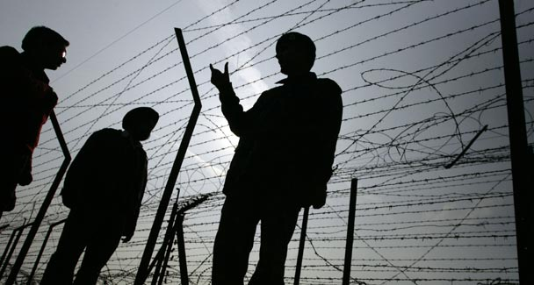
That Pakistan needs peace along its border with India in order to be free to deal with the conflict in its tribal areas is only part of the argument for establishing peace in the subcontinent.
REGARDLESS of the views of the establishment’s hawks and howsoever strong they may be, Islamabad must give a positive response to Prime Minister Manmohan Singh’s offer of peace.
Normal relations and mutually beneficial cooperation between the two closest South Asian neighbours has always been desirable for many reasons but their urgency has been increased many times over by the extremists’ challenge to the Pakistan state.
No sane person on either side of the border can deny that the threat to the stability of Pakistan is also a threat to India’s vital interests, and their joint efforts are needed to ensure victory over the terrorists.
That Pakistan needs peace along its border with India in order to be free to deal with the conflict in its tribal areas is only part of the argument for establishing peace in the subcontinent. Much more urgent is the need for India-Pakistan cooperation for winning the battle for democracy, tolerance and social justice. Losses in this battle will plunge the people of both India and Pakistan into unimaginable ordeals.
Hitherto a common view in Pakistan has been that India is ignoring the threat to itself posed by the terrorists’ campaign against Pakistan. There was reason to believe that the pro-confrontation lobby in India saw in Pakistan’s predicament an opportunity to squeeze it for concessions it might not be willing to make in normal times. Such elements should not be expected to stop undermining the Indian prime minister’s initiative. It is in Pakistan’s interest to ensure that he is not forced by anyone to withdraw his offer.
The Pakistan government too will be under pressure from hardliners in its ranks and outside. Any compromise with such elements will cause Pakistan irreparable harm. Islamabad should therefore press for the earliest possible resumption of the composite dialogue with India.
Unfortunately, several new factors have fuelled tension between India and Pakistan. One of them is the way the Ajmal Kasab affair has been dealt with by both sides. The unnecessarily prolonged haggle over Kasab’s confessional statement merely exposed the size of the trust deficit. Was it impossible for India to supply Pakistan with an English translation of the court and police record in Marathi and was it impossible for Pakistan to get this work done?
Questions regarding the admissibility of a text not officially admitted by India could have been sorted out in due course. The two sides have to act in a spirit of cooperation to put the Mumbai outrage behind them. Pakistani authorities have been accusing India of interference in Balochistan and the tribal areas. One hopes they have much more credible evidence to support their charges than the use of Indian-made weapons by the Taliban in Waziristan or the receipt of some funds by the Baloch nationalists from Afghanistan.
The extremists’ access to arms manufactured in a particular country is no decisive proof of that country’s support for their cause and experts in money-laundering have considerable experience in using channels through any country. In any case, these complaints should be addressed on an urgent basis at India-Pakistan joint meetings.
This matter will assume greater seriousness as India’s relations with Afghanistan are likely to grow with faster speed than at present. If Pakistan succumbs to the temptation of opposing India’s overtures to Afghanistan it will only reduce the chances of normalisation of relations with both Afghanistan and India.
A better way of protecting Pakistan’s interests in a democratic Afghanistan would be to grant the latter its due place in South Asian councils and develop a regional response to the twin curse of foreign intervention and civil war that are perpetuating the Afghan people’s three decades-long tribulations. No single power can guarantee Afghanistan’s recovery and peaceful progress; the task can only be accomplished by countries in Afghanistan’s vicinity (all of them including Pakistan and India) acting in concert.
The significance of the fact that Mr Manmohan Singh chose to extend his hand of peace while on a visit to Srinagar is unlikely to be missed by Pakistani hawks. They will again advance settlement of the Kashmir issue as a precondition for normal relations with India.
Nobody can deny the importance of the Kashmir issue, especially to the people of Jammu and Kashmir who have been wronged by both India and Pakistan. But the disastrous consequences of sustaining a costly confrontation until the Kashmir issue is resolved are too apparent to permit persistence in this policy.
While talks to move towards a Kashmir settlement acceptable not only to India and Pakistan but also, and more essentially, to the people of Jammu and Kashmir, should continue, progress or setbacks in this area must not obstruct other initiatives for cementing India-Pakistan friendship and cooperation. More and more people are realising that a Kashmir settlement will follow India-Pakistan friendship and not precede it.
Above all, peace-loving people in both India and Pakistan are getting weary of meetings and talks that do not result in increasing India’s stakes in a stable and prosperous Pakistan and Pakistan’s stakes in a stable and prosperous India. Apart from giving a boost to India-Pakistan trade it is necessary to think of joint industrial ventures and meaningful cooperation in the fields of agriculture, education, health and culture.
It is possible that the current political crisis in Pakistan will be advanced by one side or another to put India-Pakistan bilateral talks on hold. The time for using such arguments has passed. In today’s situation the only sensible course is to press on with establishing peace in the subcontinent regardless of the political crises in either country or a change of regime here or there.

