Do ministers’ visits help?
By Kuldip Nayar
Friday, 16 Jul, 2010
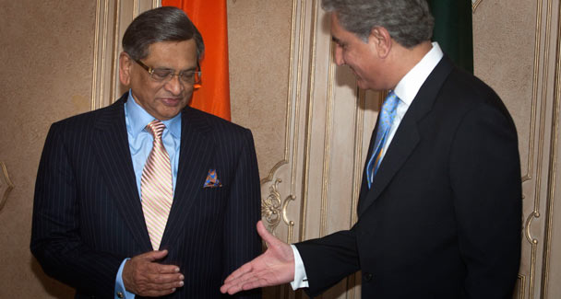
Foreign Minister Shah Mahmood Qureshi, right, extends his hand to visiting Indian External Affairs Minister S.M. Krishna for a shake hand prior to formal talks at the Foreign Ministry in Islamabad. –AP Photo/B.K.Bangash
Former prime minister Inder Kumar Gujral would always say that a solution between Pakistan and India had to be evolved, not presented to the people, as if a magician had pulled a rabbit out of a bag. He had a point.
The two sides — particularly the politicians and the establishments — had to chew the solution and then gulp it down, which is a slow process. This is like a building which would be erected brick by brick. Therefore, people-to-people contact is the obvious way out for the two countries to discuss and debate the various issues facing them at length, without even reaching a consensus of any sort.
My experience shows that the contact comes to be confined to those who can get a visa or are lucky enough to be part of a Track-II committee. Governments on both sides are frustratingly cussed and slow.
They have hardly left any scope for contact among the common people on both sides. India’s home ministry is further tightening visa eligibility criteria so that it can keep out “unwanted elements”. Norms under discussion include indicating income criteria and minimum educational qualifications for entry into India. This is an approach meant to allow in only the elite.
The meeting between foreign ministers of the two countries is a step forward after the talks between the two home ministers and foreign secretaries. What they say and the steps they take are important for the two countries to normalise relations. And they should do it quickly because the people want normalisation without further loss of time.
Yet the most important thing is how to disabuse minds on both sides. The feeling of national solidarity is nurtured on the two sides by emphasising the ‘misdeeds of the other’. When nationalism feeds on downing the ‘enemy’, there is little hope in building an atmosphere of confidence. Nationalism, in fact, is prejudice.
Prime Minister Manmohan Singh’s remark that trusting and verifying the sincerity of Pakistan may be justified because of India’s feeling of betrayal after many successful attempts to reach an understanding. Yet it only underlines the depth of distrust. Who is to verify what and how? These are ambiguous questions and should not be raised when the two countries are yet to outline even the agenda of talks. New Delhi does not want to give them the name of a ‘composite’ dialogue, the phrase which Pakistan prefers.
People in both countries have to overcome the memory of partition’s traumatic experience. Happenings of those days are still being passed by one generation to the other. I can tell you from my experiences — I travelled from Sialkot to Amritsar on September 13, 1947 — that there was no difference between the Hindus and Muslims in killing and looting members of the other community.
They killed one million people and uprooted nearly 20 million families. I was pained to see the Pakistani establishment telling one side of the story. It has put up boards at the Wagah border to show how Muslims were killed by Hindus and Sikhs. The Muslims were no less guilty. It would be better to consider that incident an aberration in a long history of amity between Hindus and Muslims.
But the tragedy of partition is only renewed again and again when Pakistani textbooks arouse hatred against Indian people, not the state. Although the observations have been reportedly toned down, they still talk about “India’s evil designs against Pakistan” and identifying “the events in relation to Hindu-Muslim differences.” How can children forget what is taught to them in schools? They carry the same impression when they grow up. It is time that both countries set up a joint commission to go through textbooks and directives given to those who prepare them.
No doubt such a step will do away with the hatred cultivated at a young age. Yet the fear of a small state that Pakistan has been — the natural fallout of partition — is understandable. It feels pitted against a big state, India. And most Pakistanis still believe, even after 62 years of the formation of the country, that New Delhi wants to destroy their country. This thinking gives grist to the propaganda mills of extremist organisations. Civil society in both countries has to fight against such attitudes. Would Pakistan survive the difficulties it faces? I am reminded of what Atal Behari Vajpayee wrote in the visitors’ book at Minar-i-Pakistan: “India’s integrity and prosperity depends on the integrity and prosperity of Pakistan.”
The prisoners on both sides are a sad commentary on the attitude of rulers and bureaucrats. Indian and Pakistani prisoners languish in jails long after their sentence is over. The crime of most of them is that they had strayed into the other country. Poor fishermen particularly have become victims in the ‘hostile’ atmosphere. The fishermen of Gujarat and Diu in India and Pakistan’s Sindh suffer the worst. Unknowingly they enter into the other’s waters and get arrested. As of now there are around 560 Indian fishermen in Pakistani prisons and more than 150 Pakistani fishermen in Indian jails.
Of those arrested, 95 per cent of them are from Gujarat and Diu while a higher percentage is from Sindh. Generally they become pawns in the hands of the political leadership of the other country. They are released only when the leadership in either country feels it is politically beneficial to do so. Though both countries accept that they are innocent, they continue to stay in each other’s prisons for a long period.
When the missions on both sides have too many undercover agents, a war of spies has been seen. When one country declares an officer persona non grata followed by deportation, then there is retaliation from the other side. India and Pakistan have frequently gone through the exercise where intelligence persons have been deported in large numbers.
I still believe that people-to-people contact on a wide scale will improve the situation in the two countries and lessen fear, suspicion and mistrust. But I do not see such a possibility in the near future because terrorism has changed the scenario. It is true that Pakistan is prey to it. But so many reports by US think tanks have said that the Taliban — who attack Pakistani cities at regular intervals — are trained and funded by elements, including the ISI, from within Pakistan.
Now that both New Delhi and Islamabad are determined to fight against terrorism jointly, with the help of other Saarc nations, some kind of mechanism should be created to eliminate the Taliban.
The writer is a senior journalist based in Delhi.

