Officialdom’s doublespeak
By Huma Yusuf
Sunday, 21 Feb, 2010
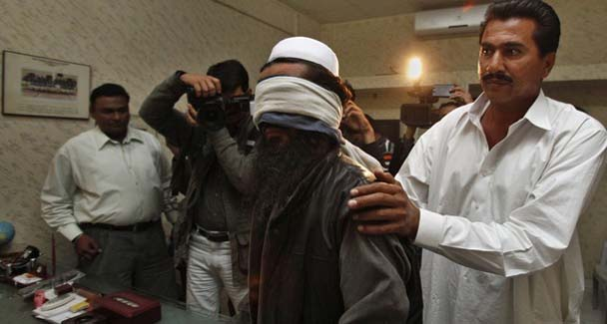
A Policeman in plain cloth showcase a handcuffed and blindfolded suspected militant to the media in Karachi.—Reuters
There has been a definite shift in Pakistan’s counterterrorism policy. And once again Pakistanis are the last to know. The disclaimers issuing from Islamabad since the arrest of Afghan Taliban commander Mullah Baradar have reached new highs of dissimulation.
Rather than continue to stoke the suspicions of the polity, the Pakistan government should make its policy towards the Taliban — both Pakistani and Afghan — transparent.
Baradar’s arrest, followed by the capture of other Al Qaeda-linked militants, indicates that Islamabad has decided to crack down on Afghan militants on Pakistani soil. The arrests have been seen as evidence of close cooperation between Pakistani and American intelligence agencies. Soon after Baradar’s arrest, White House spokesman Robert Gibbs hailed the increased cooperation between the ISI and CIA.
That’s when the doublespeak began. Interior Minister Rehman Malik termed the news of Baradar’s arrest — reportedly the result of an ISI-CIA joint operation — as ‘propaganda’. Foreign Minister Shah Mehmood Qureshi stated that Pakistani authorities had made the arrests “because it is in our interests to do so”. And US special envoy Richard Holbrooke denied that the arrests had anything to do with America’s recently revamped Afghanistan policy.
Such statements are proliferating because there are many theories about why Pakistan has decided to pursue the Afghan Taliban: the arrests are quid pro quo for US drone strikes that killed Baitullah — and Hakeemullah — Mehsud; the arrests are a small measure to appease the US while Pakistan keeps up its double game; the arrests are meant to decrease the trust deficit between Islamabad and Washington, so that Pakistan is invited to mediate in any future negotiations between the US, the Afghan government and the Taliban.
Some analysts have also suggested that Baradar’s arrest is an attempt to force Pakistan’s place at the negotiating table, for one of two reasons. Firstly, Baradar is reported to have tried to disassociate the Afghan Taliban from Pakistani intelligence — by removing him from the playing field, our authorities are hoping to stay in the game. Alternatively, since Baradar is now in Pakistani custody, any engagement with him has to necessarily include Pakistan, thereby reinstating our government in its historic role as mediator.
The various motives assigned to Pakistan for taking on the Afghan Taliban all point to the same endgame: Islamabad wants to retain influence over the government in Kabul. Not only does the Pakistan Army continue to think Afghanistan is essential for purposes of ‘strategic depth’, there are also concerns about the expanding Indian presence. Moreover, Islamabad needs to maintain close ties with Kabul to manage aspirations for a ‘Greater Afghanistan’, which would envelop Pakistan’s Pushto-speaking population as well.
In a sense, then, Pakistan’s ultimate goals for the region are clearly laid out. But our government has to be more transparent about the means it is employing to achieve that end. Is the plan to cooperate with the US so that Washington urges Kabul to reach out to Islamabad? Or is the idea to become the first point of contact between the Taliban and the rest of the world so that in the event the Taliban rejoin Afghanistan’s political process Islamabad is already established as an ally?
In Pakistan’s case, the answer lies somewhere between these two scenarios. Indeed, our authorities’ preparations for all possible outcomes of the US-led war against terror in Afghanistan are widely acknowledged. But as this balancing act ensues, Pakistanis must be kept in the loop. The fact is, we now risk a situation in which our government is well ingratiated with Washington and Kabul, but has lost all credibility in the eyes of its own public.
For months now, Pakistan has been acting coy about the extent of its cooperation with US intelligence, even though all signs of a growing partnership are evident. Despite the fact that Gen Ashfaq Kayani described the Waziristans as an ‘intelligence black hole’, 2010 has seen a dramatic escalation in US drone attacks. Many of these have been successful in targeting high-value militants.
In recent weeks, Pakistani and US officials have been more open about the fact that Pakistani military and intelligence are feeding targeting information to US intelligence. Certain people in the government have said that operatives from private US security firms are present in Pakistan. These revelations have fuelled anti-Americanism. However, Pakistanis have also been angered because they believe that their government is answerable, first and foremost, to the public at large. In this context, the policy shift towards the Afghan Taliban could spur the public’s mistrust of the government.
Since the crackdown against the Afghan Taliban also involves arrests, detentions and interrogations, it is essential that the authorities come clean about their plans for dealing with suspected foreign terrorists. Currently, Pakistan is leading Baradar’s interrogation, with some American involvement. Malik, meanwhile, has stated that Baradar will not be handed over to the US; rather, he could be deported to Afghanistan. If he is accused of wrongdoing in Pakistan, however, Baradar will be tried locally. The Pakistani state is already burdened with the legacy of Gen Pervez Musharraf’s decision to run secret prisons for terror suspects and enable extraordinary rendition.
Over the years, the missing persons issue has torn the country apart and will remain a stain on Pakistan’s human rights record. The recent outcry against Dr Aafia Siddiqui’s verdict is a reminder that this issue has hit a raw nerve in Pakistan, and Pakistanis do not want their government participating in more machinations involving interrogations, terror suspects and the US.
In other words, the issue of joint operations and intelligence-sharing between Pakistani and American agencies may seem like a foreign policy issue. But the fallout of Pakistan’s counterterrorism strategy will be distinctly local — nothing less than the government’s credibility with its own people is at stake.

