Let the talks continue
By I.A. Rehman
Thursday, 11 Feb, 2010
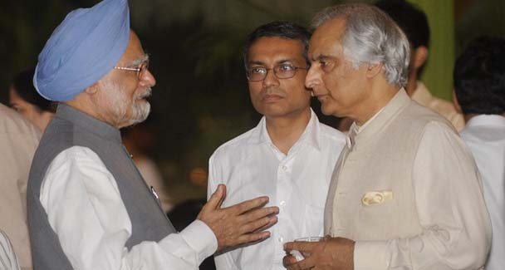
Pakistan Ambassador to India Shahid Malik talks with Indian Prime Minister Manmohan Singhan.—File photo
The Indian offer to resume bilateral talks and Pakistan’s positive response deserve the support of all peace-loving people on both sides of the border, even though the objective of the meeting between the foreign secretaries is primarily “feeling the pulse”.
No one should be surprised at the attempts in both camps to hedge their bets. India has tried to say that its offer for talks does not mean a resumption of the composite dialogue that was suspended over a year ago. Pakistan has argued that the talks this month should at least be a step towards revival of the disrupted dialogue.
At the same time Prime Minister Gilani has said that New Delhi has been goaded into making the present gesture by external actors, implying India’s incapacity for a rational move on its own.

These are plainly crude attempts at placating hawkish elements on both sides, that have been nourished at state expense for decades.
It should not be difficult to realise the importance of India-Pakistan talks even if they are confined to exploring possibilities of cooperation in the fight against terrorism. An understanding in this area is in the supreme interest of both countries.
A proposal floated in some quarters envisages a strategic understanding between the intelligence agencies of the two countries or at least the revival of the framework for contacts they had once maintained.

The merit of the move is obvious as no Indo-Pakistan cooperation to fight the common enemy (that terrorism is) will be fruitful if it is not backed by the intelligence agencies.
However, realism demands acceptance of the limits to the officials’ capacity to achieve peace. They cannot answer their governments’ fears of a backlash from confrontationist lobbies if they are seen to be deviating from their traditional policies. This dilemma cannot be resolved without meaningful intervention by civil society in each country.
Fortunately, peace constituencies exist in both countries, however small they may appear to the media and officials. There are many people in India and Pakistan who have consistently raised their voice in favour of peace and amity on the subcontinent.

A recent example is that of a former intelligence official, V. Balachandran, a former special secretary to the Indian government, who was a member of the two-man committee set up by the Maharashtra government to probe the police response to the Mumbai terrorist attacks.
In a presentation made at a civil society meeting on India-Pakistan peace strategies, Balachandran reproduced excerpts from a paper he had written in 2004 in which he had argued that the powerbrokers in Pakistan did not stand to gain by peace and that it was a large part of the population that suffered due to strained relations.

He had pleaded for more and more ‘people to people’ contacts among journalists, sportspersons, artists, writers, lawyers, human rights activists, film stars, traders, etc. Further, India had a duty, he had said, to give credible assurances to all sections of Pakistani society that it did not want Pakistan to break up.
Writing in January 2010 Balachandran said the Mumbai attacks of November 2008 did not change the situation. “The Indian public was convinced that ordinary Pakistanis were not involved in these attacks.

They do believe that the Pakistan government should put down such criminal acts. There is reason for this since innocent Pakistani public as well as government establishments are being targeted just as they are spreading their activities into India … Any Indian unilateral measure against Pakistan will only hurt a segment of the peace-loving Pakistani population which is not desirable for long-lasting peace.

It will also hurt India. I stand by my views in my note of 2004 and feel that only a sustained Indo-Pakistan dialogue will contribute to South Asian peace. It will also help in marginalising jihadi and fundamentalist elements who are supporting each other in both countries and elsewhere.”
Well-meaning individuals apart, quite a few groups have been working on confidence-building measures. Substantial progress towards the resolution of differences between the subcontinental neighbours was claimed for the back-channel diplomacy started in the wake of the Nawaz Sharif–Atal Behari Vajpayee understanding.
The spokesmen of the Musharraf regime also claim they had almost reached a settlement with India. A similar effort was supposed to have been made when Islamabad nominated a former foreign secretary to take the place of the late Niaz A. Naek. But these are in reality official initiatives and suffer from a serious flaw in that the people are not taken along.
For the same reason the joint deliberations of experts — retired diplomats, bureaucrats and academics — can have limited success despite the fact that decision-makers on both sides may be more receptive to the counsel of “people from amongst us” than they are to entreaties by ordinary citizens.
At another level one finds groups and individuals who avoid contentious issues and concentrate on social and cultural exchanges between the people of India and Pakistan.

They tend to believe that peace can be established without resolving the disagreements between the two countries or without creating each country’s stakes in the progress and prosperity of the other country.
Such groups can surely create space for mutual goodwill and they can bring the hostility level down — no mean achievement. But they cannot by themselves guarantee durable peace. Besides, what they achieve in months can be undone in a day by a gang of terrorists.
What is needed today is a blend of peace-preaching and people’s direct contribution to tackling, in a fair and just manner, all the issues that have led to endless confrontation between the two closest neighbours.
In other words, those deliberating behind closed doors need to associate ordinary citizens with their work and those singing peace songs in open fields should shed their inhibitions about talking politics.

Peace will not be achieved by pushing matters under the carpet, for this ideal the people will have to sustain a strong movement that will give the political authorities the courage to take the essential steps they are at the moment afraid of taking.

