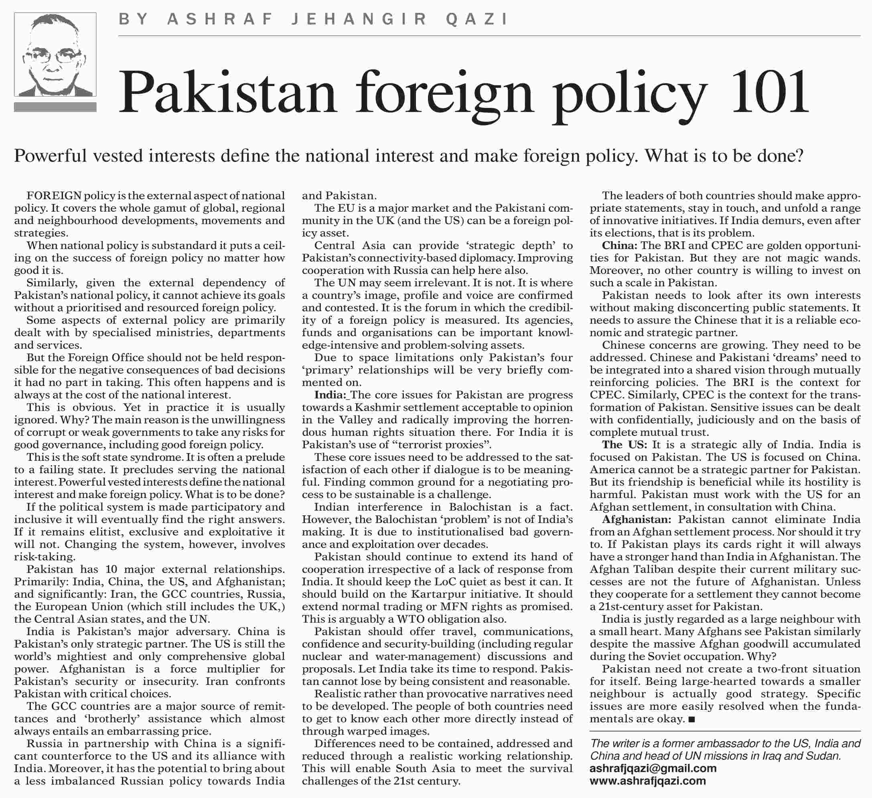
[TOP]

More from this page
- PMRA: senseless and dangerous
- Labour abuse
- Basant U-turn
- A horrifying scenario

