Atmosphere of mistrust
By Kuldip Nayar
Friday, 05 Mar, 2010
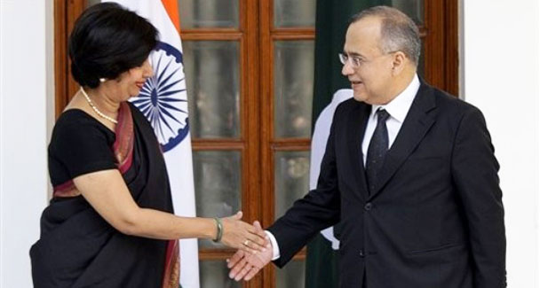
Indians and Pakistanis are the best of friends when they are not talking at each other.
It is unfortunate that Minister of State for External Affairs Shashi Tharoor hijacked a successful trip by Prime Minister Manmohan Singh to Riyadh.
Tharoor’s remark that Saudi Arabia could be an interlocutor for talks between New Delhi and Islamabad was embarrassing.
Tharoor may be indiscreet but I suspect that somehow, he got the impression that the prime minister would go along with him. True, an interlocutor is not a mediator. But he participates in talks.
Tharoor’s observation did not work due to a strong reaction against it in the country. India’s enunciated policy after the Simla conference in 1972 has been to talk to Pakistan, without involving a third party. Has there been some rethinking? Whatever the import of Tharoor’s observation, it gives oxygen to the dead dialogue between the foreign secretaries of India and Pakistan.
Islamabad’s reaction to Tharoor’s remark was on expected lines: it was ready for talks without conditions. This throws light on the talks held last week in Delhi. No doubt, Foreign Secretary Nirupama Rao made it clear to her Pakistani counterpart Salman Bashir that the talks would be confined to terrorism. But Salman Bashir touched all points, including Kashmir and water, although not at great length. Yet the whole dialogue was cursory.
The talks must have been a formality because a few hours later I found both foreign secretaries sitting separately, engaged in an animated discussion, at the Pakistan House in Delhi for dinner. There was no recrimination, no rhetoric, no raising of voices. They talked about confidence-building measures and conciliation.
This is how the two sides behave when they are relaxed and when they have no agenda to sell, no government message to convey. In fact, Indians and Pakistanis are the best of friends when they are not talking at each other.
However, the talks show that both countries are prisoners of mistrust and hostility. The reason why the two remain distant lies in their inability to overcome the prejudice they have nourished against each other for decades. The two foreign secretaries did not know what their political masters were contemplating. Still, had they fixed a date for the next meeting in Islamabad, people on both sides would have taken a positive view of the talks?
How far Salman Bashir could go was known to him because before arriving in Delhi he had met the high-ups. Bashir was surprised by India’s allegation of involvement of Pakistani army officials in the Mumbai carnage as was Nirupama Rao by the charge that New Delhi was involved in Balochistan.
The arrest of Hafiz Saeed, the Jamaatud Dawa chief, is New Delhi’s criterion to judge Pakistan’s sincerity in fighting the terrorists who are reportedly operating in India. New Delhi concedes that the law courts in Pakistan are independent but wonders why he is free to threaten war against a neighbouring country.
What may have made the otherwise suave and soft-spoken Salman Bashir lose his cool was the strong message that national security adviser Shiv Shankar Menon gave him. Menon reportedly did not mince his words in accusing Pakistan of sending terrorists to India as part of Islamabad’s state policy. He repeated many a time that he was the prime minister’s adviser.
Since the meeting with Menon was before the press conference, Salman Bashir did not maintain the equanimity which he showed during talks with Nirupama Rao. Phrases like ‘don’t lecture us’ were probably meant for Menon. Yet his observation that India’s dossier against Saeed was ‘literature’ was indiscreet. The Pakistani foreign secretary was quiet when he met the national security adviser. Was Menon conveying New Delhi’s thoughts? I have my doubts because Prime Minister Manmohan Singh is considered a dove. He reiterated in Riyadh that he was willing to go the extra mile to make up with Pakistan.
Since Manmohan Singh’s government is increasingly on the defensive because of the inflation, I do not think that it is in a position to take bold initiatives on Pakistan. The opposition, led by the Bharatiya Janata Party, has created an atmosphere where it is difficult for New Delhi to depart from the status quo. This should not surprise either Islamabad which is prepared for a long haul or Washington which is more focused on Kabul and Islamabad than New Delhi.
The silver lining was Prime Minister Singh’s reiteration that there was no option other than talks and that the two countries must come to an agreement to live like good neighbours. In the years since independence, both countries have gone down the same path, knowing that it leads to nowhere. Maybe both have no fresh ideas. Maybe both have come to accept their inability to solve the problems which confront them.
Perhaps civil society on both sides can help. Some persons who have been working on the improvement of relations between India and Pakistan for years can meet to see if they have some new ideas on which they agree. The proposals made by them may change the situation which remains frozen.
The governments on both sides would find it difficult to reject the suggestions if they have unanimous backing. Ultimately, the pressure of the public on both sides will make the governments relent. Are ordinary people committed to rapprochement between India and Pakistan and ready to go through fire and water to prove their credentials?

