Anger sans reason
By I.A. Rehman
Thursday, 28 Jan, 2010
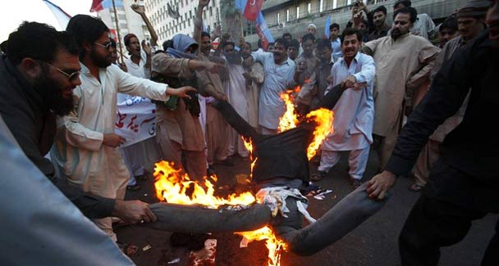
Protesters shout slogans and burn an effigy of Lalit Modi, the chairman of the Indian Premier League (IPL), in Karachi. India and Pakistan are trading diplomatic barbs over cricket in the latest setback to efforts to improve relations between the two nuclear rivals, who have had strained ties since the 2008 Mumbai attacks.
One wonders as to how long it will take India and Pakistan to start regretting their part in the affair of the so-called Indian Premier League’s snub to Pakistani cricketers, for neither party can claim to have reason on its side.
While discussing the IPL’s, or more correctly its bidders’, treatment of Pakistan’s T20 celebrities, no attention has been paid to its greater disservice to sports — turning cricketers into self-seeking mercenaries whose services are available to the highest bidder in a public auction. The need to weigh the IPL scheme’s impact on values sportspersons have upheld for ages should not have been ignored.
Like players in other team sports, such as soccer, hockey or rugby, cricketers have traditionally played for their teams. Even when they play for their countries, as members of outfits selected by their national authorities, their foremost loyalty is to the team.
Loyalty to the team obviously takes precedence over a player’s allegiance to his country when he/she joins a group of players from other countries, like Indians or South Africans who played in Tests for England.
There have also been teams comprising players from more than one country, such as the Commonwealth cricket teams that toured Pakistan in the 1950s or the Kerry Packer Circus that came up later on, or the dream teams that are put together after major cricketing events. In all such cases players are expected to keep the team’s standard high. Anyone who deviates from this rule is blamed for lacking in esprit de corps.
In the IPL scheme the players are barely attached to the team, though they do try to attract the attention of the financiers, and are wholly concerned with their success in earning fat fees. One of the foremost ideals of sportspersons is thus lost in a wild scramble for lucre. In simpler words this means putting a premium on selfishness and commerce at the cost of sports.
Further, the system of sale and purchase of players at an open auction, as if they are slaves or sacks of sawdust, should repel anyone who takes his/her sport as a dignified, almost sacred, undertaking. Players do enter into contracts with clubs and promoters through confidential negotiations and those receiving more than one offer do weigh their choices (not necessarily on the basis of the amount of remuneration alone) before any deal is clinched and made public. But the way the IPL auction takes place is incompatible with the sense of pride with which every sportsperson must approach his calling. The disappointment of those who fail to find their buyers thus carries an element of shame at having put themselves up for auction.
The Pakistani players ignored at the auction were justified in feeling humiliated because they were obviously not judged on merit. A quiet withdrawal should have been a proper option — in the case of Pakistan’s official and non-official meddlers too. Instead they were keen to turn the slight caused to some commercial-minded players into a matter of national disgrace.
The retaliatory measures announced by them — cancellation of the visit to India by parliamentarians and the election commissioner and calls to boycott all sports events scheduled to be held in India — made little sense. All such decisions normally advance a demand till the fulfillment of which the protest is supposed to continue. What do the angry Pakistanis want IPL or India to do to satisfy their bruised ego? They cannot be unaware of the fact that the disruption of sports ties with India, or ties in any other area, cannot be sustained forever. The Indians, too, are learning this all over again.
The response from the other side also betrayed lack of reason. The statement that the Government of India was not responsible for the actions of a private establishment did not add to anybody’s knowledge. What it disclosed was an element of insensitivity to the cause of India-Pakistan détente that was under threat. A word of sympathy for the Pakistani cricketers and a promise to probe the matter could have defused the situation.
That the matter did warrant a probe is obvious. While ignoring the Pakistani players the bidders at the auction undoubtedly disregarded their commercial interests. What made them do that? Two reasons have been mentioned — security concerns and uncertainty about the Pakistani players’ success in reaching the stadia. Did the bidders realise these problems on their own or were these hurdles suggested to them by some persons in or close to authority? That is something the Indian home minister may try to find out, now that he has recognised the potential (or shall we say market value) of the Pakistani cricketers on display.
The attitude of the IPL speculators is hard to understand because other commercial elements are trying to make huge profits from India-Pakistan joint variety shows.
However, what should be a matter of special concern to all people of goodwill is that the hiatus in relations between the two governments is widening the gulf between the people of India and Pakistan. Until some time ago, men and women devoted to culture, the arts, literature and sports on both sides could stay aloof from inter-governmental squabbles; but now the subcontinent seems to have taken a big leap backward. A decline in the prospects of promoting India-Pakistan understanding on peace and cooperation between them through cultural exchanges and sports moots will harm both sides.
Cooperation between India and Pakistan was always necessary in the interest of the people of the two countries, but this need has never been as pressing as now. If earnest efforts to revive normal relations between them are not mounted soon the demons of hate and hostility will push them further away from each other and incidents like the IPL affair will continue to poison the minds of new generations.
An immediate objective before New Delhi and Islamabad should be the reactivation of the hotline between their top leaderships. They can have better success in damage control than the bureaucrats who mostly specialise in stoking up bitterness without reason.

