A win-win situation
By Iqbal Ahmad Khan
Sunday, 14 Feb, 2010
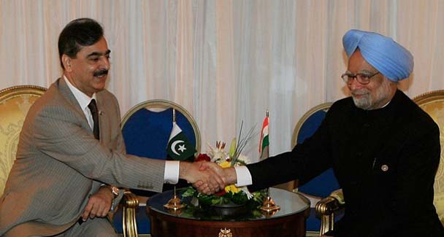
For Pakistan and India, failure to overcome the challenges is no longer an option.
Amdist the recent death and destruction that has ricocheted throughout Pakistan, the imminent resumption of dialogue between Pakistan and India represents a silver lining in the cloud.
It has rekindled hope among the many sane persons who fervently desire peace and prosperity in the region. They belong neither to the lunatic fringe hell-bent on liquidating their adversary nor to sceptics who believe, contrary to historical evidence, in the inevitable futility of dialogue between the two mutually suspicious neighbours.
In certain Pakistani circles the Indian proposal for resumption of the dialogue has been hailed as vindication of Pakistan’s position that India ought not to have suspended the composite dialogue no matter what the provocation.

Pakistan’s diplomacy, the argument goes, was able to skilfully channel international concerns in persuading India to resume talks in order to mollify Pakistan’s anxieties in relation to its eastern frontier.
The approach suited the US and its western allies desirous of a greater Pakistani focus on the war on terror.

Additionally, the decision at the London conference to talk to the Taliban, reintegrate them into Afghan society and rejection of the idea of making India part of a regional framework entrusted with bringing peace and security to Afghanistan were considered as Pakistan’s diplomatic successes.

These developments are believed to have produced concerns in India regarding gains painstakingly acquired in post 9/11 Afghanistan.
This, to a certain extent, may be true. It would, however, be unwise and not statesmanlike to trumpet Pakistan’s gain as India’s loss.

This is not a zero-sum game. Both Pakistan and India, and the vast South Asian region, are likely to profit from the revival of wide-ranging and meaningful talks between the two major regional players. Pakistan should learn lessons from history, not history as we wish it to be, but history as it is.
Pakistan’s confrontation with India — 1965, 1971 and Kargil — brought about in chronological order economic decline, territorial disintegration and international rebuke. Internally, it gave rise to militarism and militarisation and the demise of democracy. It is obvious we have paid a very heavy price in confronting India and have nothing to show for it.
On the other side, India would find it difficult to realise its full potential in the global arena, if it is unable to mend fences with its principal neighbour.
As for coveting the prestigious permanent seat in the UN Security Council, its continued intransigence in implementing the resolutions of the Security Council on Kashmir will continue to pose a major impediment.

If there still are people in leadership positions in India who believe that they can extinguish the azadi flame burning in the hearts of Kashmiris or can brush the dispute under the carpet, they too like Pakistan need to learn from history.

Pakistan on its part must take a fresh look at what exactly Kashmiris have in mind when they clamour for azadi.
Potentially, Pakistan can profit immensely from the talks and should, therefore, pursue it resolutely, skilfully and imaginatively. The agenda for the talks, its shape and direction should be determined by the elected representatives of the people of Pakistan.
The Foreign Office should be the focal point in Pakistan and the principal coordinator and implementer. Any attempt to sidetrack the Foreign Office could at the very least lead to embarrassment and at its worst to serious diplomatic setbacks, just as any attempt to deviate from the policy and strategy of the democratic government by any institution or agency could undermine the country’s vital national interests.
Former Foreign Minister Sartaj Aziz in his impressive book Between Dreams and Realities has drawn attention to the negative impact of the Kargil operation on the India-Pakistan peace process following Prime Minister Vajpayee’s landmark visit to Lahore.

Mr Aziz contends that the Kargil operation caused irreparable damage to Pakistan’s principled and legitimate stand on Kashmir in the international arena. It is also imperative that the government take extraordinary care to ensure that non-state actors do not succeed in scuttling the talks.

The role of the intelligence agencies would be critical. Regrettably, so far they have not been able to crown themselves with glory.
Pakistan, contrary to popular belief, has more in common with India than any other country in the world. This is true of our geography, history, language, culture, laws and customs.

Equally true, the numerous affinities that exist between Pakistan and India are matched by the many problems that confront the two countries.
Inherited territorial and maritime disputes combine with conflicting foreign policy and national security goals and an underlying mistrust and suspicion to pose major challenges for the leadership and peoples of the two countries.

Thus far both have failed to overcome the challenges. No longer, however, is failure an option. Fortunately, the revival of the dialogue has created a win-win situation.
The present government is committed to the resolution of all outstanding issues and disputes with India through dialogue and negotiations.

The party has to its credit one of the finest accomplishments of Pakistan’s diplomacy, the Shimla Accord. It has brought about a distinct improvement in Pakistan’s relations with its western neighbour, Afghanistan.
The international community has acknowledged the crucial role that Pakistan can play in restoring peace and security within Afghanistan. A great opportunity presents itself for the establishment of peace and stability on the country’s eastern and western borders. Pakistan simply cannot afford to fritter it away.

At this delicate juncture hare-brained ideas of strategic depth and coercive diplomacy should be farthest from our minds. The government is in an unenviable position given the monumental problems it has both inherited and created for itself internally.

It should focus at the strategic picture, cut down its liabilities and establish realistic priorities. Peace with India and within Afghanistan should be at the top.

