A small victory
By Shahid Javed Burki
Tuesday, 09 Feb, 2010
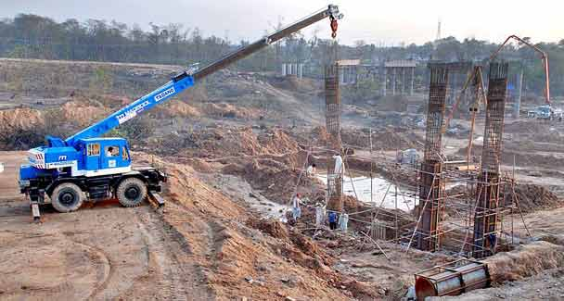
It is important for Pakistan to launch a massive programme for the development os terror hit areas such as Malakand division and South Waziristan in order to ensure that the people there remain loyal to the Pakistani state.
THE recent conference in London to chart the future course for Afghanistan produced a small victory for Pakistan. Islamabad had insisted for many years that a long-term, stable solution to the 30-year-old Afghan problem could only be found if some of those identifying themselves with the Taliban movement were accommodated within the governing structure.
This position was first advanced by Gen Pervez Musharraf and followed by the present government. The Americans, however, would not have anything to do with anybody who went under the banner of the Taliban movement. But then an interesting thing happened. The Taliban emerged as different groups, each with its own agenda.
At least three major Taliban groups emerged. The first was the group headed by Mullah Omar who had led the government the Taliban had formed in Kabul in the mid-1990s. It is widely believed that this group was led by leaders of the ‘Quetta shura’ whose main goal is said to be to bring Afghanistan under the control of the Taliban. That could happen only if the Americans were made to leave Afghanistan. The bulk of support for this group came from the many local commanders involved in various insurgencies in Afghanistan.
The second group was led initially by Jalaluddin Haqqani and is now under the control of his son Sirajuddin. The older Haqqani had been helped by the Americans, the Saudis and the Pakistanis to fight the Soviet occupation of Afghanistan. Having achieved that objective they were unable to work together to govern the liberated country, paving the way for the Taliban regime.
When the Americans moved into Afghanistan in late 2001 and pushed the Taliban out of Kabul, the Haqqani group shifted to Pakistan’s North Waziristan. It has remained there, supporting the insurgents in the areas adjoining their sanctuary in Pakistan. Since the senior Haqqani had served in Mullah Omar’s government his Taliban movement retained some contacts with the Quetta shura. But the linkages are believed not to be strong.
The third group had little to do with the insurgency in Afghanistan but wanted to bring about change in Pakistan. It was formed out of several small tribal groups and was given the name of Tehrik-i-Taliban Pakistan (TTP). Initially led by Baitullah Mehsud who was killed last year in a drone attack, the TTP quickly expanded its reach.
Last summer its affiliate in Swat took over the district and advanced into Buner. They were only a short distance away from Islamabad. It was then that the army moved to reclaim the areas, carrying out a successful operation. It followed it up with an equally successful operation in South Waziristan. Recently, newspapers carried the story that Hakimullah Mehsud, Baitullah’s successor, had died of injuries sustained in a drone attack sometime earlier.
While Pakistan drew a sharp distinction between these three groups, the Americans were of the view that all of them had to be treated the same way. They were pleased with Pakistan’s move against the TTP in Swat, Buner and South Waziristan but were unhappy that Islamabad was not anxious to go into North Waziristan against the Haqqani group or to hit the Quetta shura.
Neither of the two groups had launched attacks against Pakistan while the TTP was involved in many terrorist activities that had killed hundreds of people in various parts of Pakistan. Also, Islamabad, worried about the political vacuum that might occur once the Americans and Nato forces began the promised withdrawal from Afghanistan. It wanted a situation where it could depend on these two groups of Taliban to help establish a regime in Kabul that would be friendlier towards it than the one headed by President Hamid Karzai.
What motivated the Afghan president to dispense with his enduring antipathy towards the Taliban movement to hold out an olive branch to some of them in London?
In fact, Karzai and his associates went to London to get the support of the countries assembled there to help him win over those in the Taliban movement who were its foot soldiers for economic reasons and not out of ideological compulsions. His finance minister asked for assistance amounting to $1.2bn, with $200m dispersed immediately so that employment opportunities could be created for these people. The regime held out the assurance that this money would not be used to bribe the Taliban but for promoting development.
This, in fact, is a recognition by Karzai that an important reason for his mounting troubles was of the poor governance of Pakhtun areas, most of which border Pakistan. The president was also thinking of the time when the Americans would not be present in large numbers to prop up his administration. The time had come for him to bring under his tent those Pakhtuns who were prepared to work with him.
While the outcome of the London conference vindicates Pakistan’s long-held position, it also points to the importance of focusing on economic development as a way of countering insurgency. It is important for Pakistan to launch a massive programme for the development initially of Malakand division and South Waziristan — two areas where the army has scored impressive successes — in order to ensure that the people there remain loyal to the Pakistani state.
A well-articulated programme of economic development will have the support of the West and should not impose a heavy financial burden on Islamabad. This is a good time to start work on it.

