A role for China
By Huma Yusuf
Sunday, 24 Jan, 2010
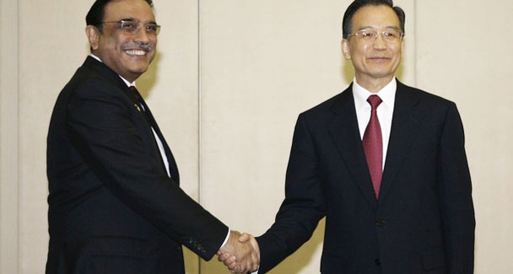
China's Premier Wen Jiabao (R) shakes hands with President Asif Ali Zardari. Having China on board would give Pakistan the confidence that a long-time ally with a transparent regional agenda is looking out for Islamabad’s interests. – Photo by Reuters.
Although think tanks in the United States are working overtime to solve the Pakistan ‘problem’, their final reports are drawing rather obvious conclusions: choking terror funding and promoting economic development. However, a new think tank report suggesting that the US and China put the stabilisation of Pakistan on top of their bilateral agenda raises an interesting prospect for combating regional terrorism.
Indeed, Chinese involvement in the war against terror could be productive, especially given the tenor of US Defence Secretary Robert Gates’s recent visit to Pakistan.
The policy paper US-China Relations: Seeking Strategic Convergence in Pakistan was published by the Brookings Institution earlier this month. Its authors, Bruce Riedel and Pavneet Singh, argue that Pakistan’s displeasure with Washington’s never-ending demands and oscillating foreign policy will make it difficult for the US government to help Islamabad manage the Taliban insurgency without international cooperation.
The report also points out that China has much at stake in Pakistan, and should be interested in staving off a collapse of its state institutions. After all, Beijing has invested billions in highways, ports and pipes here that are meant to serve China’s economic, energy and security needs. Moreover, the recent unrest among Muslim Uighurs in the Xinjiang province has also intensified concerns that the spread of militancy in Pakistan could contribute to a destabilised Chinese mainland.
Riedel and Singh recommend that Islamabad, Washington and Beijing join hands to tackle the Taliban threat, since each has a strong interest in “sustaining a stable Pakistan”. In the context of an expanded bilateral agenda — with the US and China coming together on issues such as economic growth, denuclearisation in North Korea and Iran and climate change — identifying security goals for South Asia could emerge as a point of agreement between the two competing powers and help set the tone for future cooperation on other challenges.
At first, the suggestion that Washington and Beijing work closely to strengthen governance in Pakistan reeks of arrogance — another case of great powers setting the agenda and dictating terms to developing nations. But there is also something to be said about the benefits to Pakistan of such an arrangement.
Much has been written about China’s shifting attitude towards Pakistan. In recent years, Beijing has made it clear that it will not single-handedly bankroll this country, get involved in a Pakistan-India conflict, or tolerate any spill-over effects of militancy. Moreover, as Beijing and New Delhi’s energy and economic interests converge on the world stage, the two countries are becoming strategic partners (even if suspicions and border disputes remain). This development is bound to further influence Sino-Pakistan relations.
In its period of ‘harmonious development’, China has also shown a willingness to become politically involved with multilateral organisations working towards peacekeeping, trade agreements and regional security. Islamabad must stay attuned to Beijing’s changing foreign policy means and goals, and a trilateral effort towards addressing a global problem such as terrorism will help keep our government in the loop and maintain strong Sino-Pakistan ties.
Moreover, if the US and China work together on a counter-terrorism strategy for Pakistan, Islamabad — and the Pakistani public at large — will feel more confident that America’s main interests here are to stabilise the country, rather than something more nefarious.
In recent months, the US has been accused of threatening national sovereignty, aiming to exploit natural resources in Balochistan, trying to seize Pakistan’s nuclear weapons, establishing military bases, breaking up the country and promoting India’s regional interests — in other words, everything except dealing with the global phenomenon of terrorism. Gates’s trip — his perceived (perhaps mistakenly) support for Indian military action against Pakistan and the confirmation of the presence of Blackwater and DynCorp — is likely to heighten suspicions about US motives in this region.
In this context, Chinese involvement can help allay Pakistani suspicions and bridge the trust deficit that is growing between Islamabad and Washington. After all, the US and China have competing interests in Pakistan and clashing ambitions for regional dominance. Beijing will not let the US serve its own ends at the expense of the Pakistani state, its people and China’s plans for using this country as an energy and economic corridor.
The involvement of a third stakeholder will also result in more transparency regarding Islamabad’s counter-terrorism strategy. Our inconsistent and non-visionary approach towards dealing with home-grown militancy coupled with soaring anti-Americanism has led to much dissimulation about drone attacks and the presence of private US security companies in Pakistan.
Making both Islamabad and Washington answerable to Beijing would force all parties involved to articulate their end goals regarding terrorism as well as announce proposed means to fight militancy. In turn, this transparency would give Pakistanis a clearer sense of how — and therefore greater input into the ways in which — the war against terror is being fought on their soil.
Of course, if the US is going to find a regional partner to help stem terrorism here, it should be India. For Pakistan to fully commit to a prolonged military and socio-political fight against militancy, the Kashmir issue has to be resolved and the threat of military action along the eastern border eradicated. For the moment — in the wake of the US-India civilian nuclear deal and given India’s developmental ambitions in Afghanistan — a US-India partnership would be too suspect. But to set the stage for an Indian role in a regional counter-terrorism strategy, Beijing’s involvement is essential.
Having China on board would give Pakistan the confidence that a long-time ally with a transparent regional agenda is looking out for Islamabad’s interests. The different powers — the US, China and, at some stage, India — would also serve as checks on one another, preventing any one from pushing through its agenda for the region.
Knowing that this balance has been struck could leave Pakistan free from concerns about infringed sovereignty and balkanisation and give Islamabad space to focus on putting its house in order and dealing with the threat within.

