A challenging doctrine
By Javed Hussain
Monday, 08 Feb, 2010
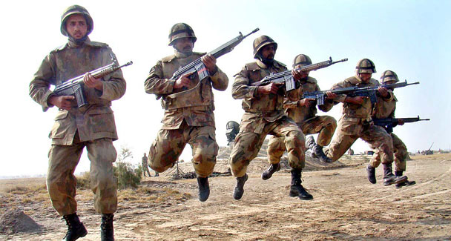
Cold Start will be a portent of escalation, and inevitably a disaster for Pakistan and India.

On Dec 13, 2001, five gunmen attacked the Indian parliament building. An hour later, 12 people including the gunmen were dead. In the days that followed, India blamed the militant groups based in Pakistan for the attack.
On Dec 18, 2001, the Indian government ordered the commencement of Operation Parakaram (Operation Victory), the largest mobilisation of Indian forces since 1971. It appeared that war was inevitable. Yet, after a 10-month standoff, Operation Parakaram was terminated. India had lost face.
The main reason why this happened was the time taken by the three strike corps to reach their wartime locations from central India. It took them three weeks during which time Pakistan was not only able to deploy its forces but also to internationalise the crisis.
Until 2004 the Indian army’s strategic thought envisaged the deployment of seven corps in defensive role and three corps in offensive role each built around an armoured division supported by mechanised infantry and artillery. After the defensive corps had blunted Pakistani attacks, the strike corps would undertake counter-offensive operations aimed at the destruction of the Pakistan Army’s two strategic reserves also built around an armoured division.
After Operation Parakaram the Indian army concluded that this doctrine was inflexible because of the huge size of the strike corps — they have long deployment times, are difficult to manoeuvre, while their concentration in the forward areas gives away the general strategic direction they would adopt. And above all, the doctrine inhibited a quick response to challenges posed by acts like the attack on the Indian parliament (and seven years later in Mumbai).
As a consequence, in 2004 the Indian army announced the development of a new limited war doctrine called Cold Start to respond to what it calls proxy wars by Pakistan. It would seek to inflict significant damage on the Pakistan Army before the international community could intervene on Pakistan’s behalf, while at the same time ensuring that the conflict did not escalate to a level where Pakistan was tempted to use nuclear weapons.
The essence of the Cold Start doctrine is reorganising the army’s offensive power that resides in the three strike corps into eight smaller division-sized integrated battle groups (IBGs) consisting of armour and mechanised infantry and artillery, closely supported by helicopter gunships, air force and airborne troops (parachute and heliborne). The IBGs are to be positioned close to the border so that three to five are launched into Pakistan along different axes within 72 to 96 hours from the time mobilisation is ordered.
Cold Start thus envisages rapid thrusts even when the defensive corps’ deployment is yet to be completed, and high-speed operations conducted day and night until the designated objectives are achieved.
In a war limited by time, mobility is the single-most important factor which if used to its full potential will help attain the political aim in the desired time and space framework. But this requires a perfect matching of the physical means of mobility with the mobility of the mind, as the value of a highly mobile force can be reduced to zero by commanders whose minds are characterised by lack of imagination, initiative and flexibility. “Adherence to dogmas has destroyed more armies and lost more battles and lives than any other cause in war. No man of fixed opinions can make a good general.” (J.F.C. Fuller)
In the 1965 war the Indian 1 Corps, spearheaded by the 1st Armoured Division, had penetrated seven miles only into Pakistani territory in Sialkot sector in 21 days, while in the 1971 war, the same corps having about eight tank units did marginally better by penetrating eight miles in 14 days, that too when opposed by light covering troops. In both wars the Indian army was schematic in its operations. Changes in dispositions such as forming a new defensive line, reassigning of objectives, switching forces not in accordance with their original plan, took time. Above all, their commanders at all levels lacked enterprise, imagination and initiative.
Given this, while Cold Start is a sound concept, though not original, the Indian war directors need to question the ability of their commanders at all levels to execute it efficiently and sustain the advantage gained from striking first. The “law of the initial advantage of the aggressor” assumes critical importance, as it is the aggressor who generally sets the pattern which operations will take. The Germans in the Second World War and the Israelis in the 1956 and 1967 wars had translated the concept of blitzkrieg, characterised by surprise, speed and concentration, with devastating results against numerically superior forces because they had a flair for conducting high-speed operations with flexibility, rapidity and less military routine.
The probable objective areas for Cold Start could be (1) Ravi-Chenab corridor from two directions, an IBG along Jammu-Sialkot-Daska axis and another across the Ravi to link up with the first IBG, and (2) in the south against Reti-Rahim Yar Khan-Kashmore complex. To counter Cold Start, the Pakistan Army will have to create more armour-dominated brigade-sized reserves from the existing resources if possible, and a more flexible military system and structure.
For Pakistan the dimensions of time and space assume paramount importance as it lacks territorial depth, is opposed by a larger adversary and lacks the resources to fight a protracted war. The strategy of pre-emption is thus imposed on Pakistan in the same way it was imposed on Israel prior to the 1967 war. The fact that the Pakistani Army can occupy their wartime locations earlier than the Indian army confers on it the ability to pre-empt Cold Start; failure to do so could lead to firing of low-yield tactical warheads at IBGs as they cross the start line or even earlier.
Cold Start would be a portent of escalation, and inevitably a disaster for both. It is a doctrine that challenges both countries.

