Militarism in retreat
By Ahmad Faruqui
Monday, 17 Aug, 2009 | 08:15 AM PST |
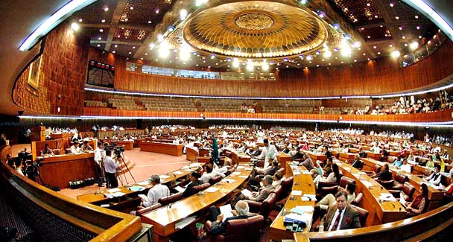
Parliament needs to weigh on the political crimes committed by Musharraf and decide whether or not to prosecute him. — Photo by APP

Provinces
Devolution of powers fraud, says Magsi

'Pakistan ka Khuda Hafiz'

Pakistan and India have just celebrated 62 years of independence. Indeed, both countries have come a long way since the Ides of August in 1947 when the Union Jack was lowered on the British Raj.
But Pakistanis have one more reason to celebrate than their Indian siblings. After having been ruled by the military for half of their existence, they are once again a democracy. Indeed, with the recent judgment of the Supreme Court, they are observing the retreat of militarism.
Will this be a permanent retreat? No. Unless some structural changes are made in the body politic, it is quite possible that a future Bonaparte will move to suspend the constitution, fire the cabinet, dismiss parliament and rule implicitly or explicitly through the dint of arms.
That has been the example bequeathed to the nation by Generals Ayub, Yahya, Zia and Musharraf. Instead of coming to the aid of the civilian administration during times of crisis, they invoked the law of necessity to legitimise and perpetuate their rule. Once in power, they have worked to make the military the dominant institution in the country and to place senior retired officers in executive civilian postings. The net effect is that even when the military is not in power, its primacy goes by unchallenged in all walks of life.
What are the steps that have to be undertaken to make sure the scourge of militarism is excoriated? First and foremost, the military needs to stay focused on defending the country. The primary enemies facing the country are the proponents of religious extremism. Their power to disrupt normal developmental activities and to terrorise the population has grown in the last few years. The army needs to neutralise this threat by taking out the ringleaders and by liquidating their henchmen who are beyond negotiation.
Second, the military has to be held accountable for all its actions, like any other branch of government, to the people, as represented by parliament. It cannot be above the law.
Third, the military has to take orders from the civilian administration and not the other way around. It can advise the government on military matters. But it cannot make defence or foreign policy. That is the province of the elected rulers.
Fourthly, the military cannot view the rest of the country as a marketplace within which to place its retired officers and servicemen. They have to compete for those jobs like everyone else.
Fifthly and finally, the military has to re-examine its long standing animus against India. While Pakistan has been languishing in the backwater of history, plagued by the backlash engendered by the proxy war in Kashmir, India has grown by leaps and bounds.
The longer term threat to the national security of Pakistan arises from poverty, not from India. The Indian threat has been played up countless times to feed the ambitions of the military to grow its strength, to acquire sophisticated weaponry and to seize the commanding heights of the economy. It is time that the defence budget was scaled down to more realistic levels so that much needed funds can be freed up for creating more schools, colleges and hospitals.
This five-point plan will take time to accomplish. And its goals won’t be achieved by Supreme Court judgments or acts of parliament. Success will require the collective resolve of the people of Pakistan. They will have to openly and consistently speak out against military rule so that no future general will feel empowered to seize power in their name and hoodwink them into accepting the myth of his indispensability.
Towards that end, would it be useful to make an example of the last military dictator by putting him on trial? After all, he admitted he broke the law when he declared an emergency on Nov 3, 2007.
His rationale, that sometimes one has to cut off a limb in order to save the body, taken from a speech that Abraham Lincoln made during the American Civil War, was nothing but gratuitous. And it failed to stem the tide against him. He now lives in self-imposed exile in London, socialising and playing the tabla and giving speeches at $100,000 a pop. A leading official of the British government has pleaded to the Pakistani government that Musharraf should not be tried for treason, since that will distract from the war against the Taliban and create regional instability.
Not only is this blatant interference in the affairs of another sovereign country. It also reflects a double-standard.
When the war against the Irish Republican Army was at its peak, it is unlikely that anyone in Britain would have allowed the chief of the defence staff to suspend parliament, remove the cabinet and move into 10 Downing Street. Even during the height of the Second World War, when Hitler was threatening to annihilate Britain with V2 rockets, that did not happen. Nor did that happen when a Napoleonic crossing of the English Channel seemed imminent.
Much closer to home, not once has India experienced a coup. Indeed, the only time an emergency was declared, it was done so by an elected prime minister. And Indira Gandhi paid for it politically. Similarly, Israel has more than once faced an existential crisis but not once has it seen a coup.
The Supreme Court has declared Pervez Musharraf a ‘usurper’ because of the acts he carried out against the superior judiciary between March and December in 2007. It noted that prior to Nov 3, several military governments had violated the constitution and dismissed elected civilian governments. But what gave Musharraf’s action ‘a singular nature’ was that they only assaulted the judiciary because he was afraid that they would disallow his re-election.
Parliament needs to weigh on the political crimes committed by Musharraf and decide whether or not to prosecute him. It is not just Musharraf who they would be putting on trial. It would be the black art of militarism itself. What better way is there of ridding the country of that menace once and for all?
A concern has been raised that such a trial would be seen as an act of vendetta. To ward off that perception, if Musharraf is found guilty, he could simply be banished. For him, that would be punishment enough.

