Reversing history
By Ahmad Faruqui
Monday, 01 Feb, 2010
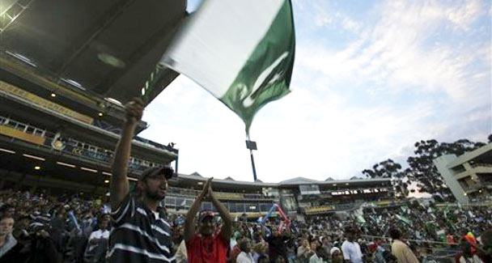
There is a Manichean split between those who believe that things will go from bad to worse in Pakistan and those who believe that history is about to reverse itself.
Leszek Kolakowski, the Polish-born Oxford philosopher who passed away last year, left behind a striking insight: “We learn history not in order to know how to behave or how to succeed, but to know who we are.” This is a message of tough love for countries such as Pakistan to whom history has not been kind.
Admittedly, Pakistan’s rulers are in good company. Like France’s Bourbons and Britain’s Windsors, they have “forgotten nothing and learned nothing”. But this serious cognitive weakness did not prevent France and Britain from attaining greatness. So there are grounds for hope.
But how much hope is warranted before the discussion crosses over into fantasy? There is a Manichean split between those who believe that things will go from bad to worse in Pakistan and those who believe that history is about to reverse itself.
Typical of the former viewpoint is a report that was published 10 years ago by the US National Intelligence Council. Dealing with the year 2015, it laid out a grim prognosis. That description for a future that is now just five years ahead was prescient in many respects:
“Pakistan will not recover easily from decades of political and economic mismanagement, divisive policies, lawlessness, corruption and ethnic friction. Nascent democratic reforms will produce little change in the face of opposition from an entrenched political elite and radical Islamic parties. Further domestic decline would benefit Islamic political activists, who may significantly increase their role in national politics and alter the makeup and cohesion of the military — once Pakistan’s most capable institution. In a climate of continuing domestic turmoil, the central government’s control probably will be reduced to the Punjabi heartland and the economic hub of Karachi.”
An even more dystopian scenario has been put forward recently by Ninand Seth, an Indian. By the year 2020, Seth says that Pakistan would have devolved into an Islamic Commonwealth. This would be a federation of Pakhtunistan (formed by the merger of the Frontier Province with Afghanistan), Balochistan, Sindh and Punjab. Life in the commonwealth would be characterised by the intrusion of religion in every aspect of life, political regimentation and austerity.
So what will it take for history to reverse itself? Other nations with bleak histories have shown that reversals are possible. Indonesia is the most recent example. Can Pakistan, acting on the Quaid’s motto of ‘unity, faith and discipline’, put together a sustained recovery that would put the purveyors of doom and gloom to shame?
It would seem that change will have to come from within. It cannot be imposed from without. Perhaps it will begin when a new leadership arrives that is able to drastically soften the temper of the political debate. The rancour, ill will and endless squabbling of the past six decades would end. So would the hankering for power between the political and military leaders.
In its place would come a team spirit driven to achieve the greatest good of the greatest number. A philosophy of give and take would be embraced by the major political actors. Those bad actors that don’t fall into line would be marginalised and their pernicious message of hatred and intolerance expunged from the polity and replaced with a message of love and respect for diversity.
The dispensation of executive authority would flow from the rule of law, not from the barrel of a gun or the power of mobs. The constitution would be inviolable. The so-called law of necessity would be seen finally for what it is — a travesty of justice and a prelude to military rule. It would be put to bed, once and for all. Governments would only be changed through the ballot box.
At the same time, there would be accountability for civilian rulers. No one would be above the law. National reconciliation would not be achieved by wiping the slate clean, for that simply provides an incentive for future corruption. Instead, a regimen of accountability would be instituted where those who have stolen public money would pay it back, like the MPs are doing so in the UK.
Internationally, Pakistan’s leaders would show boldness and creativity and arrive at a sustainable accommodation with India on Kashmir. This may well build from the formula that Musharraf had devised and which was being explored through serious backdoor diplomacy when the Mumbai terror attacks derailed it. The final solution may be as simple as both countries accepting the Line of Control as the international border and allowing Kashmiris on both sides to move freely across the line.
Once a stable accommodation has been reached with India, the jihadi machinery that had been set up to liberate Kashmir would be shut down. The search for physical depth in Afghanistan would end and be replaced by a mission to enrich the nation’s soul. This realignment of foreign and defence policies would allow the armed forces to be rationalised. The slogan ‘military first’ would be left to the likes of North Korea.
The search for increasingly more sophisticated weapons of mass destruction would be called off. Ultimately, ways would be found to extricate the armed forces from running businesses and returning the franchises to the private sector. The army would focus solely on its core mission — defending the borders.
On the economic front, Pakistan would finally hit its stride and demonstrate growth rates in the seven to eight per cent range, allowing per capita gross domestic product to rise by five to six per cent. Pakistan would become a middle-income country. People will wonder why it took so long to get there. The formulas for economic growth were well known. What was lacking was the will to implement them. Under a new leadership, these would finally be implemented.
The government’s Economic Survey pegs the current domestic savings and investment rates at 11.2 per cent and 19.7 per cent of gross domestic savings respectively. Through enlightened policies, these would hit 25 per cent. Additionally, to control budget deficits and put a cap on inflation, the tax base would be expanded to encompass agricultural income. And the mix of exports would be shifted from one dominated by raw materials to one dominated by finished goods and services.
Finally, and most importantly, the role of religion in society would be re-examined and redefined. All of this is a tall order but not beyond the reach of enlightened leadership.

