Towards a nuclear-free world

How the United States is working to prevent the spread of nuclear weapons, promote disarmament, and facilitate the peaceful use of nuclear energy.

BY HILLARY RODHAM CLINTON | OCTOBER 28, 2009
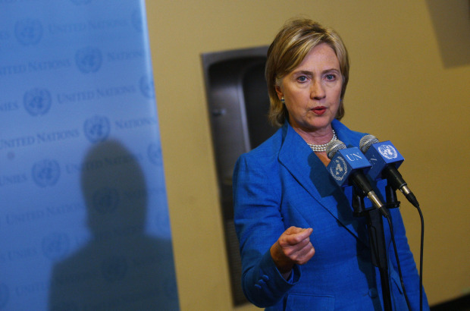
In an age of pressing global challenges, none threatens our nation or our world as urgently as the possible spread of nuclear weapons. The United States has a special responsibility to meet this challenge, and under President Obama, we seek to lead the international community in minimizing these dangers and reinvigorating the nuclear nonproliferation regime.
Recent developments underscore the threat. The international community failed to prevent North Korea from developing nuclear weapons. Iran continues to ignore resolutions from the U.N. Security Council demanding that it suspend its enrichment activities and live up to its international obligations. Too much of the world's nuclear material remains vulnerable to theft or diversion, even as illicit state and nonstate networks engage in sensitive nuclear trade. And as we saw with the failure to detect Iran's covert enrichment plant and Syria's reactor project, the International Atomic Energy Agency (IAEA) doesn't have the tools to carry out its verification mission effectively.
If we do not reverse this trend and strengthen the international nonproliferation regime, we will find ourselves in a world with a steadily growing number of nuclear-armed states, and an increasing likelihood of terrorists getting their hands on nuclear weapons.
No nation is safe from the threat of nuclear proliferation, and no nation can meet this challenge alone. In the early days of the atomic age, a handful of powerful countries could effectively set nonproliferation strategy. But in today's changing world, with information and technology leaping across borders, industrial capacity more widely distributed, and nonstate actors wielding increasing influence, it will require unprecedented international cooperation.
That is why the United States has launched a major diplomatic effort to forge a renewed international consensus on nonproliferation that is based on the shared interest of meeting a common threat and on the requirement that all nations understand and abide by their rights and responsibilities.
Last month, President Obama chaired a historic U.N. Security Council session that unanimously adopted a resolution outlining a framework for action in the years ahead. This resolution should serve as a guide for the international community as we work to strengthen the nonproliferation regime, including through the Nuclear Non-proliferation Treaty (NPT) Review Conference next spring. As we have done for four decades, we must build on the NPT's solid foundation with measures designed to tackle evolving challenges.
We seek to strengthen each of the three mutually reinforcing pillars of global nonproliferation -- preventing the spread of nuclear weapons, promoting disarmament, and facilitating the peaceful use of nuclear energy. And to those three pillars, we should add a fourth: preventing nuclear terrorism.
The most effective way to reduce the threat of nuclear terrorism is to ensure that nuclear materials that can be used to build weapons are well protected against theft or seizure. That is why the United States has proposed a plan to secure all vulnerable nuclear material worldwide within four years -- a plan that has now won the endorsement of the U.N. Security Council.
We will use financial and legal tools to better disrupt illicit proliferation networks, including by tightening controls on transshipment, a key source of illicit trade. We will seek to strengthen Nuclear Suppliers Group restrictions on transfers of enrichment and reprocessing technology. And we will also promote multilateral nuclear fuel supply and spent fuel arrangements so that states embarking on or expanding nuclear power programs can pursue their civil nuclear plans without going to the great expense and difficulty of building their own enrichment or reprocessing plants.
To be effective, the international nonproliferation regime must have teeth. The United States supports enhancing the IAEA's verification authorities and resources so it can perform its mission effectively. And we should consider automatic penalties for violations of safeguards agreements, such as suspending all IAEA technical cooperation until compliance has been restored. Potential violators must know full well that they will be caught and that they will pay a high price for failing to live up to their obligations.
To improve our standing to build broad international support for pursuing these means of strengthening the nonproliferation regime, the United States and the other nuclear-armed powers should fulfill their own obligation to reduce their nuclear stockpiles.
We are negotiating an agreement with the Russians to succeed the soon-to-expire START Treaty, significantly reducing the nuclear forces of both sides, paving the way for deeper cuts in the future, and providing for inspections and other confidence-boosting mechanisms. Step by step, we are transforming a relationship that was once defined by the shadow of mutually assured destruction into one that is based on mutual respect.
We are also seeking ratification of the Comprehensive Test Ban Treaty and negotiation of a Fissile Material Cutoff Treaty. These steps will strengthen our national security and global credibility, while moving us closer to President Obama's goal of a world without nuclear weapons.
In the meantime, we will maintain a safe, secure and reliable nuclear deterrent. We are undertaking an important review of the role of nuclear weapons in the United States' defense posture -- and will sustain our nation's nuclear arsenal and supporting infrastructure with the necessary resources.
This is an ambitious agenda. As the president has acknowledged, we might not achieve the dream of a world without nuclear weapons in our lifetime. But by making the reduction of nuclear threats one of our highest national priorities and by reaching out to a diverse group of international partners, we can help build and lead a unified international effort that will make us safer and stronger.
As President Obama said in Prague, the United States "cannot succeed in this endeavor alone, but we can lead it, we can start it." Today, we have started, we are leading, and we remain committed to meeting this gravest of challenges.

