Banyan
Land of the impure

Don’t blame the army for all Pakistan’s problems. Just most of them
Jun 17th 2010
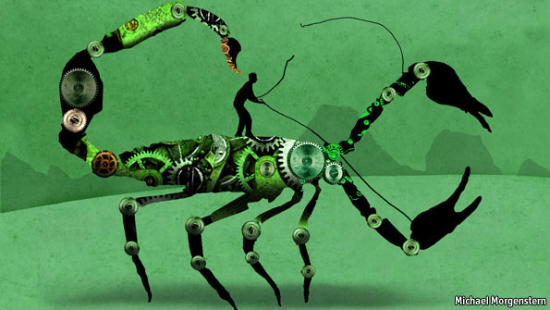
THREE score years and a bit after its founding, Pakistan—which means land of the pure—still struggles to look like a nation. Economically backward, politically stunted and terrorised by religious extremists, it would be enough to make anyone nervous, even if it did not have nuclear weapons. For these shortcomings, most of the blame should be laid at the door of the army, which claims, more than any other institution, to embody nationhood. Grossly unfair? If the army stood before one of its own tribunals, the charge sheet would surely run as follows:
One, a taste for military adventurism on its “eastern front” against giant India, which has undermined security, not enhanced it. No adventure was more disastrous than the one in 1971, which hastened the loss of East Pakistan, present-day Bangladesh. More recently, in 1999, General Pervez Musharraf, then army chief, sent troops into Indian-controlled Kashmir without deigning to inform the prime minister, Nawaz Sharif. Mr Musharraf thus forced a confrontation between two nuclear states. It was an international public-relations debacle for Pakistan. Today the army remains wedded to the “India threat”. India, meanwhile, for all its gross abuses in Kashmir, is more concerned about economic development than invading Pakistan.
Two, endangering the state’s existence by making common cause with jihadism. This policy started with General Zia ul-Haq’s “Islamisation” policies in the late 1970s. After the Soviet Union invaded Afghanistan in 1979, Pakistan (along with the CIA) financed the Afghan mujahideen opposition. The policy turned into support for the Taliban when the movement swept into power in the mid-1990s. Taliban support continues today, even though Pakistan is America’s supposed ally in Afghanistan’s anti-Taliban counterinsurgency. A new report by the London School of Economics claims that not only does Pakistan’s Inter-Services Intelligence (ISI) spy agency finance the Afghan Taliban, but the ISI is even represented on the Taliban’s leadership council. The claims have been loudly rejected, but in private Pakistani military men admit that corners of the army do indeed help the Taliban.
For years both Islamist and liberal generals have also backed jihadists fighting for a Muslim Kashmir. Though vastly outnumbered, the militants have managed to tie down a dozen Indian army divisions. Mr Musharraf and an aide once joked about having such jihadists by their tooti—ie, literally, “taps”, by which he meant their private parts.
Yet ex-mujahideen and their affiliates—known loosely as the Pakistani Taliban—have turned on their hosts. The armed forces have struck against them near the border with Afghanistan. Other militant groups which the army thought it “owned” have either joined the Pakistani Taliban or, like them, have turned against their former protectors. The army itself, even the ISI, has been a target of attacks. While officers draw increasingly nice distinctions between different jihadists, the militant groups are bleeding into one another. Now attacks are spreading into tolerant, prosperous Punjab, far from the troubled marches. No doubt now about who holds whom by the tooti.
Three, the armed forces have undermined democratic institutions. Since 1947, the longest period of civilian rule the army has tolerated is just six years. And when Mr Musharraf instigated a coup after being sacked by Mr Sharif after the Kashmir debacle, there followed more than eight disastrous years of military rule, heavily backed, as with previous such rules, by the Americans. Like General Zia before him, Mr Musharraf often found Islamist political parties more congenial than secular ones.
Admittedly, Pakistan’s governing institutions were weak from the outset, but the army’s meddling has made them even weaker. Under Mr Musharraf it has left the civil service and judiciary corrupt and demoralised. (A tenth of civil-service appointments must still go to officers.) The armed forces have a $20 billion business empire and are probably the country’s biggest land developer, as officers’ loyalty is bought with grants of land.
The leaders of the main parties are mainly to blame for their corrupt, feudal styles and for not practising the democracy they espouse even in their own parties. Yet the army also shares some of the blame for political backwardness. It has permitted only a handful of elections. Democracy might have been much more mature by now had elections been allowed to run their course.
The costs go beyond any democratic deficit. Pakistan’s economic and social development have also been stunted, as the army has sucked up resources and thwarted growth. In economic terms, educated Pakistanis think their country should be a Turkey or a Malaysia by now. Instead, it lies below Yemen in the UNDP’s ranking of human-development indicators, at 151st in the world. School enrolment ranks below Sudan. The government spends twice as much on the armed forces as on education.
Dogs with the keys to their kennel
Some say Pakistan has turned a corner. The army went back to barracks in 2008, pushed partly by the return and assassination of the populist leader, Benazir Bhutto. This year political parties reached consensus on constitutional changes that shift power towards parliament and away from the president, currently Asif Zardari, Miss Bhutto’s widower and heir to her political dynasty.
Optimists say this sets Pakistan on a path to more effective and accountable government. Perhaps. But the pessimist in Banyan counters that the army retains its huge say on national security. What’s more, civilian politics remains frequently corrupt, and personality trumps policy. What looks like a system of checks and balances today could look like gridlock tomorrow. The sort of combination, in other words, that tempts the army to poke its head out of the barracks again.

