From 9/11 to the Arab Spring

The current uprising is directed not against foreign demons, but against cruel rulers who robbed their people of a decent life.

By FOUAD AJAMI
The Arabic word shamata has its own power. The closest approximation to it is the German schadenfreude—glee at another's misfortune. And when the Twin Towers fell 10 years ago this week, there was plenty of glee in Arab lands—a sense of wonder, bordering on pride, that a band of young Arabs had brought soot and ruin onto American soil.
The symbols of this mighty American republic—the commercial empire in New York, the military power embodied by the Pentagon—had been hit. Sweets were handed out in East Jerusalem, there were no tears shed in Cairo for the Americans, more than three decades of U.S. aid notwithstanding. Everywhere in that Arab world—among the Western-educated elite as among the Islamists—there was unmistakable satisfaction that the Americans had gotten their comeuppance.
There were sympathetic vigils in Iran—America's most determined enemy in the region—and anti-American belligerence in the Arab countries most closely allied with the United States. This occasioned the observation of the noted historian Bernard Lewis that there were pro-American regimes with anti-American populations, and anti-American regimes with pro-American populations.
I traveled to Jeddah and Cairo in the aftermath of the 9/11 attacks. In the splendid homes of wealthy American-educated businessmen, in the salons of perfectly polished men and women of letters, there was no small measure of admiration for Osama bin Laden. He was the avenger, the Arabs had been at the receiving end of Western power, and now the scales were righted. "Yes, but . . . ," said the Arab intellectual class, almost in unison. Those death pilots may have been zealous, but now the Americans know, and for the first time, what it means to be at the receiving end of power.
Very few Arabs believed that the landscape all around them—the tyrannical states, the growing poverty, the destruction of what little grace their old cities once possessed, the war across the generations between secular fathers and Islamist children—was the harvest of their own history. It was easier to believe that the Americans had willed those outcomes.
In truth, in the decade prior to 9/11, America had paid the Arab world scant attention. We had taken a holiday from history's exertions. But the Arabs had hung onto their belief that a willful America disposed of their fate. The Arab regimes possessed their own sources of power—fearsome security apparatuses, money in the oil states, official custodians of religion who gave repression their seal of approval.
Enlarge Image
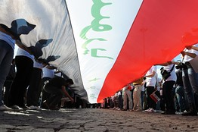
Close
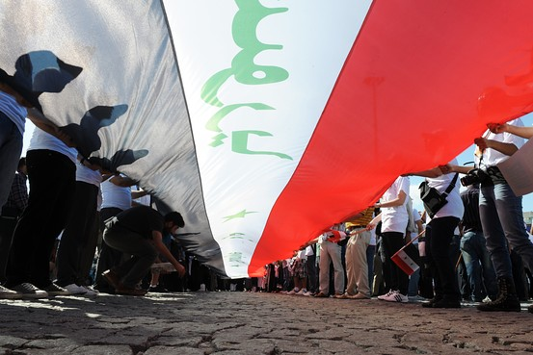
AFP/Getty Images
Demonstrators in Instanbul hold a Syrian flag in support of the protests in Syria.
But it was more convenient to trace the trail across the ocean, to the United States. Mohammed Atta, who led the death pilots, was a child of the Egyptian middle class, a lawyer's son, formed by the disappointments of Egypt and its inequities. But there was little of him said in Egypt. The official press looked away.
There was to be no way of getting politically conscious Arabs to accept responsibility for what had taken place on 9/11. Set aside those steeped in conspiracy who thought that these attacks were the work of Americans themselves, that thousands of Jews had not shown up at work in the Twin Towers on 9/11. The pathology that mattered was that of otherwise reasonable men and women who were glad for America's torment. The Americans had might, but were far away. Now the terrorism, like a magnet, drew them into Arab and Muslim lands. Now they were near, and they would be entangled in the great civil war raging over the course of Arab and Muslim history.
The masters and preachers of terror had told their foot soldiers, and the great mass on the fence, that the Americans would make a run for it—as they had in Lebanon and Somalia, that they didn't have the stomach for a fight. The Arabs barely took notice when America struck the Taliban in Kabul. What was Afghanistan to them? It was a blighted and miserable land at a safe distance.
But the American war, and the sense of righteous violation, soon hit the Arab world itself. Saddam Hussein may not have been the Arab idol he was a decade earlier, but he was still a favored son of that Arab nation, its self-appointed defender. The toppling of his regime, some 18 months or so after 9/11, had brought the war closer to the Arabs. The spectacle of the Iraqi despot flushed out of his spider hole by American soldiers was a lesson to the Arabs as to the falseness and futility of radicalism.
It is said that "the east" is a land given to long memory, that there the past is never forgotten. But a decade on, the Arab world has little to say about 9/11—at least not directly. In the course of that Arab Spring, young people in Tunisia and Egypt brought down the dreaded dictators. And in Libya, there is the thrill of liberty, delivered, in part, by Western powers. In the slaughter-grounds of Syria, the rage is not directed against foreign demons, but against the cruel rulers who have robbed that population of a chance at a decent life.
America held the line in the aftermath of 9/11. It wasn't brilliant at everything it attempted in Arab lands. But a chance was given the Arabs to come face to face, and truly for the first time, with the harvest of their own history. Now their world is what they make of it.
Mr. Ajami is a senior fellow at Stanford University's Hoover Institution and co-chair of the Working Group on Islamism and the International Order.

