Why Karachi?
By Rafia Zakaria
Wednesday, 10 Feb, 2010
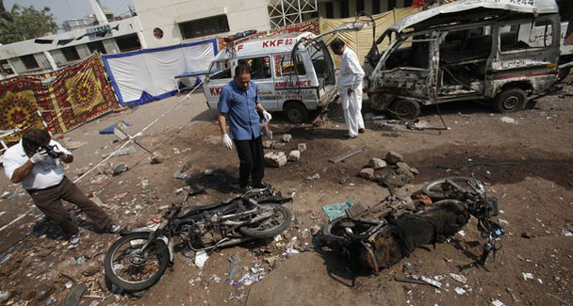
A team of investigators examine the site of a bomb blast, which killed 13 people, outside Jinnah hospital in Karachi.
The question of why a terrorist attack took place in Karachi is seemingly an unfair one. The bloodstained first decade of the new millennium has seen nearly every corner of Pakistan come under attack. Cultural centres like Lahore to markets in Peshawar to small towns like Chakwal and Mian Channu to smaller villages have all been victimised by terror.
The reason for additional consternation about attacks in Karachi, however, is simple. As Pakistan’s only mega city Karachi’s demographics, history of communal conflict and dynamics of urban governance all present a lethal mix.
In addition, its status as a global city, one with widespread (and largely unregulated) communication systems, present unique opportunities to terrorist groups wishing to use the city as a hub for monitoring and proliferating transnational networks.
Finally, more Al Qaeda planners and leaders are believed to have been apprehended in Karachi than in any other single city pointing to the fact that Karachi is not simply a target for terrorist attacks but a place which provides a cover to groups planning them. The arrests of Shawki Awad Balzuhair, Aziz Ahmed Al Maythali, Hassan Bin Attash, Rahimullah and several others all took place in the city. A recent report by the Herald magazine also detailed how Said Bahaji, a 9/11 hijacker, stayed in a Karachi hotel just months before the attacks.
In keeping with global trends that predict a doubling of the world’s urban population by the year 2030, Karachi has seen a massive influx of migrants in search of employment, some of them fleeing the conflict in Waziristan and parts of the NWFP. While the city is ethnically diverse, a large chunk of Karachi’s own population is distinct from the others. This distinction, politically translated into control by the Muttahida Qaumi Movement has meant that the city has an ethnically based vote bank.
Ties with Pakhtun migrants and adjoining Sindhi neighbours present a vexing governance issue. The ethnic construction of political power gives those in city, provincial and federal governance a vested interest in promoting the growth or cessation of certain kinds of ethnically based ghettoes around the city.
The latest saga of politically motivated targeted killings sandwiched between terrorist attacks illustrates precisely this lethal mix as well as the opportunities they provide to groups planning terrorist attacks. While it cannot be said with certainty who carried out the sectarian killings of Shia mourners last December, the attack is said to have borne the hallmark of Al Qaeda or one of the Sunni Islamist groups.
Al Qaeda has routinely exploited sectarian tensions as a means of establishing its power base as was amply visible in Iraq. However, if the attacks themselves were the work of a terrorist group, the ensuing violence, looting and destruction of property were the work of political rivals using the cover of chaos to achieve agendas unrelated to the terrorist attacks themselves.
What followed in the days after the killings was a long string of targeted attacks — which had been happening before as well — that presumably involved land mafias as well as political antagonists. Nearly 50 people were killed in the days over three days alone last month. The ensuing allegations and counter-allegations led to increasing tensions between the MQM, the Awami National Party and the PPP. Part of this tension was directly related to disagreements over the local government system and the fear that with the province intervening to take over an upheaval would result in the local governance mechanisms of the city.
The rift between the parties deepened to the extent that the MQM threatened to leave the ruling coalition at the centre and even in the provincial government. Amid the chaos, terrorists struck again last Friday, targeting a bus carrying Shia mourners and the hospital where the injured and dead were taken to. Once again, several people died.In the political and structural opportunities it presents for planning and execution, Karachi could well be Al Qaeda’s dream city. Strategically, it holds an advantage over the tribal areas in that it is unlikely to be the target of US drone attacks. The presence of Al Qaeda elements can easily be reduced and trails eradicated in a city of several million.
The proliferation of land mafias and the few resources available for governance make it easy to procure a safe house that can be a central point for planning purposes. The house can be supplied with electricity, water and other amenities entirely through illegal means. Technology, from the latest variety of cell phones to the fastest Internet connection, can be acquired with no interaction with government authorities.
The ongoing tension and never-ending low-level violence and targeted killings in the city create an effective cover by ensuring that local and provincial governments are too busy settling scores to bother about following their tracks.
Finally, Karachi represents an important target for attacks because capitalising on political fissures in the city yields enormous advantages in thwarting the Nato mission in Afghanistan. The city is the entry point for Nato supplies to Afghanistan and its destabilisation would translate into a massive blow to Nato efforts in the region.
While all efforts in the war against terror are currently being directed towards the tribal areas, Karachi’s neglected urban infrastructure and non-existent system of security provision presents a much more pressing threat. Existing ethnic and political lines are structural factors that cannot be easily changed but strengthening governance in Karachi could provide an antidote to some of the problems currently being exploited by terror groups.
However, to do so requires a realisation that the political games being played present a far greater cost to the country than is currently acknowledged.

