Nostalgia for colonial era
By Kunwar Idris
Sunday, 07 Feb, 2010
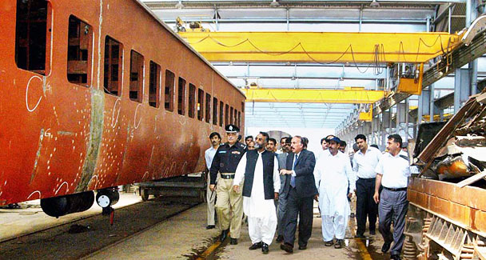
“There is a solution for rehabilitating both law and order and railways in Pakistan. We have Lalus and Kumars among us. It is the system that is in disarray.” – Photo by APP.

Provinces
Mian Channu tragedy

Mian Channu tragedy

Law and order and the railways were among the best of our colonial inheritance. But they were squandered after independence. Today, they are arguably among the worst services that Pakistan renders to its citizens.
In the colonial era, people were not free because they were British subjects but they were secure in their homes. While travelling they had the assurance that the train would take them to their destination in safety and on time.
Now as free citizens they have the right to vote, which many don’t exercise, or protest, which everybody does, but do not feel safe in their homes or travelling in trains. The pride of freedom and nostalgia for colonialism exist side by side.
So peaceful was Sindh, for instance, that towards the close of the 19th century the commissioner, Sir Bartle Frere, felt confident enough to inform the governor of Bombay that “here on the frontier (with Punjab) under the mountains not a mouse stirs without Merewether’s permission”. Mind you, William Merewether was just an assistant commissioner under the legendary deputy commissioner, Sir John Jacob.
Today, kidnappers and killers roam the streets of Karachi while a host of ministers, nazims and magistrates fret and fight. There is no Merewether to account for 10 deaths a day.
Here, we must hark back to the colonial past. Sir Bartle Frere as chief executive of Sindh was firmly of the view that power in a district or region should be delegated only to one head. John Jacob as deputy commissioner of the border region was also commandant of the Sind Horse — equivalent of today’s police and the Rangers combined.
The best system for law and order, Frere thought, “was a good vigorous despotism, in which the risks of tyranny and arbitrary oppression are minimised, one in which the despot is accessible, when every man sees, knows and can appeal to his own despot”.
In today’s parlance Frere was asking for a district magistrate, nazim or inspector general, call him what you will, to be made responsible for maintaining law and order. Here, amid killings and arson, a variety of head honchos huddle only to wag their fingers at each other.
Interestingly, Frere was also of the view that the head of law and order should have no direct dealings with “judges, canal officers and educationalists”. That too fits in with the current thinking and, by and large, also with evolving practices. The district judge is independent and development departments are supervised by elected representatives.
Confusion abounds only in the administration of law and order. Some confusion has always been there since independence; under Gen Musharraf’s laws and other contrivances, it degenerated into chaos. His Police Order that superseded the 1861 act has made the head of district police responsible to the nazim for police functions but not for administration.
The local government law also requires the nazim to “perform functions relating to law and order”. Where a function ends and administration begins cannot be made out.
What is obvious, however, is that the control of law and order has passed into the hands of the provincial home minister of the province and the federal interior minister through a hierarchy of committees of officials and public representatives which never really function.
No wonder then that no one has been held responsible for the current target killings in Karachi or the Ashura bombing or for Friday’s explosions in the metropolis.
Indeed, no one has been held responsible for the attack on Benazir Bhutto’s homecoming procession or for the lawlessness that engulfed Karachi on the arrival of the chief justice. Under the old — colonial if you like — system and laws the district magistrate would have been held accountable.
Now that the local government and police laws are being reviewed by the legislatures they must name a ‘despot’ of Sir Bartle Frere’s conception, who is accessible but not arbitrary or oppressive, for maintaining law and order and who is accountable for its violation. To be impartial he must not be a politician in the current politically charged environment.
Meanwhile, the culprits and causes for the downfall of the railways are harder to identify. The government is seen doing little to check the fast declining service and steeply climbing losses of the railways.
It was not too long ago that people travelled by Tezgam and Khyber Mail not just for financial reasons but for the sheer pleasure of the journey. At Lahore station a Spencer meal was an added attraction. Stations now are dusty and desolate. Migrant workers go to the Karachi station for a trip home only to board a bus outside for a 1,000-mile journey.
The trains in Mumbai bring in, and carry back, a million commuters every day from the suburbs to metropolitan areas. Midday meals from their homes also come by train. Trains run on time countrywide. The turnaround of the Indian railways by Lalu Prasad Yadav has become a case study at the Harvard Business School.
By contrast, Karachi has junk of a train that comes crawling from Malir to Merewether Tower. The railway rot leaves no room for a study or for pumping in more public money. A solution that governments of losing rail services have applied is to invest only in the infrastructure and contract out the operations to competing private companies. We should do the same.
Ironically, Lalu Prasad Yadav, the saviour of the Indian railways, was considered a long-serving shrewd but roguish chief minister who destroyed law and order in Bihar. Even more ironically, his low-profile successor Nitish Kumar, has restored law and order to Bihar by jailing gangsters and denying liquor shop licences to criminals.
The lesson is that there is a solution for rehabilitating both law and order and railways in Pakistan. We have Lalus and Kumars among us. It is the system that is in disarray.
kunwaridris@hotmail.com

