Land mafia and the law
By Rafia Zakaria
Wednesday, 03 Mar, 2010
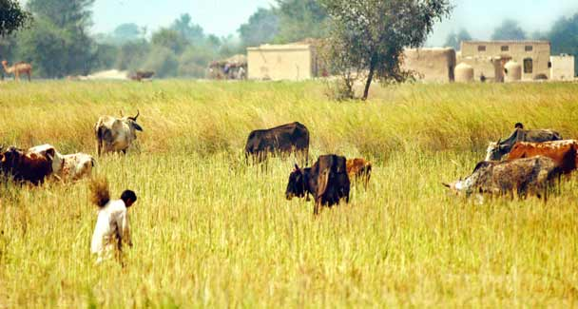
If success against the collusion of land mafias, political conglomerations and capitalist profiteering is solely at the discretion of Pakistan’s Supreme Court, then chances of ordinary citizens prevailing against the domineering tactics of land mafias are minimal.
In the outskirts of Lahore lies the village of Bagriyan, a once rural enclave of farmland and livestock that was of little interest to developers. This has changed in recent years as the population of Lahore catapulted to nearly 10 million and the village became part of the city district of Lahore.
Property values have risen and farmland is fast being converted into housing by enterprising real-estate developers looking to benefit from the urban sprawl.
The latest casualty of the unabated proliferation of housing societies has been the Government Model School for Boys, Bagriyan, which has had the unfortunate luck of being located in the path of a housing development scheme. Documents filed in the civil court in Lahore indicate that the land belonging to the school was seized by an ex-councillor of the area and a local political leader.
Literally overnight, a road was constructed right through the school’s property to provide access to the housing development scheme. According to reports published in the Urdu daily Ausaf, the school staff was terrorised when armed representatives of the land mafia showed up and supervised the construction of the access road. Adjacent rooms of the school that had been under construction at the time were demolished to enable the construction of the thoroughfare. The road was made operational by the continual presence of representatives of the land mafia, leaving students to study amid the noise and traffic now passing right through the middle of their premises.
The hapless school officials sought the help of Khawar Mehmood Khatana, a local attorney who runs the NGO Synergy International. According to advocate Mehmood’s statements, also published in the Ausaf report, each PML-N representative in the area was contacted but none was prepared to come to the aid of the school. In fact, the ex-councillor was able to obtain a stay order from the Lahore Civil Court prohibiting the school officials from obstructing the road. In this way, the Government Model Boys School, Bagriyan, which was established in 1960 and has been educating poor children of the area since then, had a significant portion of its premises taken over, apparently at the behest of those that seek to benefit from commercial development in the area and wield both political and economic power over the poor students and staff at the school.
While the school seems to be losing the battle against politically-backed land mafias, there has been some success in other quarters. As recently as last December, the Supreme Court of Pakistan — thanks to the efforts of the NGO Shehri CBE and eminent Dawn columnist Ardeshir Cowasjee — issued a decision reversing a land grant to commercial giant Makro-Habib to evacuate 4.9 acres of land originally meant for a playground.
In the Makro-Habib case, the then president Pervez Musharraf had granted 4.9 acres of prime land to the Army Welfare Trust (AWT) for 90 years at the nominal rent of Rs6,020 a year. The AWT then transferred the land to Makro-Habib in 2006 for a profit, with no thought given at all to the fact that the land belonged to the citizens of Karachi and was legally mandated by statute for public use as a playground. Because of a column written on the subject, the Supreme Court took suo motu notice of the issue and ordered Makro-Habib to vacate the premises and hand it over to the city district government that has jurisdiction over public land.
Of course had the Supreme Court not taken notice of the issue, Shehri CBE’s campaign may not have been successful. Other cases in which the NGO has agitated against incursions on public land have been less successful and have even led to fatal consequences for its activists. Prominent among these was the case of Nisar Baloch who was gunned down allegedly because of his activism on the land-grab of Gutter Baghicha, another tract reserved for a public park.
The case of Bagriyan is similar. If success against the collusion of land mafias, political conglomerations and capitalist profiteering is solely at the discretion of Pakistan’s Supreme Court and its taking notice of the issue, then chances of ordinary citizens prevailing against the domineering tactics of land mafias are minimal. In the Bagriyan case, advocate Khatana did register an appeal with the Lahore High Court (LHC) through the special human rights cell of the court, but failed to garner any attention from the LHC chief justice.
Undoubtedly, the disruption in studies at the school is not a cause that resonates with many and the road that traverses through the school signifies just how low the matter stands on the list of priorities. All this could change if the Supreme Court of Pakistan would take notice of the issue. Indeed, no case can be as deserving and no plaintiffs as hapless and ignored as the hundreds of students eking out an education in this underprivileged school.
While such action may not eliminate the ever-stronger land mafias operating in Karachi and Lahore, nor solve the systemic problems with the provision of justice and land ownership in the country, it would demonstrate to those with the least power that those with the most can stand up for justice even when political calculations do not dictate that they do so.

