Self-defeating exercises
By I.A. Rehman
Thursday, 18 Feb, 2010
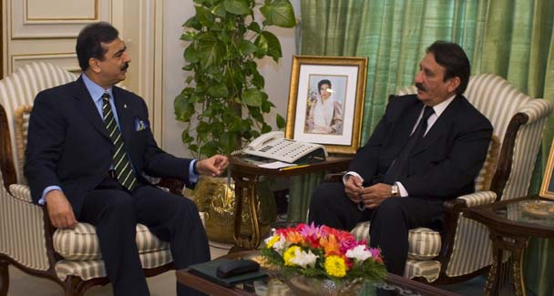
PM Gilani talks with Chief Justice Iftikhar Chaudhry during their meeting in Islamabad.—AP
Influential intermediaries have succeeded in easing the confrontation between the executive and the judicary that the president’s utterly inept advisers had created.

But the debate on the procedure for the appointment of judges will continue to cause crises till a rational solution is found.
The present constitutional position regarding the appointment of judges is quite clear. A Supreme Court judge is appointed by the president under Article 177 of the constitution after consultation with the chief justice of Pakistan.

For the appointment of a judge of a high court under Article 193, too, the president is required to consult the chief justice of the Supreme Court.

Although in such cases the president is also obliged to consult the governor and the chief justice of the high court concerned, primacy is attached to consultation with the chief justice of the Supreme Court.
Differences of opinion on the interpretation of these constitutional provisions, which caused several crises during 1958-89, were addressed first in the Supreme Court’s answer to a presidential reference of 1989 and more decisively in the Supreme Court verdict in the judges case of 1996.

In the latter case the court ruled that the consultation required under both the articles had to be effective, meaningful, purposive and consensus-oriented, leaving no room for complaint of arbitrariness or unfair play.

The president was bound to accept the opinion of the chief justice or give reasons in writing for not accepting that opinion. (These reasons, too, one supposes would be justiciable.)
The judiciary has also benefited from a good turn done to it by Gen Pervez Musharraf. In the Legal Framework Order of 2002, he chose to define ‘consultation’ in Article 260 (definitions) in the following words: “‘consultation’ shall, save in respect of appointments of judges of the Supreme Court and high courts, mean discussion and deliberation which shall not be binding on the president.”
In simple words, in respect of the judges’ appointment the opinion of the consultee is binding on the president, while in other matters it may not be the case.
So long as the Supreme Court verdict in the judges case and the Musharraf definition hold the field the president’s hands are firmly tied. If the president or the government were not happy with their ouster from the process of the judges’ appointment they should have secured an amendment to the constitution that laid down an alternative mode of selecting judges.

They did not even care to capitalise on the formula on the subject given in the Charter of Democracy while there was time to do so. (Now it is doubtful if the second party to the charter will care to honour the relevant provision.)
However, the presidency’s inability to win the argument against the judiciary’s interpretation of the basic law does not mean that it has no case. It can be shown that the judiciary’s rigid position on the total extinction of the executive’s role in the process of judges’ selection will not be sustainable in the long run.
To begin with, the 1996 judgment in the judges case has not been universally accepted as a piece of unblemished wisdom. That it was a reaction to a series of government’s attacks on the globally acknowledged rights of the judiciary is understandable.

But if the executive’s policy of deciding on judicial appointments without reference to the heads of the judiciary marked one end of the pendulum the 1996 verdict swung the pendulum to the other extreme. Neither position is in accord with the principles of democratic dispensation and the separation of powers.
Quite a few learned writers on the subject have declared that neither the executive nor the judiciary should have veto powers in the matter of appointment of judges. Indeed the dominant trend is to make key judicial appointments subject to consensus between the ruling party and the opposition.
An Indian authority has summed up the argument in these words: “Giving finality to the judges is as bad as giving finality to the government. A veto is bad wherever it is vested.

Therefore, the power to appoint judges must be vested in a body that is independent and represents the government, the opposition as well as the judiciary. This has also been recommended by the (Indian) National Commission to Review the Working of the constitution (NCRWC).”
Besides, the judiciary itself has not always been able to respect the 1996 judgment. The latest instance of its deviation was the reported move to appoint Justice Khalil Ramday (whose qualifications and outstanding merit cannot be questioned though) as an ad hoc judge of the Supreme Court soon after his retirement. This was contrary to the 1996 ruling that no ad hoc judge should be appointed to the apex court against a permanent vacancy.
Sooner or later the 1996 verdict will have to be reviewed with a view to achieving a friction-less balance between the judicial and executive organs of the state with due regard for the majesty of the people’s will.

All political actors in the field should keep in mind the possibility that they may find themselves, on coming into power, in a predicament similar to President Zardari’s.
Unfortunately, the debate on the subject has been muddied by two factors. First, the trust deficit between the executive and the judiciary has reached absolute limits.

It seems neither side is inclined to stop suspecting the motives of the other. In this situation a rational understanding, even of the kind reached between the president and the prime minister in 1989, is apparently impossible. Only time will tell how long and in what form yesterday’s compromise will endure.
Secondly, it is difficult to dispel the impression that political parties (where they are in power), privileged lawyers’ groups and, if one may be permitted to say, some elements around the judicial establishment, are trying to grab the judiciary’s commanding heights and the reasons are obvious.
All this does not augur well for the future. The energies of the state’s two vital organs could continue to be dissipated in haggles no democratic polity can afford, and access to justice might become more and more difficult for the poor and the marginalised.
Have the people of Pakistan forfeited their right to a decent deal from the masters of their destiny?

