Pakistan and Rome Statute
By Ahmer Bilal Soofi
Thursday, 10 Dec, 2009
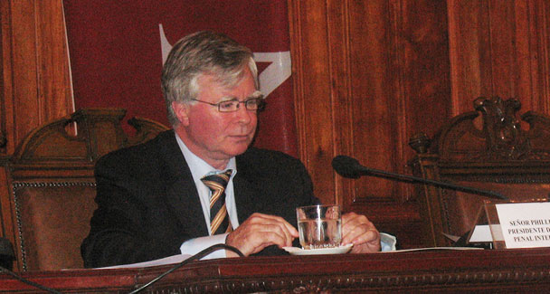
Pakistan in 2009 is facing challenges that were not conceived in 2005 when Mr Philippe Kirsch who remained ICC president from 2003 till 2009 visited. Back then discussions were held with him about armed conflict scenarios in Pakistan in a speculative sense.

It was in 2005 that I received a call from Hasan Shad, a lawyer interning at the International Criminal Court (ICC), saying that the president of the ICC was planning a trip to India and asking whether the Research Society of International Law would be interested in extending an invitation to him.
I immediately said yes and followed up with a formal letter of invitation. The president was pleasantly surprised to receive an invitation to visit Pakistan from a Pakistan-based international law think-tank instead of the government. He accepted the invitation and eventually arrived in Pakistan in December 2005.
Surprisingly, the government and the ministry of foreign affairs were quite unnerved when they heard that the ICC president was coming to Pakistan on the invitation of a private concern, as it may have made their American friends uneasy. (Remember, the Bush administration was not happy with the ICC and its universal jurisdiction that could extend to American soldiers serving in various conflict zones throughout the world.)
President Philippe Kirsch, it turned out, was actually very happy to visit Pakistan. He addressed a gathering of Islamabad’s legal and intellectual community at the Institute of Strategic Studies and also delivered a lecture at the National Defence University. On our request, Justice Iftikhar Chaudhry was kind enough to host a dinner for the then ICC president attended by all judges of the Supreme Court. The next day Mr Kirsch drove to Lahore. A seminar was arranged for him and later the same evening he left for New Delhi.
The ICC president was obviously not on a mission to persuade Pakistan to become a member of the ICC. But his visit did bring to attention the issue of whether Pakistan should join the ICC. In the discussions that took place, the implications of ratification of the Rome Statute of the International Criminal Court were openly discussed. People interacting with him asked specific questions about scenarios involving Pakistan’s becoming an ICC member.
During my speeches in the presence of the ICC president, I specifically proposed that Pakistan should consider ratification and also simultaneously prepare implementing legislation of the Rome Statute.
Philippe Kirsch — who remained ICC president from 2003 till 2009 — has the credit of steering the ICC skilfully, despite the open dislike of the US and Israel, and has effectively made it perhaps the most powerful international judicial forum of the world. Recently, it issued warrants of arrest against the sitting president of Sudan, Omar al-Bashir. Its chief prosecutor Luis Moreno-Ocampo, a Harvard law professor, has unnerved the Israeli military by accepting on his desk the inquiry into war crimes by Israeli soldiers.
Pakistan in 2009 is facing challenges that were not conceived in 2005 when Mr Kirsch visited. Then, we had discussed with him armed conflict scenarios in Pakistan in a speculative sense. Today, unfortunately, these scenarios have become a bitter reality. Pakistan’s army is engaged in a major military operation within its own territory. It is facing an enemy which does not fall within the classical definition of ‘combatant’; but the said enemy or miscreants are nonetheless committing war crimes (for instance suicide bombing irrespective of the distinction principle, etc).
The anti-terrorism laws do not generally apply to crimes committed during conflict. Furthermore, the Pakistan Army faces the possibility of a situation where soldiers of other states such as the US and Afghanistan may be involved in a conflict with respect to the territory of Pakistan. Moreover, a large contingent of Pakistan’s army personnel are sent on peace-keeping missions in various conflict zones throughout the world and each soldier faces the possibility of incurring liability under the ICC.
These circumstances further create justification for the ratification of the Rome Statute and for preparing implementing legislation for establishing offences of war crimes, genocide and crimes against humanity. The implementing legislation should not only take cognisance of regular combatants, but expand its jurisdiction to non-combatant miscreants as well. This would be a novel precedent as generally domestic legislation carried out by states which have ratified the Rome Statute confines the responsibility of offences to regular ‘combatants’.
I am suggesting that such implementing legislation must include non-state actors and non-combatant miscreants as well. After all, they are a reality in the Pakistani theatre of combat and they are perpetrators of offences that are enlisted as war crimes in Articles 7 and 8 of the Rome Statute, against unarmed civilian citizens of Pakistan.
The ratification of the Rome Statute shall also discipline the legal handling of these military operations to a considerable extent. The rules for the internment of arrested miscreants may well be issued. Distinction between acts of terror prosecutable under the Anti-Terrorism Act and war crimes prosecutable pursuant to the Rome Statute would be made much clearer. Right now all offences (bomb blasts, suicide bombings, etc) are placed in the legal basket of anti-terrorist laws

